**Gamify Python**

**<< Build Games to Master Code>>**



**SATLUCIFERAN**

**Copyright © 2025 by Satluciferan. All rights reserved.**

To my father, who taught me to think.  
To my mother, who taught me to feel.  
To every teacher who believed, even when I doubted.  
To the late nights, the early mornings, and the quiet persistence.  
This book is for the dreamers who dare to build with code.  
May you find clarity, confidence, and cosmos in every line.

**Acknowledgments**

This book exists because I wanted to make learning Python both fun and accessible. Too often, programming feels intimidating or overly technical for beginners. But when you turn code into games, something changes—learning becomes an adventure. Loops manage lives, functions power characters, and logic becomes your superpower.

I truly believe that after practicing with the games and challenges in this book, readers will not only improve their Python skills but also sharpen their logical thinking and creativity. You'll finish each chapter having built something real—and with that, a sense of confidence that grows line by line.

To the open-source Python community: thank you. Your tools and knowledge are the reason books like this can exist.

To the developers behind Pygame: your framework made it possible to teach code visually, playfully, and powerfully.

To educators and mentors who share Python with joy—you’re an inspiration.

And to the readers who dive into code and keep going even when it’s tough: this book is for you.

**Preface**

Welcome to a different kind of Python book—one that doesn't just teach code, it makes you play it. Every chapter in this book unlocks a coding concept by building a complete, interactive game. Whether you're just starting or brushing up your skills, this book will help you learn Python in the most fun and memorable way possible.

**Chapter 1: Setup and First Steps**

Before we dive into game-building, we need to prepare your coding environment and learn some Python basics. This chapter walks you through installing Python and a beginner-friendly code editor like VS Code or Thonny. You'll learn about Python files, how to write and run a script, and how to interact with users through input and output. By the end, you’ll build your first small game—a number guessing game—that gets your logic flowing and sets the stage for what’s to come.

**Chapter 2: Tic Tac Toe – Mastering Logic and Flow**

Now that you can run Python programs, it’s time to explore game logic. Tic Tac Toe is a perfect challenge to learn about conditional statements, nested logic, and how to represent a game board with lists. In this chapter, we’ll break down how to build a two-player game that can detect wins, ties, and invalid moves. You'll learn to think step-by-step through game turns and outcomes, laying the groundwork for future games.

**Chapter 3: Hangman – Strings and Loops**

Hangman is a fun, visual way to master strings, loops, and sets. This chapter teaches you how to slice and index strings, loop through letters, and keep track of guessed characters. We’ll also play with basic ASCII art to make the game more engaging. You’ll walk away understanding string manipulation, iteration patterns, and how to manage game state dynamically.

**Chapter 4: Quiz App – File I/O and Functions**

Let’s level up by building a quiz app that reads questions from a file and interacts with the player. You’ll learn how to load text and CSV files, handle basic errors, and use functions to organize your code. We’ll also add scoring logic and randomization to keep the quiz fresh. This chapter is perfect for understanding how Python works with external data and how to structure programs cleanly.

**Chapter 5: Snake – Object-Oriented Programming**

Snake is a classic arcade game and a brilliant way to learn object-oriented programming (OOP). You’ll define classes for the snake and its food, handle keyboard input, and manage collision detection—all using the Pygame library. This chapter introduces core OOP ideas like encapsulation, methods, and object interaction, all within a game loop structure. Once you complete this, you’ll be comfortable thinking in terms of objects and events.

**Chapter 6: Pong – GUIs and Motion**

Pong is a timeless classic—and a great way to introduce graphical programming and motion in Python. In this chapter, you'll learn how to use Pygame to draw moving shapes on the screen and handle real-time keyboard input. We'll build paddles, bounce the ball around the screen, and add collision detection for a competitive two-player experience. As a bonus, you'll add sound effects to make gameplay more immersive. This chapter will give you a solid foundation in basic GUI elements and interactive animation.

**Chapter 7: Memory Match – Working with Lists and Timers**

This game tests your memory and introduces new coding tools like timers and delayed feedback. You'll learn how to shuffle and display cards, track user input, and temporarily reveal matches before hiding them again. We’ll use lists to manage game state and time.sleep() to pause the game at the right moments. By the end, you’ll have created a polished, satisfying game that’s as challenging to build as it is to play.

**Chapter 8: Platform Jumper – Introducing Physics and Gravity**

Let’s jump into one of the most exciting game genres—platformers. This chapter introduces core physics concepts like jumping, gravity, and momentum using arrays and sprite mechanics. You'll build levels, control player movement, and handle platform collisions in real time. It’s your first real experience simulating physics in a 2D world. This chapter is a creative challenge where art, logic, and motion come together.

**Chapter 9: Game Over – Polish and Progress**

Now that you've built several games, it’s time to level them up. This chapter focuses on adding polish: creating menus, saving high scores, and scaling difficulty over time. You'll also learn how to organize larger codebases, split files into modules, and make your games feel more professional and user-friendly. These skills will prepare you to transition from hobby projects to more polished, complete software.

**Chapter 10: Final Boss – Build Your Own Game**

This is your ultimate challenge. In this chapter, you’ll plan, design, and develop your very own game from scratch. Whether it's a platformer, puzzle, or new twist on a classic, you’ll reuse skills from earlier chapters and apply them to a completely original idea. You'll decide on rules, characters, assets, and structure. We'll guide you through building it step-by-step, and show you how to share it with others. This chapter is where you become a full-fledged game developer.

**Appendix**

The appendix provides essential reference material and resources to support your learning journey as you work through the games in this book. Whether you're troubleshooting errors, looking to deepen your knowledge, or simply curious about the broader Python ecosystem, this section is here to help.

**Installing Pygame Step-by-Step**  
A quick guide to installing the Pygame library across Windows, macOS, and Linux. You'll learn how to check your Python version, use pip, and verify your setup with a test script.

**Debugging Tips**  
Effective strategies for identifying and fixing bugs in your code, including how to use print statements, comments, and Python’s built-in tools like pdb and traceback analysis.

**List of Common Python Errors**  
From IndentationError to IndexError, this section breaks down the most frequent mistakes beginners make—and how to fix them.

**Exercises and Bonus Challenges**  
Extra practice for each chapter, including stretch goals like new features, game enhancements, and “what if” scenarios to take your code further.

**Resource Links and Communities**  
A curated list of the best Python forums, Discord groups, learning websites, and documentation hubs to help you keep learning long after this book is done.

**Chapter 1**

**: Setup and Your First Python Game**

*"Welcome to a different kind of Python book—one that doesn't just teach code, it makes you play it."*

**Introduction**

Whether you’re completely new to programming or just new to Python, this chapter walks you through every step—from installing the tools to writing and running your first game.

You’ll learn:

1. **What Python is** and how to install it.
2. **What a code editor** is and why we need one.
3. **How to navigate** your computer’s folders using a terminal/command prompt.
4. **Basic Python syntax**: printing, variables, data types, and user input.
5. **Control flow**: loops and conditionals.
6. **Putting it all together** in the Number Guessing Game.

**1.1 What Is Python & How to Install It**

**1.1.1 Why Python?**

Python has become one of the most popular programming languages in the world today—and for good reason. It offers a combination of simplicity, power, and flexibility that appeals to both beginners and professionals alike. There are several key reasons why Python is often chosen as the first language to learn or the main language to build projects with.

**First**, Python is an ***interpreted language***, which means that developers can write code and run it immediately without going through a separate compilation step. This allows for rapid development and testing. Beginners especially benefit from this feature, as they can see the results of their code in real time, helping them learn through experimentation and quick feedback.

**Second**, Python’s syntax is ***beginner-friendly***. It uses keywords that resemble the English language and requires minimal punctuation. For example, blocks of code are defined by indentation rather than braces {}, which makes the code cleaner and easier to read. This makes Python less intimidating for those who are new to programming and encourages good habits in code structure and readability.

**Third**, Python has a ***huge ecosystem*** of libraries and frameworks. Whether you're interested in game development, data science, machine learning, web development, or automation, Python has powerful tools available. Popular libraries like Pygame for games, Pandas and NumPy for data analysis, and Django or Flask for web development make Python incredibly versatile.

In conclusion, Python’s interpreted nature, approachable syntax, and expansive ecosystem make it an ideal language for beginners and a valuable tool for experienced developers. Whether you're just starting out or building complex applications, Python provides a strong foundation for success.

**1.1.2–1.1.3 Installing and Verifying Python on Your Operating System**

Before you can begin writing and running Python code, you need to ensure that Python is properly installed on your system. Fortunately, Python installation is straightforward and supported across all major operating systems: Windows, macOS, and Linux. Once installed, verifying the installation ensures that Python and its package manager, pip, are ready for use.

**Installing Python on Windows**

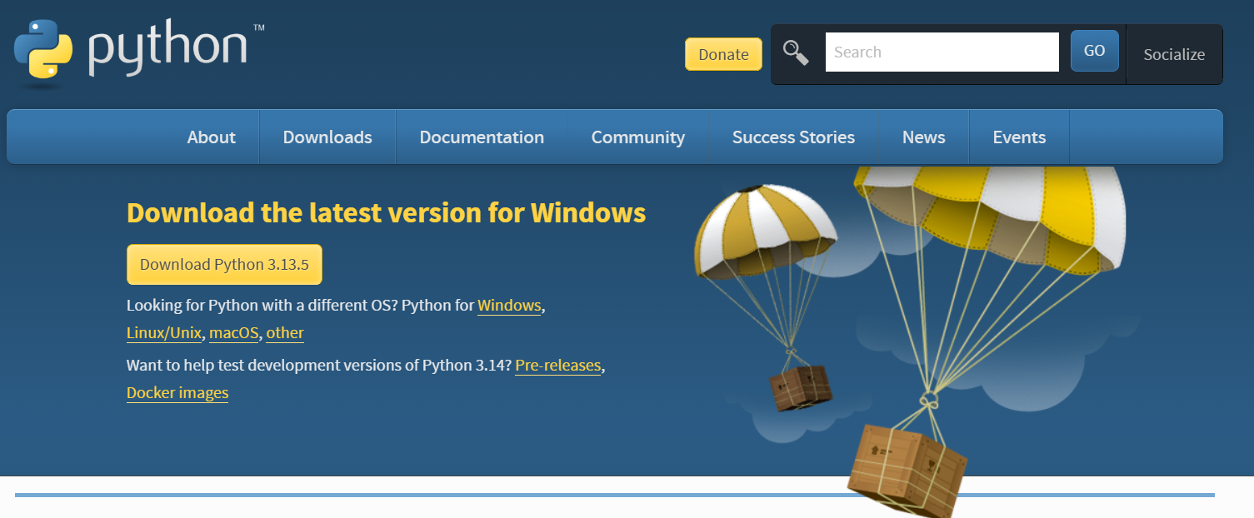To install Python on Windows, start by visiting the official website at [python.org/downloads](https://python.org/downloads).

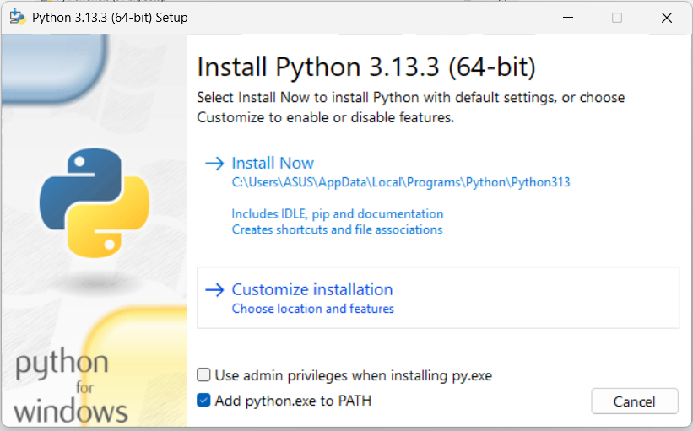 Download the installer for the latest version of Python 3.12 or newer. One critical step during installation is to **check the box that says “Add Python to PATH.”**

This enables you to run Python from the command line without needing to specify the full file path each time.

**Installing Python on macOS**

For macOS users, the process is just as simple. Download the .pkg installer file from the same website. Run the installer and follow the instructions. After installation, Python will be available at the path /usr/local/bin/python3, which allows you to use the command python3 in the Terminal to run Python programs.

**Installing Python on Linux**

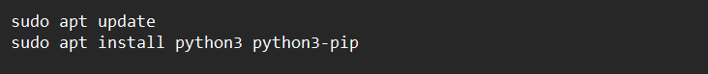Most Linux distributions come with Python pre-installed. However, to ensure you have the latest version, you can update your system and install Python manually. For Debian-based distributions like Ubuntu, open a terminal and type:

This command installs both Python and its package manager, pip, which you will use to install additional Python libraries later.

**1.1.3 Verifying the Install**

Once installation is complete, it’s important to verify that Python is working correctly. Open a **terminal** or **command prompt** depending on your OS, and type the following commands:



If these commands return version numbers (e.g., Python 3.12.1 and pip 23.2.1),

**For example:**

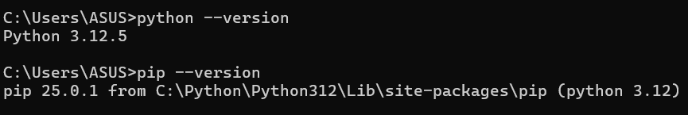

congratulations! Python and pip are now successfully installed and ready to use. You're now ready to begin writing Python code, installing packages, and exploring all the powerful tools the language offers.

💡💡💡 **You Should know:**

**What is pip?** pip is Python’s package manager. It lets you download and install third-party libraries (called "packages") from the **Python Package Index** (PyPI). For example, to install the popular game library pygame, you would run:



After installing, you can import pygame in your code. Pip makes it easy to add powerful tools without copying source files by hand.

**💡💡💡------------------------------------------------------------------------------------------💡💡💡**

**1.2 Choosing and Configuring a Code Editor**

When writing code, especially in Python, using a dedicated code editor can significantly improve both your efficiency and experience. A code editor is more than just a place to type—it's a tool designed to assist and guide you through coding, debugging, and managing your projects. One of the most popular and powerful editors for Python is **Visual Studio Code (VS Code)**.

**1.2.1 Why Use a Code Editor?**

A modern code editor offers several helpful features that go far beyond what a basic text editor can provide:

* **Syntax Highlighting:**  
  Code editors color different parts of your code—like keywords, strings, and comments—so it’s easier to read and understand at a glance. This reduces errors and improves readability.
* **Auto-completion:**  
  As you type, the editor suggests possible completions based on your context. This not only saves time but also helps you avoid typos and learn correct syntax as you go.
* **Integrated Terminal and Debugger:**  
  Many editors let you run and debug your code directly inside the program, without having to switch between multiple windows. You can test, troubleshoot, and fix errors all in one place.

These features make coding smoother, especially for beginners who are still learning the language and structure.

**1.2.2 Visual Studio Code (VS Code)**

One of the best editors for Python is **Visual Studio Code (VS Code)**. It's free, lightweight, customizable, and works on all major operating systems.

**Steps to Set Up VS Code for Python:**

1. **Download and Install:**  
   Visit [code.visualstudio.com](https://code.visualstudio.com) to download and install VS Code.

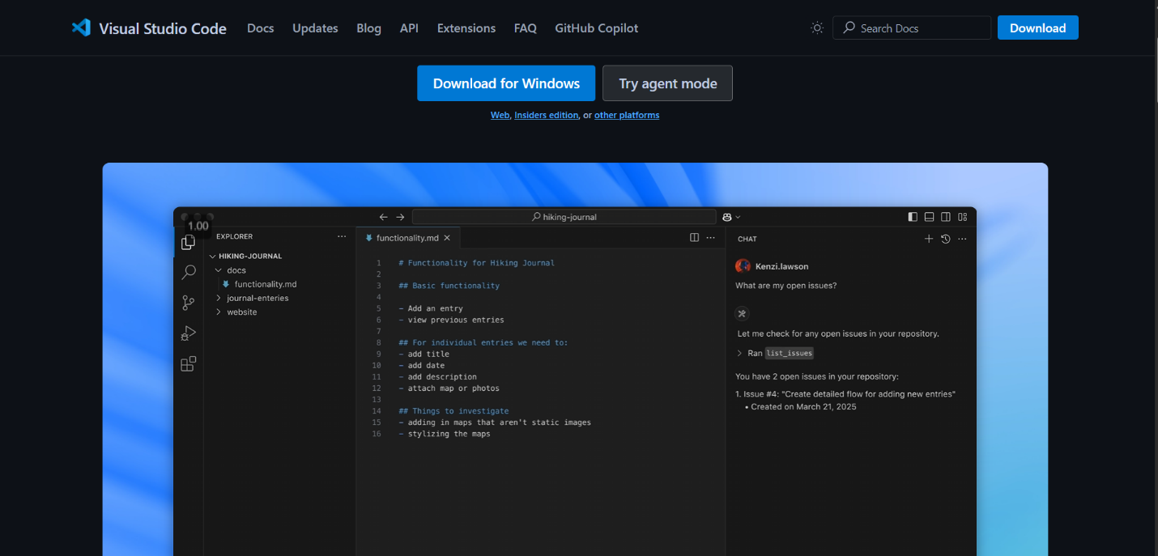

1. 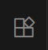**Install Python Extension:**  
   Open VS Code and go to the Extensions panel on the left sidebar (icon that looks like building blocks).

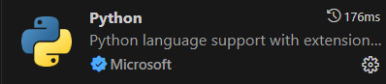  
Search for **“Python”**

and install the extension from **Microsoft (ms-python.python)**.  
This enables Python-specific features like code suggestions, linting, and debugging.

1. **Select the Python Interpreter:**  
   Press Ctrl+Shift+P (or Cmd+Shift+P on macOS) to open the Command Palette.  
   Type **“Python: Select Interpreter”** 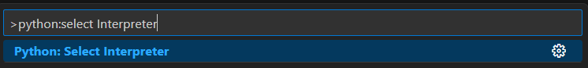
2. and choose the version of Python you installed earlier (usually Python 3.x.x).
3. **Verify in the Integrated Terminal:**  
   Open the built-in terminal by pressing Ctrl+Shift+` (the backtick key).  
   Type **python --version** to confirm that VS Code is using the correct Python version.

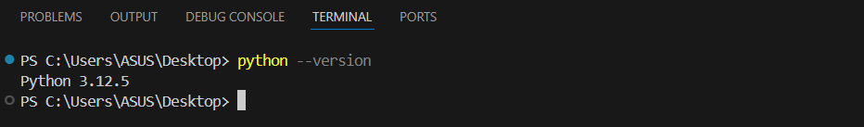

Once these steps are complete, you’re ready to write, run, and debug Python code efficiently—all within one powerful editor.

**Conclusion:**  
Choosing the right code editor—especially one like VS Code—can make learning and working with Python much more enjoyable and productive. With features like syntax highlighting, auto-completion, and an integrated terminal, a code editor helps beginners focus on learning the language, rather than fighting the tools.

**1.2 Understanding the Python File Structure**

Every Python project—whether it’s a simple script or a full-blown application—benefits from a clear, consistent directory layout. Even a small game might look like this:

Imagine you’re building a simple game called “guessing_game.” Your project folder will look like this:

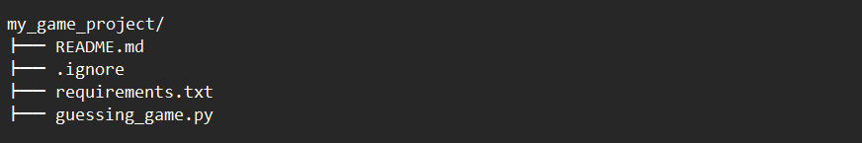

**Here’s what each part does:**

* **my_game_project/**  
  This is the **root folder** for everything related to your game.
* **README.md**  
  A plain-text document written in *Markdown*. You’ll use it to explain what your game does, how to run it, and any other notes. Anyone opening your project sees this first.
* **.gitignore**  
  If you ever use Git for version control, this file tells Git which files or folders to ignore. For example, Python automatically creates a __pycache__/ folder for compiled code—those files don’t need to be committed.
* **requirements.txt**  
  A simple list of any **external Python packages** your project needs. Right now it can be empty, but later you might add lines like requests or pygame here.
* **guessing_game.py**  
  The main **Python script** where you’ll write your number-guessing game code.

💡💡💡 **You Should know:**  **Comments and Conventions**

Good habits in commenting and naming aren’t just “fluff” you learn later—they’re the very foundation of code that’s easy to read, debug, and extend.

Let’s unpack both parts in detail so even your very first Python file feels professional.

Think of comments as the *road signs* in your code. When someone—or **you** in six months—opens a file, comments explain **why** something happens, not just **what** happens.

* **Single-line comments**

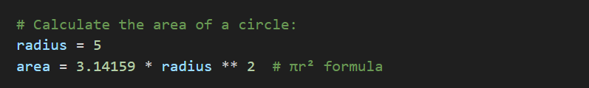use the **#** symbol.Anything after **#** on that line is ignored by Python.

Explain **“why”**: Why use 3.14159 instead of math.pi?

* 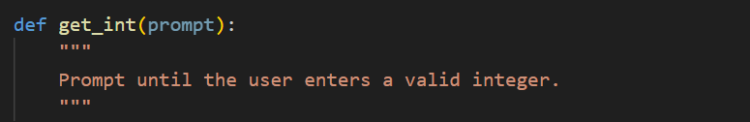**Docstrings (""" """)**  
  Describe a module, function, or class right under its definition:

**Naming (PEP 8 style):**

PEP 8 is Python’s official style guide. Conforming to it makes your code look like “real” Python, and helps any other Python developer jump in without confusion.

* 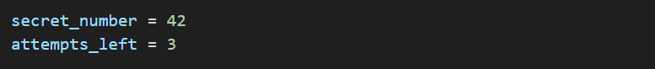**Files and variables** → use **lowercase_with_underscores**
* 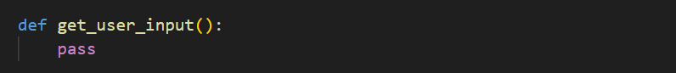**Functions** → also **lowercase_with_underscores**
* **Classes →** use CamelCase (each word starts with a capital letter, no underscores)

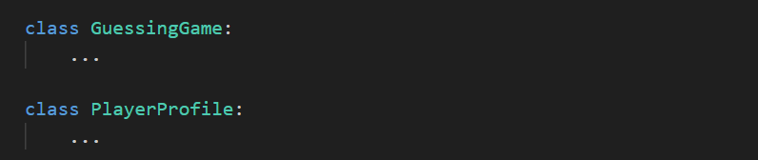

* **Constants** → use **ALL_CAPS_WITH_UNDERSCORES**

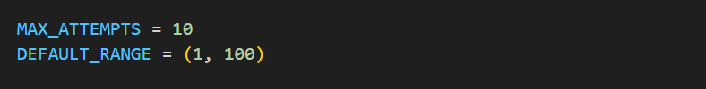

By following these conventions from day one, your code will look professional and be easier to understand.

**💡💡💡------------------------------------------------------------------------------------------💡💡💡**

**1.3 Navigating Your Files & Creating a Project Folder**

Before you can create those files, you need to know how to move around your computer’s directories.

**1.3.1 Understanding the Terminal**

**Windows (Command Prompt)**

1. **Start Menu**

* Click the Windows icon (or press the Windows key).
* Type cmd.

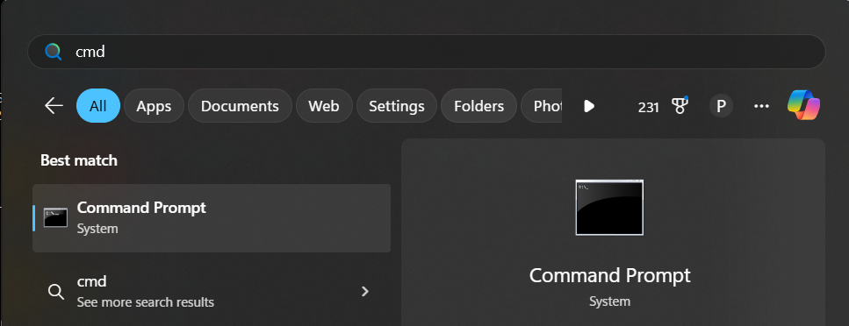

* 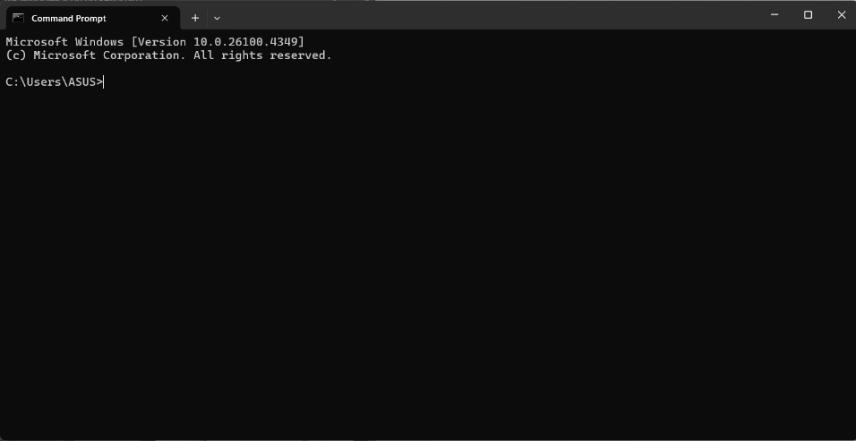Press Enter, or click Command Prompt in the search results.

**Or Run Dialog**

* Press Win + R to open the Run box.
* 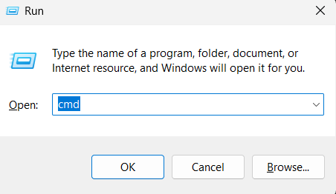Type cmd and press Enter.
* Select OK , you will see cmd interface

**macOS (Terminal)**

1. **Spotlight Search**
   * Press Cmd + Spacebar, type Terminal, and press Enter.
2. **Finder**
   * Open Finder → Applications → Utilities → Terminal.

**Linux (Terminal)**

* Keyboard Shortcut (most distributions): Press Ctrl + Alt + T.
* Applications Menu: Open your desktop’s Applications or Activities menu, search for Terminal, and click it.

Once your terminal window appears, you’ll see a prompt (e.g., C:\Users\You> on Windows or you@machine:~$ on macOS/Linux). From here, you can type:

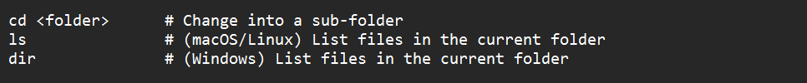

and press Enter to execute each command.

**1.3.2 Create Your First Project Folder**

1. **Choose a location**  
   Navigate in your file explorer to a place like **Documents** or **Desktop** or **else**

**For example I will create at** C:\Users\ASUS\Desktop\Python_bookV2

1. **Create the folder**  
   Make a new folder called:



So : my file path should be C:\Users\ASUS\Desktop\Python_bookV2\**chapter_1**

**Open it in VS Code**

* Launch **Visual Studio Code**.
* Select **File → Open Folder…** and choose your new chapter_1 folder.

💡💡💡 **You Should know:**

* You can easily open your folder by this
  1. Go to your folder higlight it like this
  2. 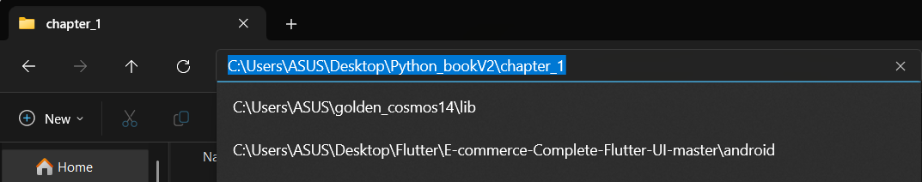type **cmd** at Address Bar and press Enter

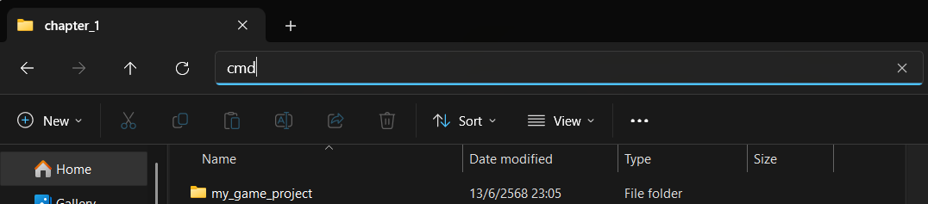

* 1. Cmd will show interface at your folder path

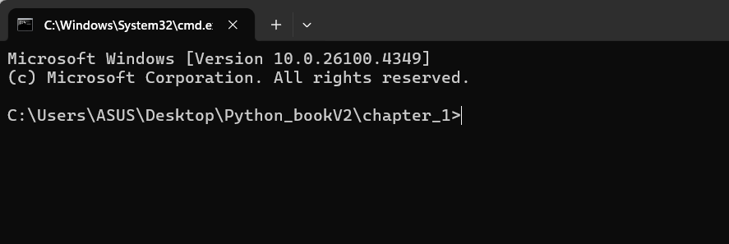

* 1. Type **code .** to open **VS Code**

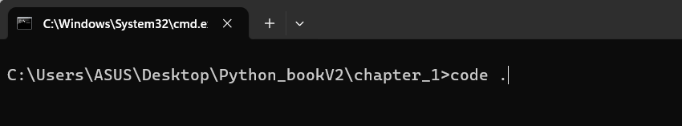

* 1. After press Enter , VS Code open

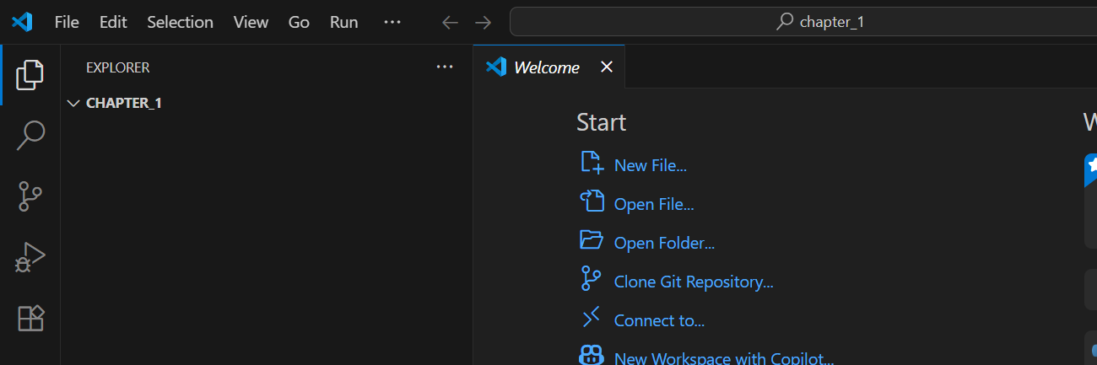

**💡💡💡------------------------------------------------------------------------------------------💡💡💡**

**Add your initial files**  
In the Explorer panel on the left:

* Click the **New Folder** icon : type **guessing_game**

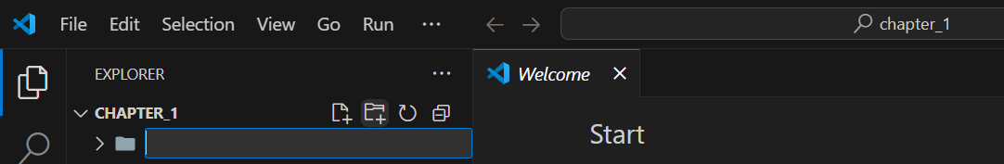

* Inside **guessing_game** Click the **New File** icon

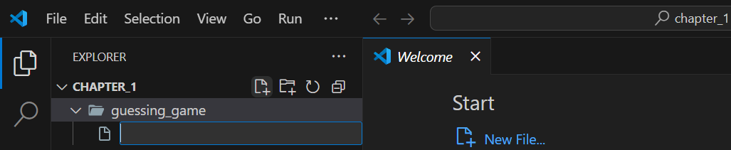

* Create three files:

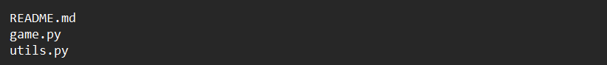

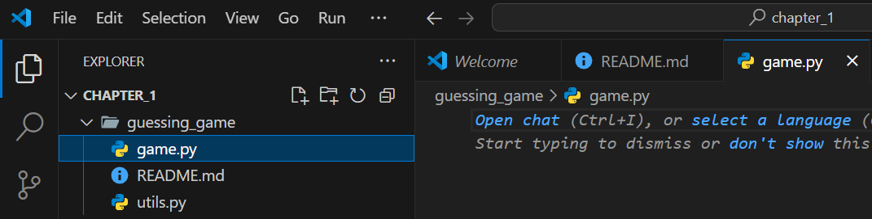

*Later* we’ll write code in **game.py** and move helper functions into **utils.py.**

**1.4 Python Fundamentals: print, Variables & Data Types**

Now that you have your project set up, let’s dive into the very basics of Python by editing game.py. Even if you have never seen code before, you’ll be able to follow along.

**1.4.1 Printing to the Console**

The simplest thing you can do in Python is **output** text to the screen with the built-in



Open game.py and type:

**Example_1.1.py :**



When you **run** this file (in VS Code’s integrated terminal: **Ctrl+ Shift +`** then python game.py`), you’ll see:



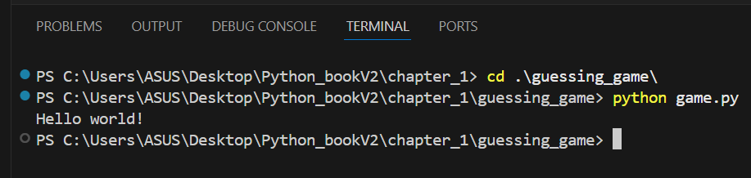

You can also print **multiple** values at once:

**Example_1.2.py :**

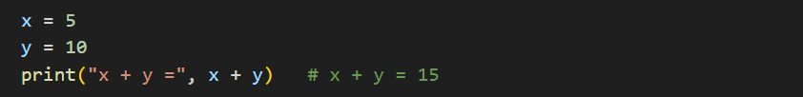

Here, Python prints the text "x + y =" followed by the result of x + y, which is 15.

**1.4.2 Variables & Data Types**

A variable is simply a name that stores a piece of data. You can later use that name to refer to the data.

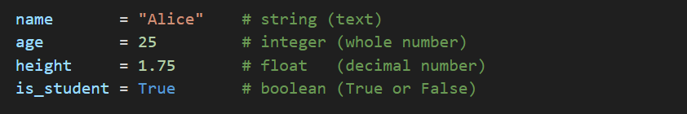

* **Strings** hold text, wrapped in quotes ("..." or '...').
* **Integers** are whole numbers.
* **Floats** are numbers with a decimal point.
* **Booleans** are either True or False.

To see what type Python thinks a variable is, use the built-in



**When you run this,**



**you might see:**

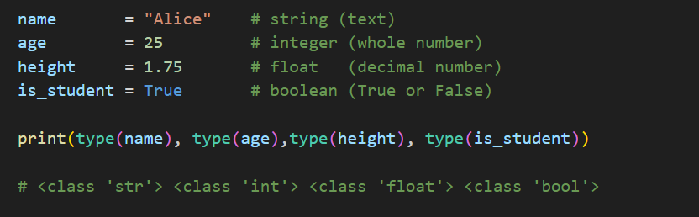**example_1.4.py**

**1.4.3 User Input**

Most programs need **input** from the user. Python’s



function pauses your program and waits for the user to type something:

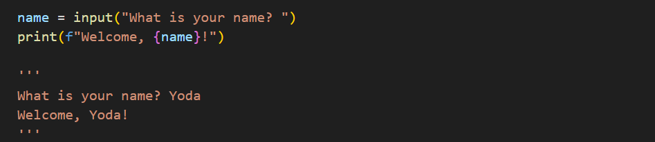Whatever the user types is always returned as a **string** (text).

* The **f"…{name}…"** syntax is called an **f-string**, letting you insert variables directly into text.

💡💡💡 **You Should know:**  **Syntax & Readability**

* **f-Strings**Precede the string with f and insert expressions directly inside **{}**:

**example_1.6.py :**

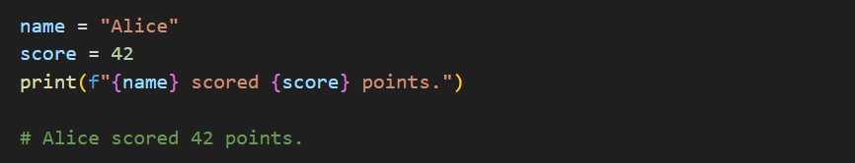

* **str.format()**Use **{}** placeholders and call .format() with the values in order or by name:

**example_1.6.py**

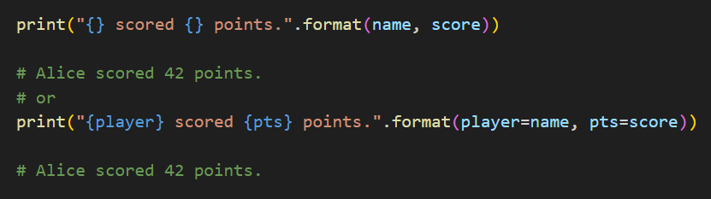

**💡💡💡------------------------------------------------------------------------------------------💡💡💡**

If you need a **number** instead of text, convert the input from string to integer or float:

**example_1.7.py :**

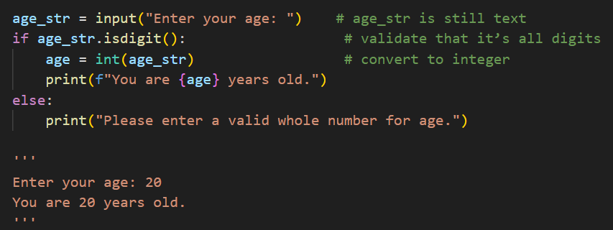

* **age_str.isdigit()** checks that every character is a digit (0–9) before conversion.
* Converting without validation can crash your program if the user types letters instead of numbers.

**1.5 Control Flow: Loops & Conditionals**

In any interactive program or game, your code must make **decisions** and **repeat** actions over time. Python provides two fundamental tools for this:

1. **Conditionals** **(if, elif, else)** let your program choose *which* code to run.
2. **Loops (while, for)** let your program *repeat* code until a condition changes.

Together, they form the “control flow” of your program: the path your code takes as it runs.

**1.5.1 Decision-Making with if / elif / else**

Whenever you need to branch—“*if* something is true, do this; otherwise do that”—you use an if statement:

**example_1.9.py**

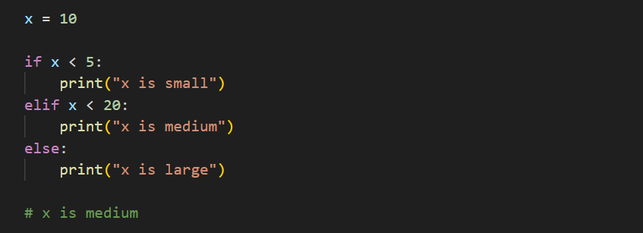

1. **if x < 5:**
   * Python **evaluates** the expression x < 5.
   * If it’s **True**, it runs the indented block below, then skips the rest.
2. **elif x < 20:**
   * Short for “*else if*.”
   * Only checked if the first if was False.
   * If x < 20 is True, that block runs.
3. **else:**
   * Runs only if **all** preceding conditions were False.
   * No condition to write—this is the **“catch-all”** case.

💡💡💡 **You Should know:** Python uses **indentation** (typically 4 spaces) to group code. Always keep your if blocks consistently indented.

**1.5.2 Repeating with while Loops**

A **while** loop executes its block **over and over** as long as a condition remains True:

**example_2.0.py :**

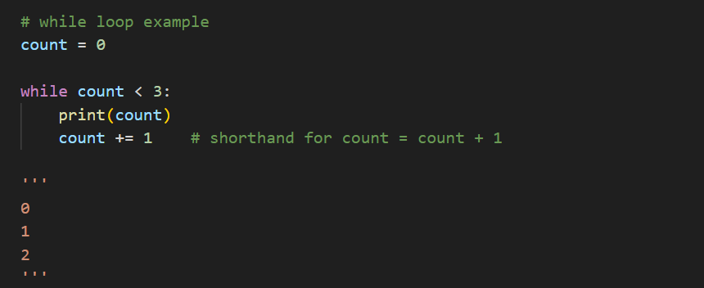

* **First iteration:** count is 0, so 0 < 3 is True. It prints 0, then count becomes 1.
* **Second:** 1 < 3 → prints 1, count → 2.
* **Third:** 2 < 3 → prints 2, count → 3.
* **Fourth:** 3 < 3 is False, so the loop ends.

💡💡💡 **You Should know:** **Beware infinite loops!** If you forget to update (count += 1) or your condition never becomes False, the loop will run *forever*, crashing or freezing your program.

💡💡💡 **You Should know:** **Compound Assignment Operators in Python**

In Python, **compound assignment operators** provide a concise way to update a variable by combining an operation with assignment.

|  |  |  |  |  |
| --- | --- | --- | --- | --- |
| **Expression** | **Equivalent** | **Description** | **Example (start: x = 5)** | **Result** |
| x += 5 | x = x + 5 | Add 5 to x | x += 5 | 10 |
| x -= 3 | x = x – 3 | Subtract 3 from x | x -= 3 | 2 |
| x *= 2 | x = x * 2 | Multiply x by 2 | x *= 2 | 10 |
| x /= 4 | x = x / 4 | Divide x by 4 (true division) | x /= 4 | 1.25 |
| x //= 3 | x = x // 3 | Divide x by 3 and floor the result | x //= 3 | 1 |
| x %= 7 | x = x % 7 | Remainder of x ÷ 7 | x %= 7 | 5 |
| x **= 2 | x = x ** 2 | Raise x to the power of 2 | x **= 2 | 25 |

**💡💡💡------------------------------------------------------------------------------------------💡💡💡**

**1.5.3 Preview of for Loops**

Python’s **for** loop is ideal when you know ***how many times*** you need to repeat:

**example_1.11.py**

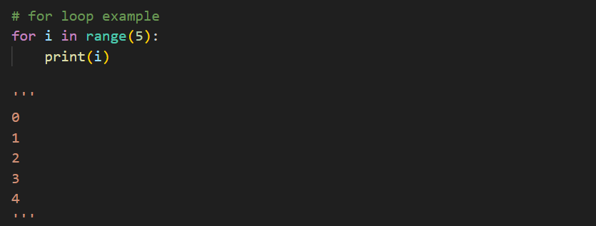

* **range(5)** generates the sequence 0, 1, 2, 3, 4.
* On each iteration, i takes the next value from that sequence.

In real games you might write:

**example_1.12.py**

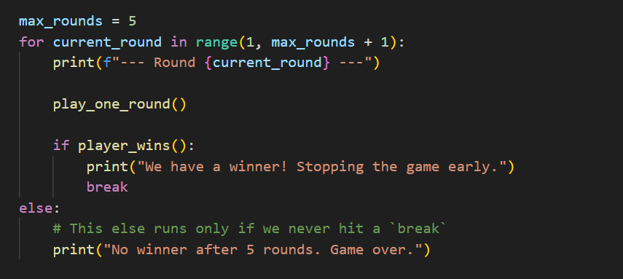

**Explain Code :**

**Setting the limit (max_rounds = 5)**  
We decide in advance to play at most five rounds.



**for current_round in range(1, max_rounds + 1):**

* range(1, 6) generates the sequence 1, 2, 3, 4, 5.
* Each loop iteration assigns the next number to current_round, so we can label each round clearly.



Displaying the round header : This helps you see in the console exactly which round you’re on.



Playing a round : This placeholder represents whatever game logic happens during a single round.

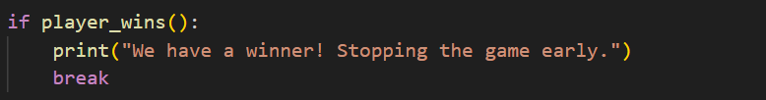

Checking for a winner

After each round, we call player_wins().

If it returns True, we announce the winner and use **break** to immediately exit the loop—no further rounds are played.

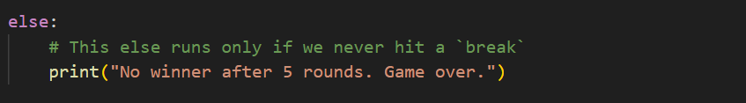

This **else** is attached to the **for** loop, not to the **if**.

It executes **only if** the for loop completes **without ever** hitting a break.

In our case, it prints a “game over” message when all five rounds finish with no winner.

**Introduction: Number_Guessing Game**

Every programmer’s journey often starts with the classic “Hello, world!”—a single line of code that proves your environment works. But real magic happens when you combine those simple pieces—**input, output, decision-making, and loops**—to create something interactive and engaging. In this chapter, we explore that magic through a small yet complete project: a **Number-Guessing Game**. You’ll see how to pick a random secret, prompt the player for guesses, guide them with feedback, and celebrate their success. Along the way, we’ll also learn how to tidy our code—making it easier to read, maintain, and extend—so that as your Python skills grow, your projects stay just as clear and enjoyable to work on.

**1. How the Number-Guessing Game Works**

Here’s the core of our game, saved as **full_game.py**:

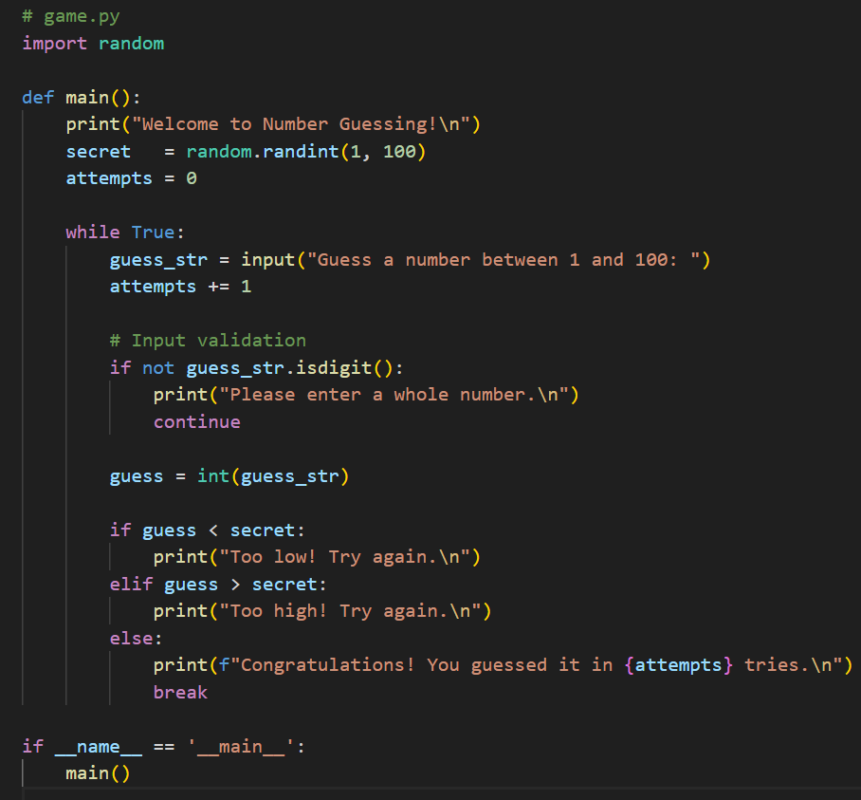

Let’s unpack it step by step:

1. **Importing Randomness**

We need the **random** module to pick an unpredictable secret number each time you play.



**Defining the main() Function**  
Wrapping our logic in a function keeps the global namespace clean and makes it easy to reuse or test later.

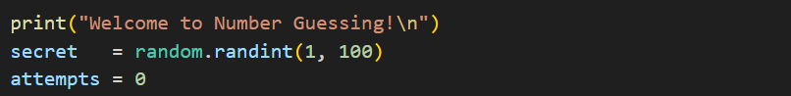

**Greeting and Secret Selection**

We welcome the player, choose a random integer between 1 and 100, and set up an attempt counter.

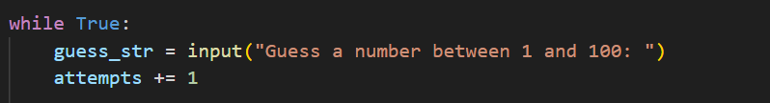

**The Infinite Game Loop**

A while True loop repeats until we explicitly break out—perfect for ongoing gameplay.

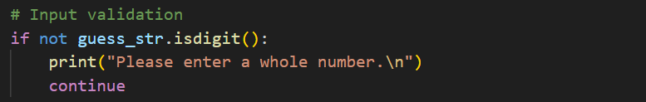

**Validation Before Conversion**

We check that the player’s input is all digits. If not, we show an error and **continue**—restarting the loop without crashing.

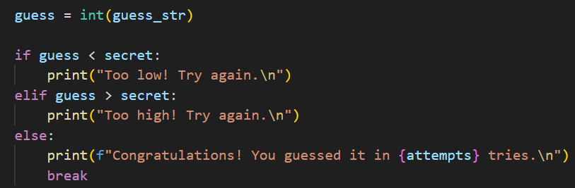

**Converting and Comparing**

Once we have a safe integer, we compare it to the secret, give tailored feedback, and **break** on success.

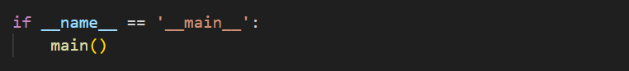

**Entry-Point Guard**

Ensures main() runs when you execute the script, but not if you import it elsewhere.

💡💡💡 **You Should know:** whats is if **__name__ == '__main__':**

Imagine you’ve written a simple Python game called **game.py**, and you want two things from it: to let players launch it directly as a game, and to let other programmers borrow its pieces without accidentally starting the game. In Python, there’s a neat trick—the “main guard”—that lets you have both behaviors in one file, and it’s simpler than it sounds.

When you run a Python file by typing: **python game.py**

Python treats that file as the “main” program. It dutifully executes every line in order, from top to bottom. But what if someone else wants to import your file to use some helpful functions—say, a Player class or a load_level() function—without actually starting the game? Without a safeguard, their script would run everything in your file, including the game startup, whether they wanted it or not. That’s like borrowing a kitchen knife and accidentally having the stove ignite.

**How Python knows the difference**

Inside every Python module (that is, every .py file), there’s a special built-in variable called __name__. Python sets __name__ depending on how you use the file:

* **Direct execution** (python game.py):  
  Python sets __name__ = "__main__".  
  It’s its way of saying, “I’m the star today—I’m running this file as the main program.”
* **Imported** (import game):  
  Python sets __name__ = "game" (the filename without .py).  
  Now your file is a toolbox module, ready to share classes and functions.

**Introducing the “main guard”**

At the bottom of **game.py**, you write these two lines:



**if __name__ == "__main__":**  
Python checks, “Am I the main program right now?” If yes, we proceed. If no—if we’re being imported—the code block is **skipped entirely**.

**main()**  
This is a function you’ve defined earlier in the file. It contains the startup steps of your game: loading levels, creating windows, starting music, entering the game loop, and so on.

Because of this guard, when someone types python game.py, they see your game in full swing. But if they write import game in their own script, nothing happens—no game window pops up—until they explicitly call game.main() or any other function you’ve provided.

**💡💡💡------------------------------------------------------------------------------------------💡💡💡**

**2. Refactor**

As delightful as this script is, mixing **input handling**, **validation**, and **game logic** in one place can make future enhancements tedious. Suppose you want to add:

* A **guess limit** (end after 10 tries).
* **Difficulty levels** with different ranges.
* A **high-score tracker** that saves to a file.

Each new feature risks tangling more code in the main loop. **Refactoring** helps by extracting responsibilities into focused, reusable pieces.

**Step 1: Spot the “Busy Block”**

In original **game.py**, the loop looks like this:

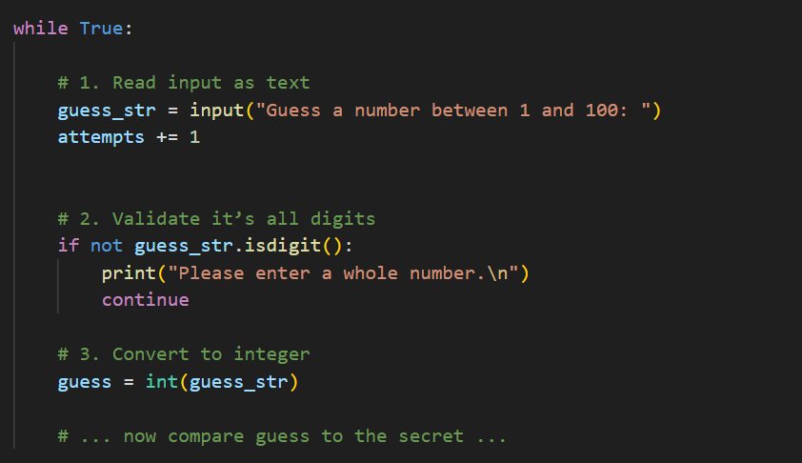

Here **1.** , **2.** and **3.** are all happening in one place. That makes the loop hard to scan—every time you read it, you have to juggle three concerns at once.

**Step 2: Extract into a Helper Function(as we created previously)**: utils.py

We’ll move concerns 1. – 3. into a new function, get_int(), in **utils.py. (as we created previously)**

The goal is:

* Show the prompt (1.)
* Loop until the user types only digits (2.)
* Return the integer conversion (3.)

**utils.py** becomes:

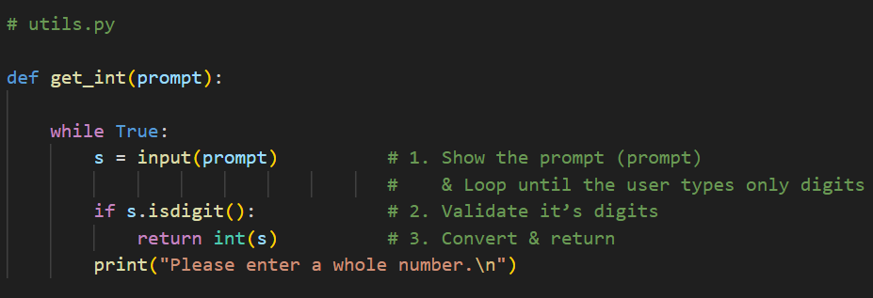

Now any script can call get_int() and get a valid integer back—no more inline duplication.

**Step 3: Replace the Block in game.py**

Back in your loop, we simply remove lines **1. – 3.**  and replace them with one clear action:

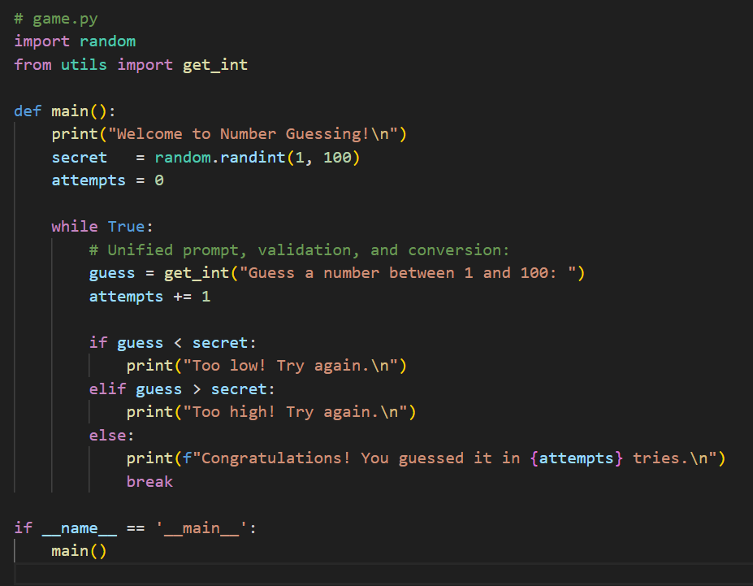

Just a quick heads-up: before you call get_int() in **game.py**, make sure you’ve added this line at the very top:



That little import tells Python exactly where to find your new helper function—without it, the code won’t know what **get_int()** means.

**Closing Thoughts for Chapter 1**

You’ve just taken your very first journey into Python—and not with a dry lecture, but by **building a real, playable game** from start to finish. Along the way you:

1. **Installed Python** and verified it works on your machine.
2. **Picked and configured** a powerful code editor (VS Code) to make writing and debugging a breeze.
3. **Learned to navigate** your files and folders with the Terminal or Command Prompt.
4. Mastered **basic syntax**—printing, variables, data types, and user input.
5. Controlled the flow of your program with **conditionals** (if/elif/else) and **loops** (while/for).
6. **Wrote, ran, and tweaked** a Number-Guessing Game, complete with input validation so it never crashes on bad data.
7. Finally, **refactored** your code by extracting input handling into a reusable helper, making your game loop clean and focused.

**Key takeaway:** Every feature you add shouldn’t clutter your main script. By breaking tasks into small, well-named functions and modules, you make your code easier to read, maintain, and extend—whether that next feature is a guess limit, difficulty modes, or a high-score tracker.

As you close this chapter, remember that the best way to learn is by **doing**. Keep experimenting:

* Tweak the game’s range (1–10, 1–1000, or let the player choose).
* Limit the number of attempts and handle “Game Over.”
* Track and save high scores in a text file.

With each new challenge, apply the same pattern: **plan**, **code**, **test**, and **refactor**. That four-step loop is your recipe for success in Python and beyond.

In **Chapter 2**, we’ll level up to **Tic-Tac-Toe**, exploring more logic, a second player’s turn, win detection, and perhaps even a simple AI. But for now—congratulations on getting Python set up and writing your first interactive game. You’re officially on your way!

**Chapter 2**

**: Chapter 2: Tic Tac Toe – Mastering Logic and Flow**

**Welcome to the next level!** In Chapter 1 you built a complete game loop, handled input, and learned to refactor. In this chapter, we’ll apply those same principles to a classic: **Tic-Tac-Toe**. You’ll organize your code into clear, single-purpose modules, work with 2D lists, and master decision structures to detect wins and ties—all while keeping your project easy to read, test, and extend.**2**

**Introducing Tic-Tac-Toe: The Game Mechanics Before the Code**

Before we dive into files and functions, let’s first experience the game in our minds—and understand the core logic that your code will later implement**.**

**1. The Playing Field: A 3×3 Grid**

Visualize nine empty squares arranged like this:

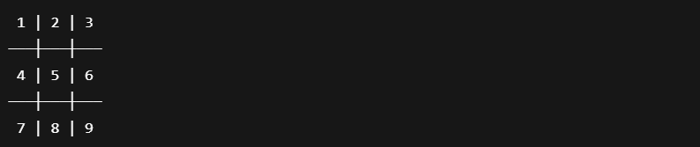

* Each square can hold one mark: either X or O.
* We’ll key them by two coordinates (row, column) or by a single number (1–9) mapped to that grid.

**2. Two Players in Alternation**

* Player X always goes first.
* Player O follows.
* They take turns placing their mark in any empty square.

**Example Turn Sequence:**

1. X marks square (1,1) → top-left.
2. O marks square (1,2) → top-middle.
3. X marks square (2,2) → center.  
   …and so on.

**3. Winning the Game**

**A player wins by placing three of their marks in a straight line:**

* **Horizontal: any of the three rows:**
  + (1,1), (1,2), (1,3)
  + (2,1), (2,2), (2,3)
  + (3,1), (3,2), (3,3)
* **Vertical: any of the three columns:**
  + (1,1), (2,1), (3,1)
  + (1,2), (2,2), (3,2)
  + (1,3), (2,3), (3,3)
* **Diagonal: the two diagonals:**
  + (1,1), (2,2), (3,3)
  + (1,3), (2,2), (3,1)

As soon as a line is completed, the game ends and that player is declared the winner.

**4. A Tie: No More Moves**

If all nine squares fill up without any three-in-a-row, the game ends in a tie (often called a “cat’s game”).

**5. Translating to Code: Core Logical Steps**

When your program runs, it will need to:

1. **Represent the board**
   * Internally as a 2D list (e.g., **board[row][col]**).
2. **Display the board**
   * Print the grid so players see **X’s**, **O’s**, and empty spots.
3. **Accept and validate input**
   * Ask the current player where they want to move.
   * Ensure the chosen square is within bounds and currently empty.
4. **Place the mark**
   * Update the board structure with **"X"** or **"O"**
5. **Check for a win or tie**
   * After each move, scan rows, columns, and diagonals for three identical marks.
   * Or detect a full board for a tie.
6. **Switch players**
   * Alternate between X and O until the game ends.
7. **Announce the result**
   * Print “Player X wins!”, “Player O wins!”, or “It’s a tie!” and exit.

Rather than writing a colossal block that does all these steps, we break each responsibility into its own module:

Create a folder named **my_tic_tac_toe/** and inside it make these files:

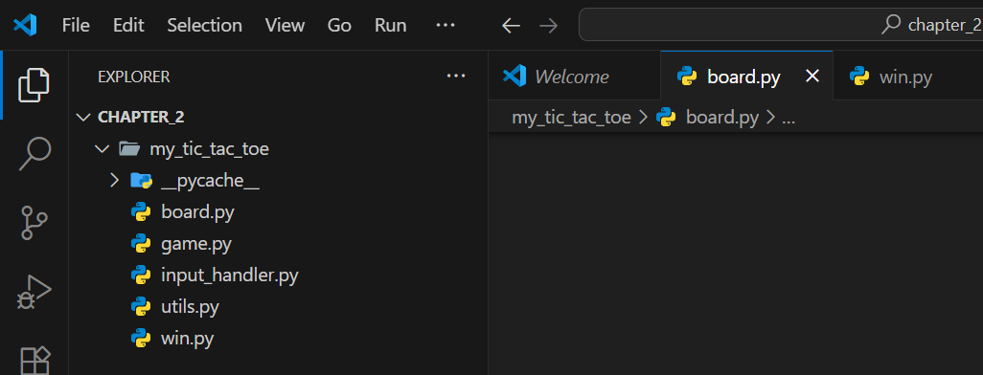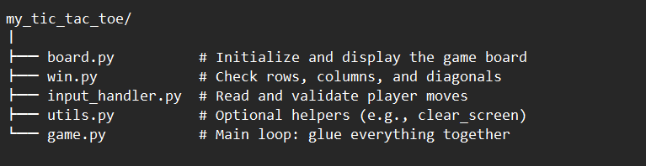

Each file has a single responsibility:

* **board.py**: Initialize and render the grid.
* **win.py**: Check rows, columns, and diagonals for a winner or tie.
* **input_handler.py**: Prompt the user, parse coordinates, and enforce valid moves.
* **game.py**: Glue everything together—run the game loop, switch turns, and announce results.
* **utils.py**: Common utilities (e.g., clear_screen()).

This separation makes each piece easy to understand, test in isolation, and upgrade (for example, to a 4×4 grid or a smarter AI opponent).

**Building board.py – Your Game Canvas**

Now that you know how Tic-Tac-Toe feels, let’s write the code to render that 3×3 grid. All board-related logic goes into board.py, so rendering and resizing stay in one place.

**board.py :**

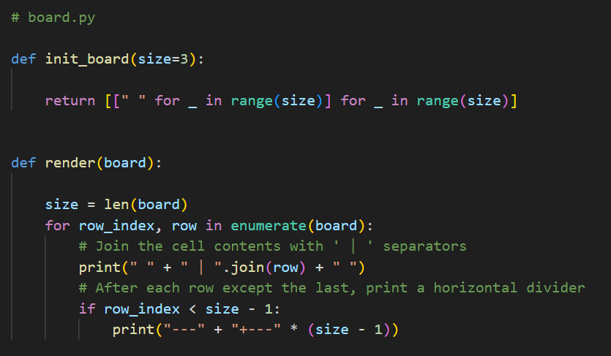

**Deep Dive:**

**board.py**

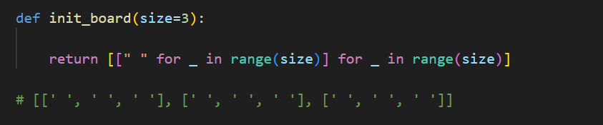

1. **init_board(size=3)**

Create and return an empty 'size × size' board. Represent the board as a list of rows,

each a list of cell strings.

* + Uses a **nested list** comprehension: for each of size rows, build a list of size " " (space) strings.
  + Result is a 2D list you can index as **board[row][col].**
  + Why default to 3? Standard Tic-Tac-Toe is 3×3, but you can pass size=4 later for a 4×4 variant.

💡💡💡 **You Should know: nested list comprehension**

A nested list comprehension is simply a list comprehension that contains another list comprehension (or loop) inside it. You can think of it like having multiple for-clauses in a single comprehension, or even building sub-lists with their own comprehension. It’s a concise way to replace nested for-loops.

You can write **nested list comprehensions** two main ways:

1. **Multiple for clauses in one comprehension**

**example_2.1.py**

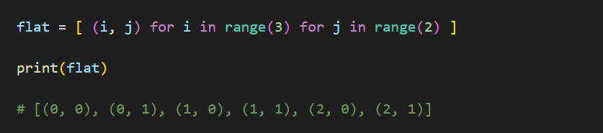

**Equivalent to: explicit nested loops**

**example_2.2.py**

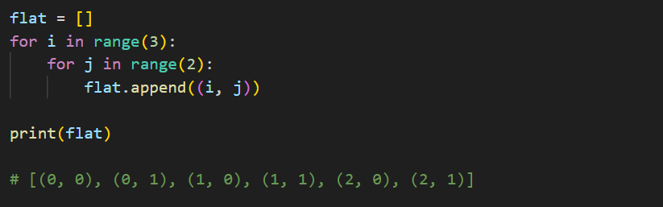

**2. Building sub-lists with an “inner” comprehension**

**Example_2.3.py**

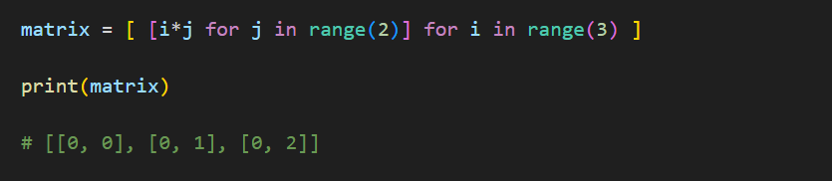

**Equivalent to: explicit nested loops**

**example_2.4.py**

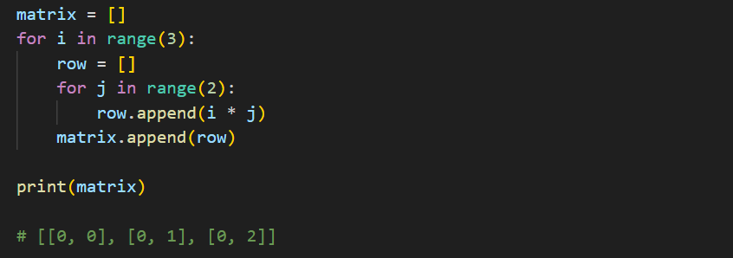

**💡💡💡------------------------------------------------------------------------------------------💡💡💡**

**board.py**

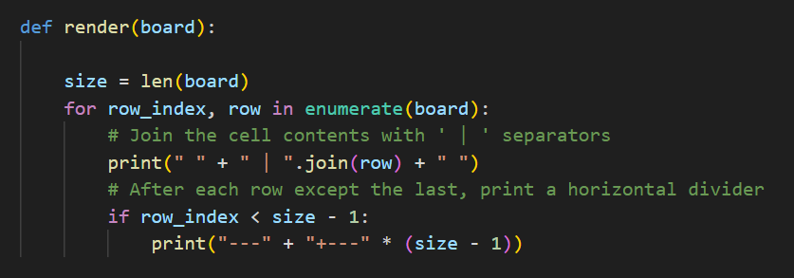

**2. render(board) :**

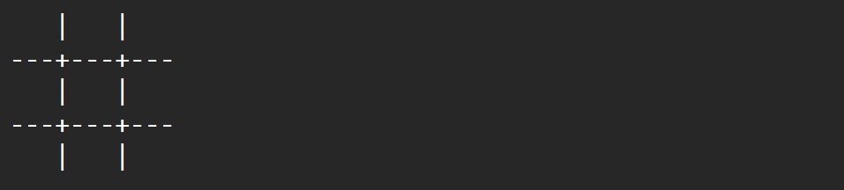    Print the current board in a human-friendly grid: like this

Let’s break render(board) into **four mini-steps**, showing you exactly what each line of code does and how the console output changes at each stage. Imagine our board is:

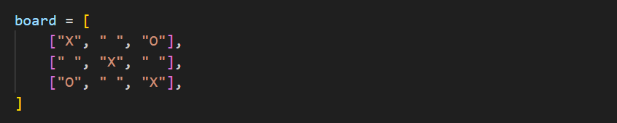

**Step 1: Print the Raw Row List**

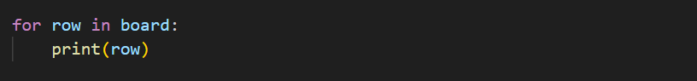

**Result :**

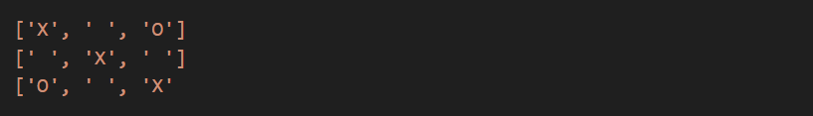

Still not very “board-like,” but we’ve accessed each row!

**Step 2: Join Cells with " | " Between Them**

**example_2.6 :**

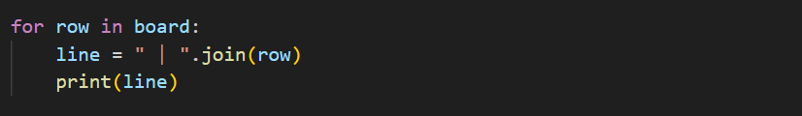

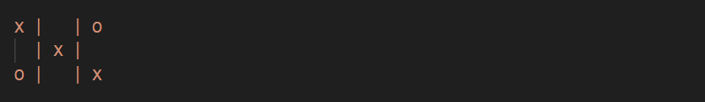**Result :**

Looks more like a row of a Tic-Tac-Toe board now.

💡💡💡 **You Should know: str.join()**

When you need to glue together many pieces of text into one continuous string, Python’s join() method is your friend. Here’s what every reader should understand—step by step and in depth—so you can use join() confidently in your own code.

**join()** lives on a **separator string** and takes an **iterable of strings** to combine. In plain English:

*“Take each piece from my list, and put this separator between them as you build one big string.”*

**Syntax:**



* **separator**: any string you like (space, comma, dash, even an empty string).
* **iterable_of_strings**: a list, tuple, or generator of strings.

**Real-World Examples**

1. Building a sentence from words

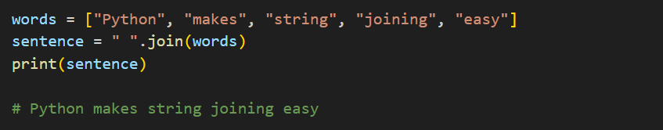**example_2.5 :**

2. Creating a CSV line

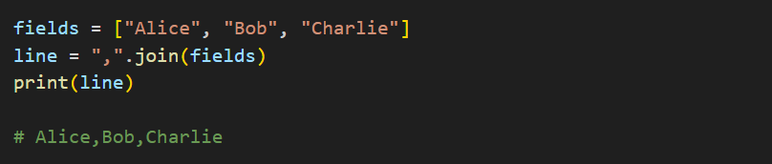**example_2.5**

3. Reassembling after a split

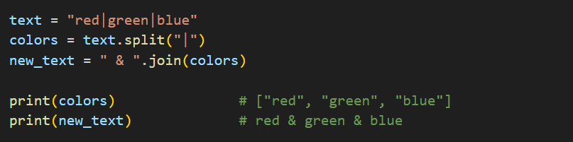**example_2.5**

**Common Pitfalls & Pro Tips**

* All elements must be strings

If you try to join numbers or other types, you’ll get a TypeError.  
**Tip**: Convert first:

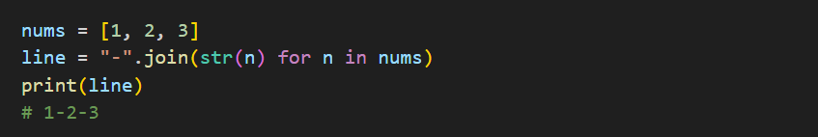**Example_2.5**

Choosing the right separator

* Space " " for words.
* Empty "" to mash characters together.
* Comma+space ", " for human-readable lists.

**💡💡💡------------------------------------------------------------------------------------------💡💡💡**

**Step 3: Add Padding Spaces Left and Right**

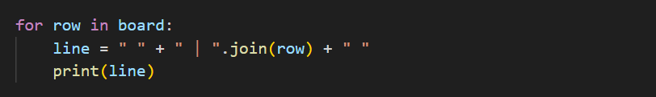**example_2.6 :**

* Adds one leading and one trailing space for visual breathing room.

**Result:**

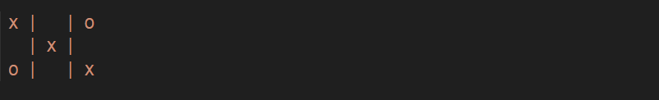

Each row now has padding so edges don’t hug the console margins.

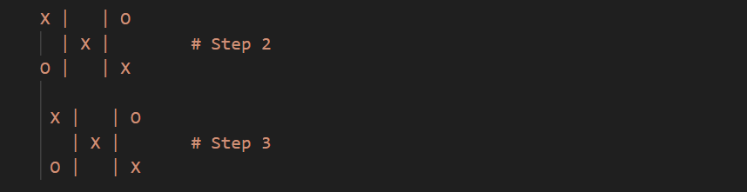**Compare step 2 & step 3 :**

**Step 4: Step 4: Draw Horizontal Dividers Between Rows**

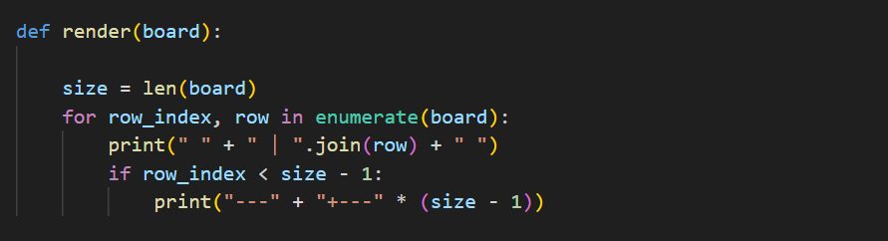

After printing a row, checks if it’s *not* the last one (row_index< 2).

If so, prints ---+---+---, creating a neat line across the grid.

**Result:**

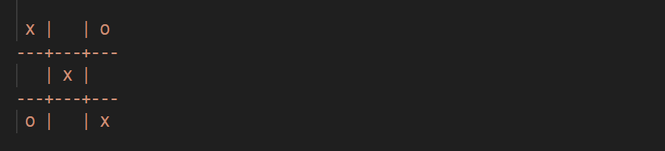

*That’s exactly the familiar Tic-Tac-Toe grid, complete with your X’s and O’s in the right spots!*

**Building win.py – Win & Tie Detection**

Before writing any code, let’s nail down **how** we decide the game is over:

1. **A Win** occurs when a player’s symbol ("X" or "O") fills three in a row:
   * **Horizontal**: all cells in any one row.
   * **Vertical**: all cells in any one column.
   * **Diagonal**: either the top-left to bottom-right or top-right to bottom-left.
2. **A Tie** happens when every cell is filled and **no** three-in-a-row exists.

**1. Imagining the Checks**

* **Row check**  
  For each row, ask: are **all three** cells equal to "X"? Or all three equal to "O"?
* **Column check**  
  For each column index i, ask: is board[0][i] == board[1][i] == board[2][i] == symbol?
* **Diagonal check**
  + Left-to-right: board[0][0], board[1][1], board[2][2]
  + Right-to-left: board[0][2], board[1][1], board[2][0]
* **Tie check**  
  Scan **every** cell: if **none** are " ", and **no** winner was found, it’s a tie.

**2. Writing check_winner()**

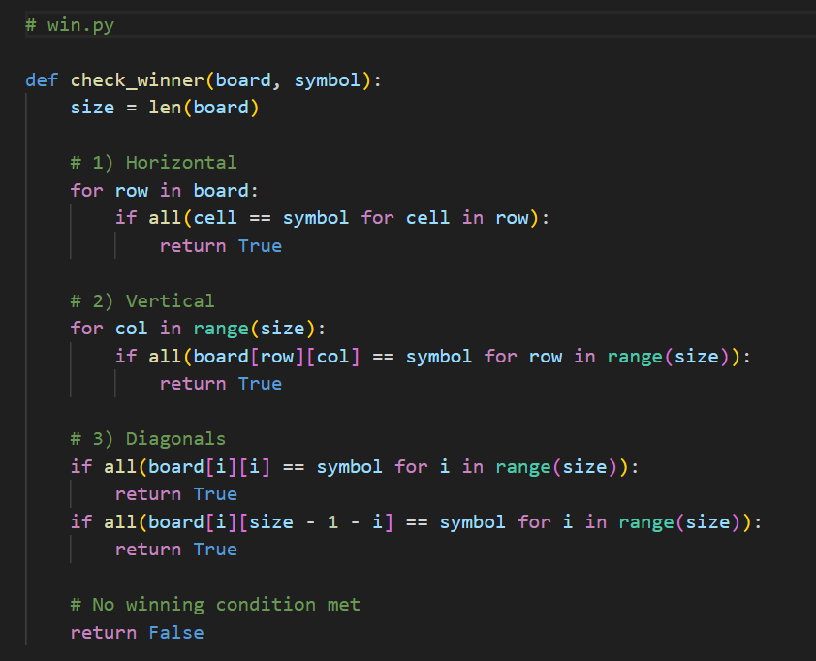

**Deep Dive:**

* **all(...)**  
  A built-in that returns True only if every element of the given sequence is True.

💡💡💡 **You Should Know: all(...)**

Python’s built-in all() function checks whether every item in an iterable is true (or truthy). It’s the quickest way to verify that a whole collection meets a condition.

**Syntax :**

* Returns True if **every element** in iterable is truthy.
* Returns False as soon as it finds the first falsy element.
* An empty iterable returns True (nothing contradicted the condition).

**2. Truthy vs. Falsy**

In Python, most values evaluate to **truthy** except for a few built-ins that are **falsy**:

* False
* 0 (zero of any numeric type)
* "" (empty string), [] (empty list), {} (empty dict), set(), None
* And any object defining __bool__() or __len__() to return zero or False.

**3. Common Patterns**

**Check all items**

**example_2.7 :**

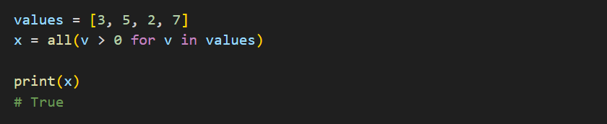

**Validate user input**

**example_2.8 :**

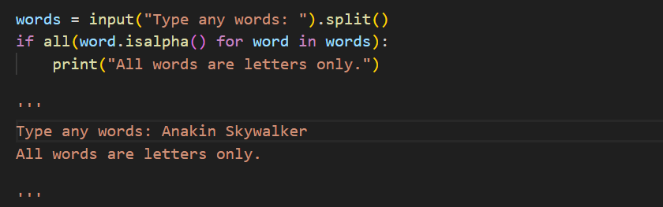

**ensure no missing data**

**example_2.9 :**

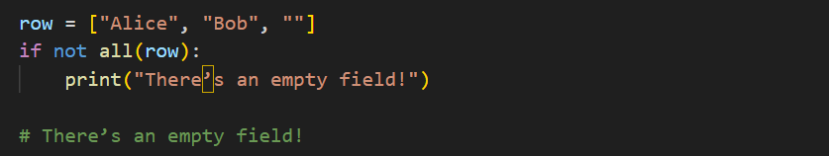

**Combine with any()**

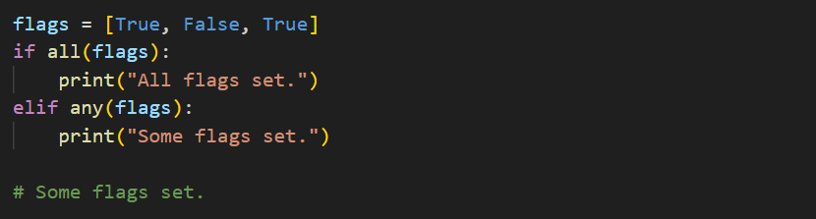

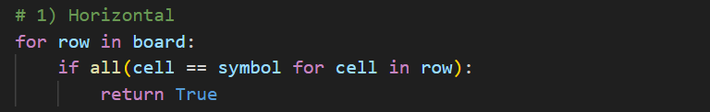**💡💡💡------------------------------------------------------------------------------------------💡💡💡**

* **Row loop**  
  for row in board: each row is a list like ["X","X","X"].
* 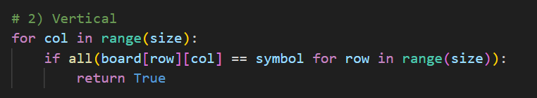**Column loop**  
  for col in range(size): iterate column indices 0,1,2.

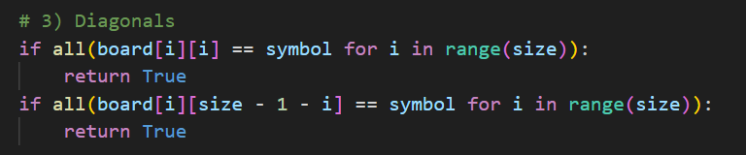

* **Diagonal checks**
  + **Primary diagonal**: positions (0,0), (1,1), (2,2).
  + **Secondary diagonal**: (0,2), (1,1), (2,0).

**Writing is_tie() :**

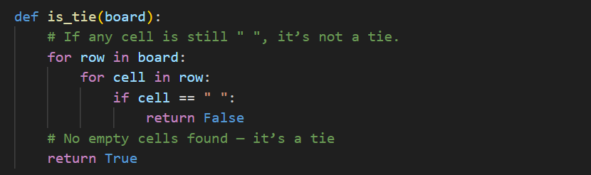**win.py:**

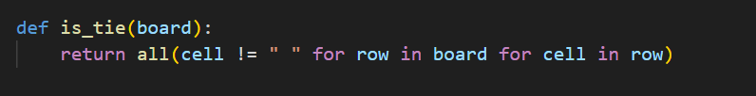Or more concisely:

* **Nested loops**: check every cell in every row.
* Only return True if **no** empty spaces remain.

**Building test_logic.py – Testing Your Win Logic**

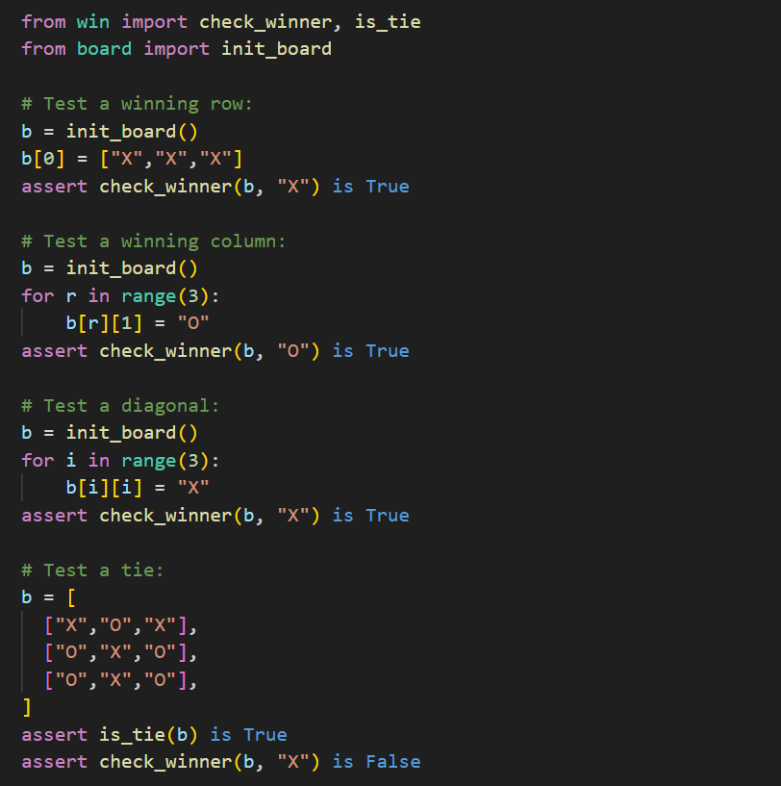

**Deep Dive:**

**1. Winning Row**

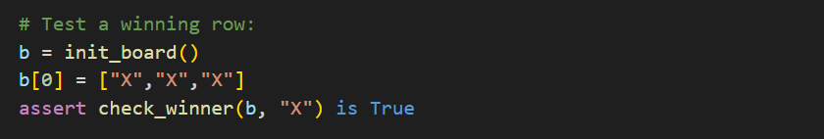

* **b = init_board() :** Start with an empty 3×3 board
* **b[0] = ["X", "X", "X"] :** Fill the top row with X’s
* **assert … is True :** tells Python: “If this isn’t True, stop right here with an error.”

**Visualizing the Board :**

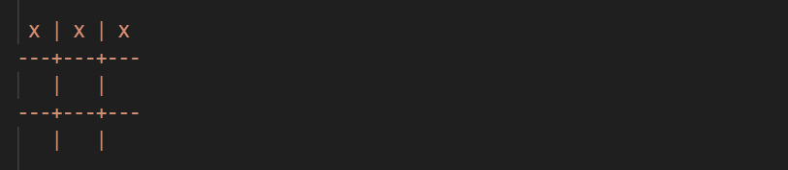

**How check_winner(b, "X") Works :**

* **Horizontal check loops over each row:**
* **Row 0 is ["X","X","X"].**
* **It evaluates all(cell == "X" for cell in row), which is True since every cell matches "X".**

**Reference from : win.py(Horizontal)**

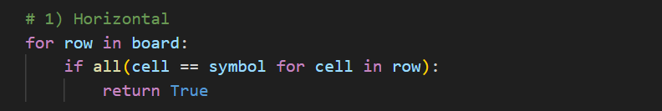

* Upon finding this, the function immediately returns **True.**

**💡💡💡 You Should Know: assert in Python**

The assert statement is a built-in way to verify that your code is working as expected. Think of it as a quick internal sanity check: if the condition you assert turns out to be false, Python will immediately stop and let you know something went wrong.

**1. The Basic Syntax :**



* **condition**: any expression that evaluates to True or False.
* **"Optional error message"**: a string you supply to explain the failure (this part is optional).

**4. Real-World Examples**

**4.1 Validating function inputs**

**Example_2.11**

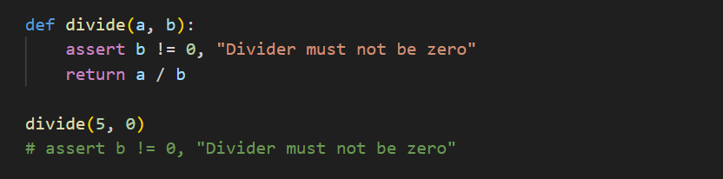

**4.2 Checking data structures**

**Example_2.12 :**

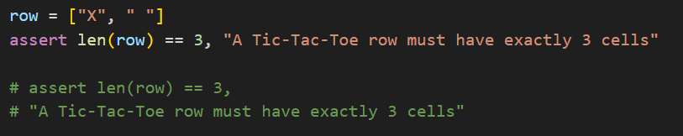

**4.3 Testing logic during development**

**Example_2.13 :**

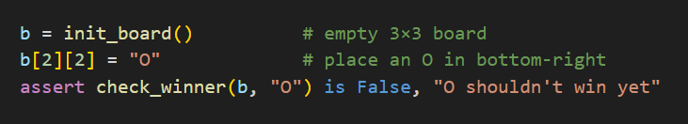

**💡💡💡------------------------------------------------------------------------------------------💡💡💡**

**2. Winning Column**

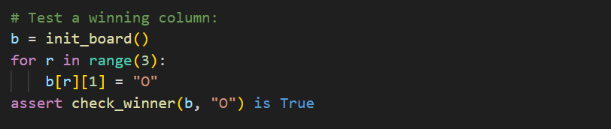

**Visualizing the Board :**

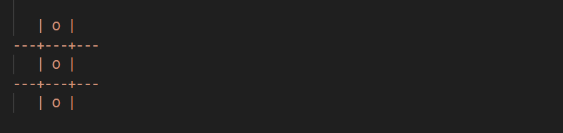

**2.2 How check_winner(b, "O") Works**

* Horizontal check sees no full row of O’s.
* Vertical check iterates col from 0 to 2:
  + At col = 1, it tests all(board[row][1] == "O" for row in range(3)).
  + That expression is True because **board[0][1]**, **board[1][1]**, and **board[2][1]** are all **"O"**.

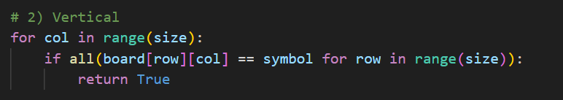 **Reference from : win.py(Horizontal)**

* The function returns True.

**3. Winning Diagonal**

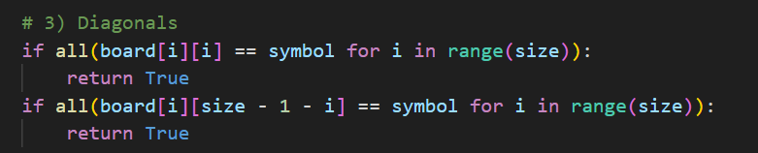

**Visualizing the Board :**

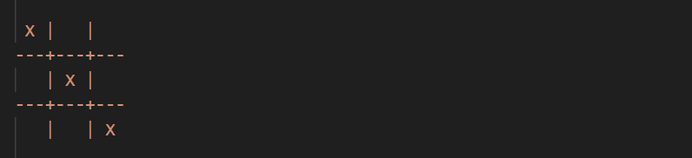

**3.2 How check_winner(b, "X") Works**

* Horizontal and vertical checks fail (no complete row or column).
* Primary diagonal check runs:
  + Tests all(board[i][i] == "X" for i in range(3)).
* Since (0,0), (1,1), and (2,2) all hold "X", it returns True.

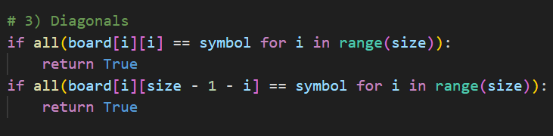 **Reference from : win.py(Dianonals)**

**4. Tie (No Winner)**

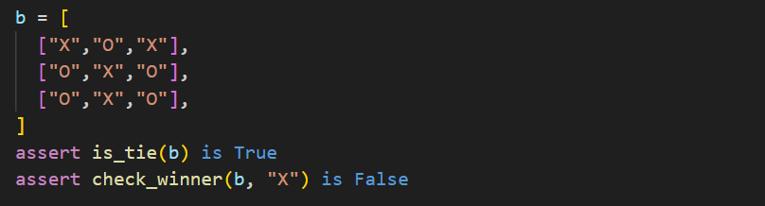

**Visualizing the Board :**

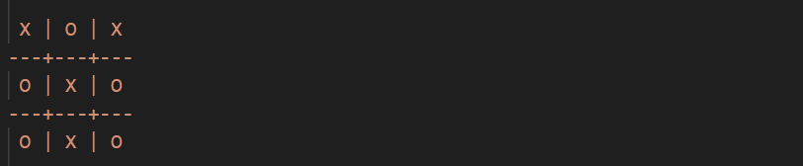

**How is_tie(b) Works**

The concise version all(cell != " " for row in b for cell in row) checks every cell:

**Reference from : win.py(is_ite(board))**

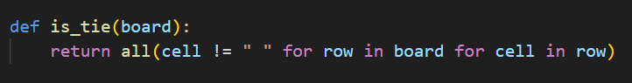

* Finds none equal to " ", so returns True.

**How check_winner(b, "X") Works**

* It tests all rows (none are ["X","X","X"]), all columns, and both diagonals:
  + No line of three "X" exists, so after all checks it returns False

**Building utils.py and input_handler.py – Handling Player Moves** **Handling Player Moves**

Before players can place their X or O, we need to guide them through choosing a valid square. This involves:

1. Prompting the current player for a row and column.
2. Converting their text input into numbers.
3. Checking that those numbers fall within the board’s bounds (1–3 for a 3×3).
4. Ensuring the chosen cell is still empty.
5. Repeating the process until a valid move is made.

Let’s walk through this logic step by step—imagine you’re the player encountering each scenario—and then see how it translates into code.

**Building utils.py: Your “Get Integer” Helper**

**Goal:** Never crash on bad text—keep asking until the user types a whole number.

**utils.py**

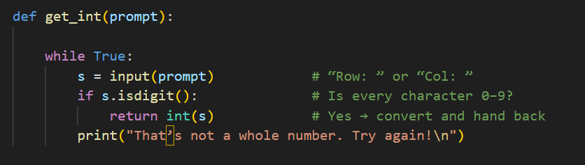

* + Display the prompt (text).
  + Wait for the user to type something.
  + If it’s all digits, convert to int and return.

       Otherwise, show an error and repeat.

**Imagine typing “two” at the prompt:**

* s.isdigit() is False, so you see “That’s not a whole number.”
* The function loops, re-displays your prompt, and waits again.

**1. The Player’s Perspective**

**1.1 First Prompt: Row Number**



* You see “Row:” and type 2, then press Enter.
* If you type “five” or a blank, we’ll catch that in step 3 and re-prompt.

**1.2 Second Prompt: Column Number**



* You now type 3 for the third column.
* Again, non-digit or out-of-range inputs will trigger an error message and start over.

**1.3 Checking the Chosen Cell**

* If row = 2, col = 3, we look at board[1][2] (because we subtract 1 for zero-based indexing).
* If that cell contains a space " ", it’s free—move accepted.
* If it already holds "X" or "O", we tell you “That cell is already taken” and start again at the Row prompt.

**The Validation Loop in Code**

Prompt the player until they choose a valid, empty cell.

Returns (row_index, col_index) as zero-based integers.

**Input_handler.py**

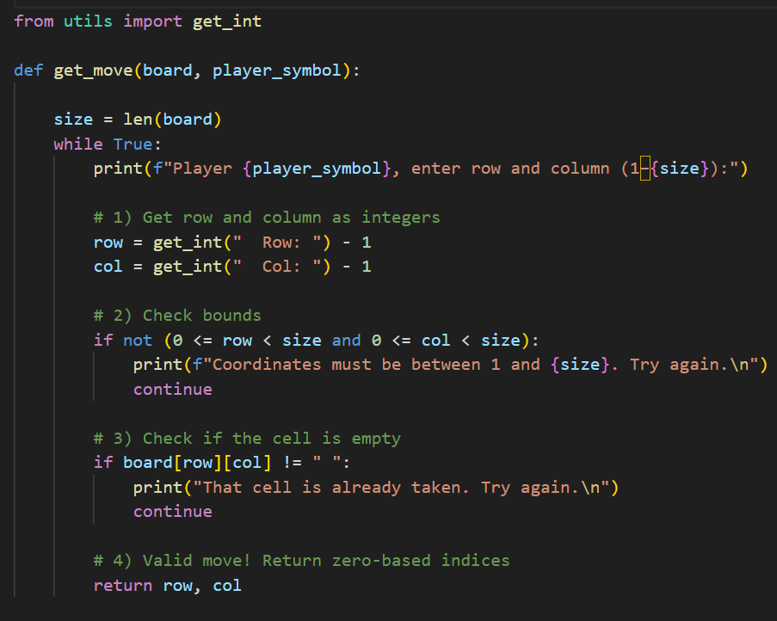

**Walking Through the Code :**

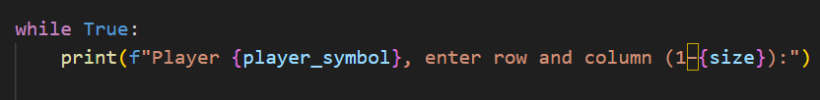

**3.1 while True: Loop**

* Why? We keep asking until the player provides a valid move, then return.

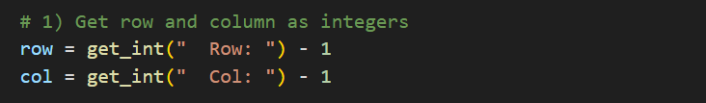

**3.2 Using get_int() for Clean Input**

Imagine you type “2”:

* get_int() ensures it’s a digit, converts it to 2.
* We subtract 1 to turn it into zero-based indexing (1 in Python’s lists).

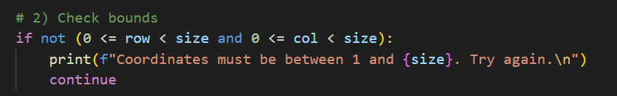

**3.3 Bounds Check**

* If you typed “4” or “0”, (0 <= row < 3) fails.
* We inform you of the allowed range and loop back to Row prompt.

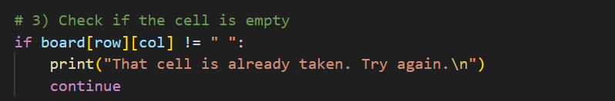

**3.4 Occupancy Check**

* If the chosen square already holds X or O, we reject it.
* A friendly message reminds you to pick an empty spot.

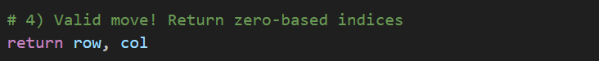

**3.5 Returning a Valid Move**

* Once both checks pass, we exit the loop and hand back the tuple (row, col).
* The calling code in **game.py** will then place the symbol at **board[row][col].**

**magining a Full Interaction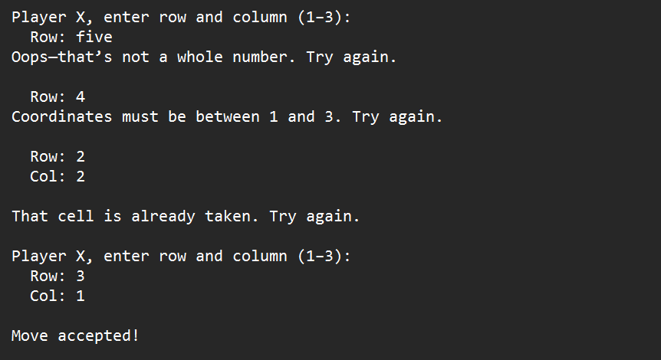 :**

By structuring the prompts and checks this way, you guarantee your game:

* **Never crashes** on bad input.
* **Guides** players back on track with clear messages.
* **Only returns** when a perfectly legal move is chosen.

**Building utils.py: clear_screen()**

**Clarity**Without clearing, each new board state prints beneath the last, creating a messy history:

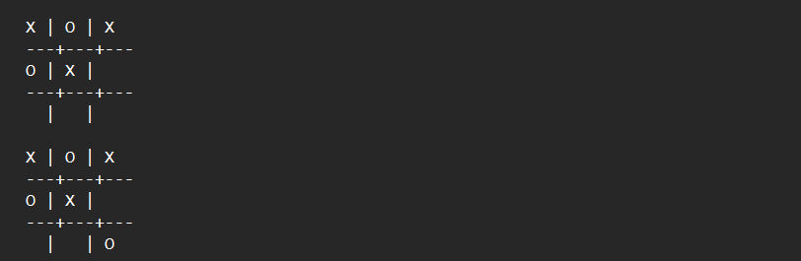

By wiping the screen, players focus only on the current state:

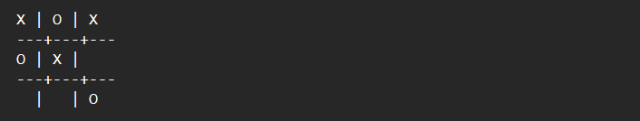

**Immersion**It feels more like an actual game: each move repaints the board, just as if you were drawing on a real surface.

**Writing clear_screen()**

Open **utils.py** and add:

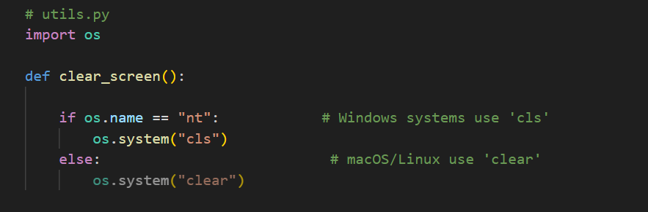

**Deep Dive:**



**1. import os** Gives us access to system-level features, including:

* **os.name:** a short string identifying your operating system (“nt” for Windows, other values for macOS/Linux).
* **os.system():** runs a command in the shell, just like typing it at the prompt.



**2. Detect the OS**

* On Windows (os.name == "nt"), the command to clear the screen is cls.
* On other systems, the standard command is clear.
* **os.system("cls")** , **os.system("clear")** : Wipes the terminal window, so the next board display appears at the top.

**Building game.py: The Main Game Loop**

With the board, win logic, input handler, and utilities in place, it’s time to orchestrate them into the running game. Think of game.py as the conductor: it calls each module in turn to make the game flow naturally.

**game.py**

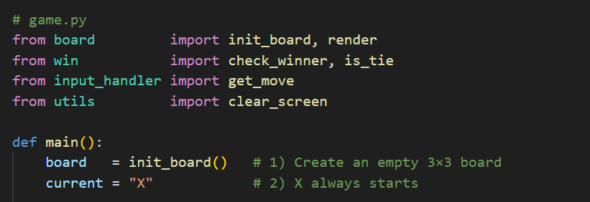

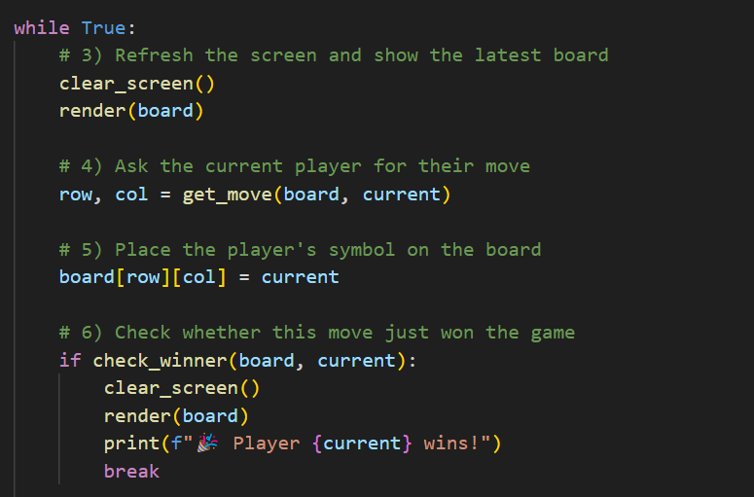

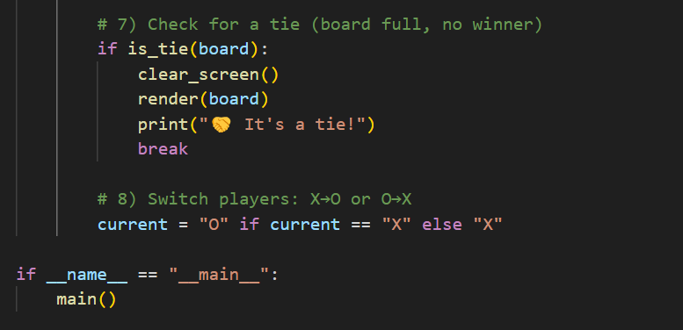

**Deep Dive:**

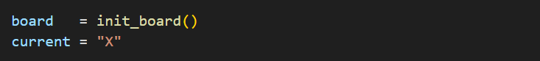

**Initialize**

* init_board() gives us a clean 3×3 grid of spaces.
* We set current = "X" because X always moves first.

**Game Loop**

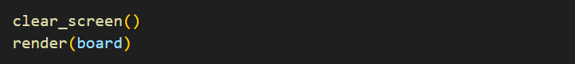

* Clear + Render: We wipe the screen and redraw so each move appears on a fresh board.
* Get Move: get_move() prompts “Player X” (or O) and returns a valid (row, col).
* 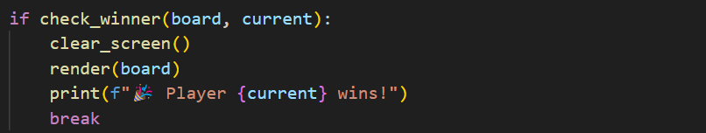Update Board: We place the symbol into our 2D list.
* 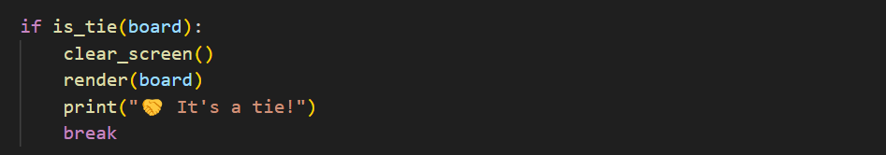Win Check: If that symbol formed three in a row, we redraw one last time and announce the winner.
* Tie Check: If the board is now full with no winner, we announce a tie.
* Switch: Flip from X → O or O → X and loop again.



* Using the **if __name__ == "__main**__": main() guard ensures this script only runs the game when executed directly, not when imported.
* To start our Tic-Tac_Toe game just run from this **game.py**

**Closing Thoughts for Chapter 2**

Congratulations—you’ve just built a fully modular Tic-Tac-Toe game in Python! Let’s recap the key lessons and how they set you up for future projects:

1. **Game Mechanics First**  
   By visualizing the 3×3 grid, turn sequence, win conditions, and tie scenario before writing code, you formed a clear mental model of how the game should flow. This clarity made each module’s purpose obvious.
2. **Separation of Concerns**
   * board.py handles drawing and resizing the grid.
   * win.py contains all logic for victories and stalemates.
   * input_handler.py validates and returns safe player moves.
   * utils.py provides small helpers like clearing the screen.
   * game.py orchestrates the overall turn-by-turn loop.  
     Breaking the game into these files keeps each file small, focused, and easy to test or extend.
3. **Step-by-Step Logic**  
   In game.py, you saw the eight clear steps—initialize, clear & render, get move, update board, win check, tie check, switch player, repeat—forming a predictable, maintainable loop.
4. **Robustness Through Testing**  
   By walking through concrete board states (winning row, column, diagonal, and tie) and using assert statements, you ensured your win/tie logic is rock-solid before the game ever runs.
5. **Polished User Experience**  
   Utility functions like clear_screen() transformed a scrolling mess into an immersive, real-time board that repaints cleanly each move.

**What’s Next?**

With Tic-Tac-Toe under your belt—complete with modular design, clear flow control, and thorough testing—your Python skills are growing sharply. In Chapter 3: Hangman, you’ll tackle:

* String manipulation (revealing letters, masking words)
* File I/O (loading word lists from text files)
* More complex control flow (loops, conditionals, and state tracking)

Get ready to dive into another classic, and further sharpen the patterns and best practices you’ve now mastered. Onward to Hangman!

**Chapter 3**

**: Hangman – Uncovering Strings and File I/O**

Ready for a new challenge? In Tic-Tac-Toe you mastered 2D lists and win logic. Now we’re moving to Hangman, where string manipulation, file reading, and state tracking shine. You’ll build a word-guessing game that feels just like the classic pen-and-paper version—and you’ll organize your code so each piece is easy to understand, test, and extend.

**3.0 Game Mechanics Before the Code**

Before touching Python, let’s play Hangman in our minds:

1. **Secret Word**
   * The computer picks a hidden word (e.g. “PYTHON”) from a list.
   * Players see a row of blanks (_ _ _ _ _ _) matching the word’s length.
2. **Guesses & Lives**
   * The player guesses one letter at a time.
   * Correct guesses reveal all occurrences of that letter in the word.
   * Incorrect guesses cost one “life”—often drawn as parts of a hanging stick figure.
   * Typical lives: 6 (head, body, two arms, two legs).
3. **Win & Lose Conditions**
   * Win: Reveal every letter before running out of lives.
   * Lose: Use up all lives before the word is fully uncovered; the stick figure is complete.
4. **Display Elements**
   * Word state: e.g. P _ T _ O N
   * Used letters: track both correct and incorrect guesses.
   * Remaining lives: show a counter or ASCII art of the gallows.
5. **Game Flow Recap**
   * Load word list from a text file.
   * Choose one secret word at random.
   * Initialize word state, used letters, and lives.
   * Loop: display state → prompt letter → validate input → update state → check win/lose.
   * Announce victory or defeat and optionally reveal the word.

**3.1 Project Structure**

Organize your files into a folder named my_hangman/:

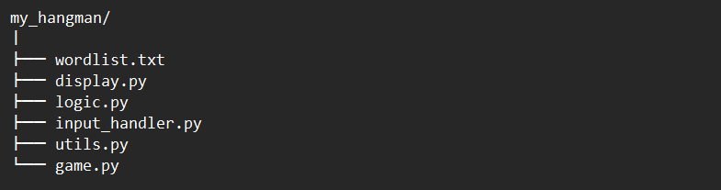

* wordlist.txt: your dictionary of possible secret words.
* display.py: drawing the blanks, filled letters, used guesses, and gallows art.
* logic.py: deciding if a guess is correct, updating the masked word, and tracking lives.
* input_handler.py: ensuring the player types a single unused letter.
* utils.py: loading words from file, choosing a random word, and console utilities.
* game.py: the main loop: load, pick word, loop until win/lose, and report the result.

***Why this layout? Each file has one clear job. You’ll write focused functions that you can test in isolation—no tangled spaghetti code.***

**wordlist.txt**

**Format**

* One word per line, no extra spaces.
* Upper‐ or lowercase is fine—our loader converts everything to uppercase.

**Here’s a sample you can copy & paste into your wordlist.txt:**

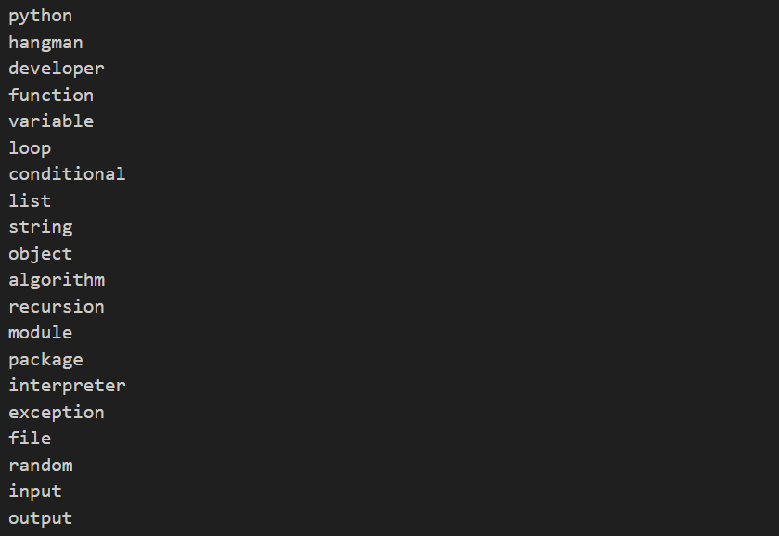

**utils.py – Loading the Word List & Picking a Secret Word**

Before we can start guessing letters, our program needs a secret word. We’ll keep a simple text file—wordlist.txt—with one word per line (e.g., PYTHON, HANGMAN, DEVELOPER, etc.). Our job in utils.py is to:

1. Read that file into Python.
2. Clean each line (remove newline characters).
3. Filter out any blank lines or invalid entries.
4. Randomly select one word for the game.
5. Reuse our clear_screen() helper to keep the console fresh**.**

**1. Imagining the File I/O**

1. Open wordlist.txt for reading.
2. Loop over each line in the file:
   * A line might look like "PYTHON\n".
   * We strip the trailing \n to get "PYTHON".
3. Collect every valid word into a Python list:



Use Python’s **random.choice()** to pick one word from that list.

**Writing the Code in utils.py**

Open **utils.py** (or create it) and add the following:

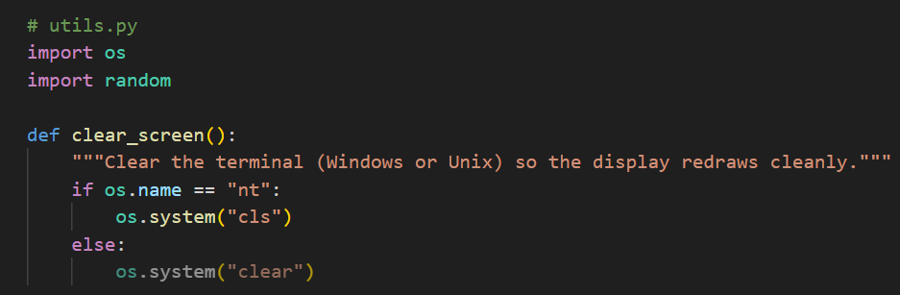

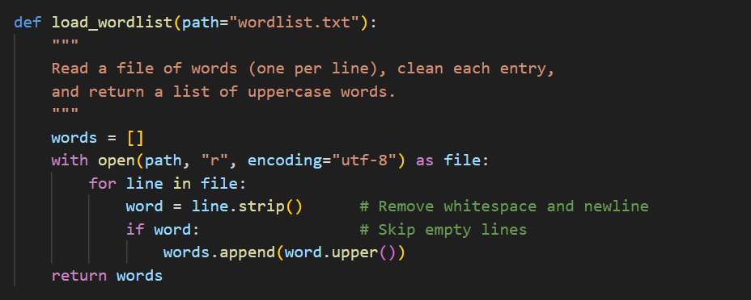

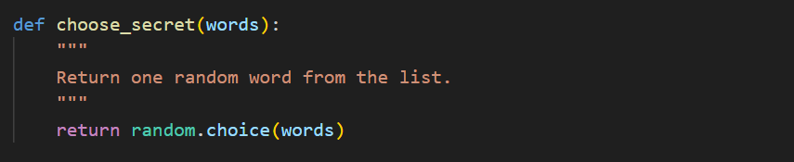

**Deep Dive:**

**Opening the File Safely**

* **with** ensures the file is closed automatically when done.
* **"r"** opens for reading.
* **encoding="utf-8"** handles non-ASCII words if your list grows.

💡💡💡 **You Should know:** **with open(..., mode)**

When you work with files in Python, the safest, cleanest pattern is the **context manager** form:



This single line both opens the file and guarantees it will be **closed** when you’re done—even if errors occur. Let’s explore the common **modes** and why with is your best friend.

**With :**

* **Automatic cleanup**: You don’t have to call f.close() yourself; Python closes the file when the with block ends.
* **Error safety**: Even if an exception is raised inside the block, the file is still closed properly.
* **Readable structure**: Indentation shows exactly where file operations begin and end.

**The common modes :**

|  |  |  |
| --- | --- | --- |
| **Mode** | **Meaning** | **Typical use** |
| "r" | Read (default) | Load or inspect an existing file’s contents. |
| "w" | Write | Create a new file or **overwrite** an existing one. |
| "a" | Append | Add new data **after** existing content. |
| "r+" | Read & Write | Open for both reading and writing. |
| "b" | Binary mode (combine with others) | Read or write raw bytes (e.g. images). |
| "t" | Text mode (default; can omit) | Read or write strings with encoding. |

You can combine modes, e.g. "rb" (read binary) or "a+" (append & read).

**Tips & Best Practices**

**Default mode**

* open("file.txt") is the same as open("file.txt", "r").

**Encoding**

* For non-ASCII text, specify encoding=**"utf-8":**

**example_3.1.py**

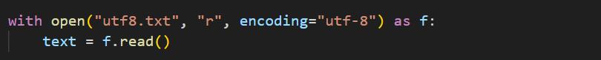

**Line-by-line reading**

* Use a loop to save memory:

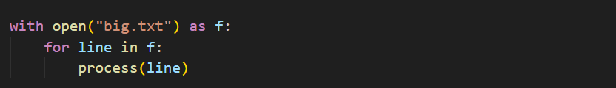

**Avoid mixing modes carelessly**

* "w" deletes existing data—you might prefer "a" if you want to keep it.
* "r+" leaves the file pointer where reads left off; consider f.seek(0) if you need to reread.

**Remark :**



* **0** is the **offset** (number of bytes) from the **start of the file**.
* Calling this moves the file pointer back to the **beginning**.

After **f.seek(0),** the next read will start at byte 0—exactly the start of the file.

**💡💡💡****------------------------------------------------------------------------------------------💡💡💡**

**Stripping Each Line**

* **.strip()** removes leading/trailing whitespace, including \n (newline).
* If the line was " HANGMAN \n", you now get "HANGMAN".

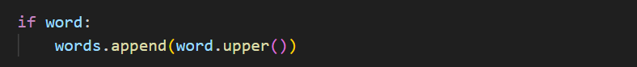

* **Empty strings** (from blank lines) evaluate to False, so we skip them.
* **.upper()** standardizes everything to uppercase, simplifying comparisons later.



**Collecting into a List**

By the end of the loop, words might look like:

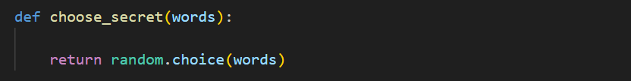

* **random.choice()** picks one element at random.
* Every word in the list has equal chance.

**4. Testing It Interactively**

1. **Load then print** the first few words:

**test_file.py**

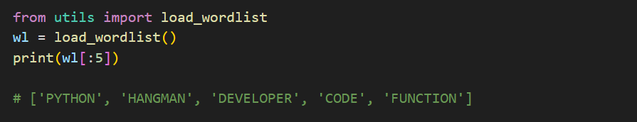

**2. Choose secrets repeatedly**:

**test_file.py**

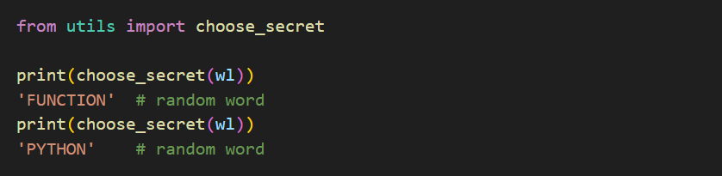

**3. Combine load + choose**:

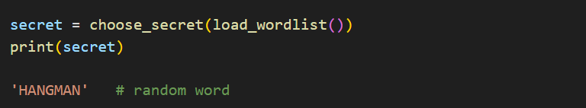

**Conclusion :**

* **Modularity:** utils.py now handles all word‐list tasks—game.py remains focused on gameplay.
* **Reusability:** You can call load_wordlist() and choose_secret() in any other word‐based game.
* **Robustness:** By stripping and filtering, you avoid surprises from stray blank lines or inconsistent casing.
* **Simplicity of Use:** In your main game loop, acquiring a secret word is now one clear line:

**display.py – Showing Word Progress & Gallows**

Now that we can **choose** a secret word, it’s time to **show** the player how they’re doing. Our display.py module will handle:

1. **Masked Word**
   * Reveal letters the player has guessed.
   * Show underscores (_) for letters still hidden.
2. **Used Letters**
   * List all letters the player has already tried (both correct and incorrect).
3. **Gallows or Lives Indicator**
   * Display a simple ASCII-art gallows that grows with each wrong guess, or a numeric life counter.

By centralizing all rendering here, the main loop in game.py stays clean, and you can tweak the visuals later without touching game logic.

**1. Imagining the Display**

Suppose the secret word is **“PYTHON”**, the player has guessed **['P','O','X']**, and has **4 lives** remaining. We want to show:

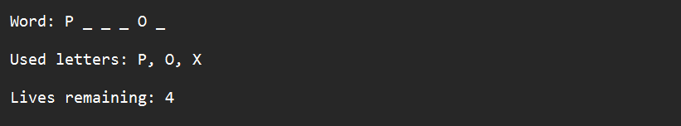

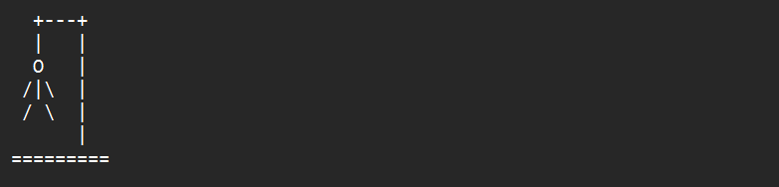a simple gallows:

**2. Writing display.py**

Create **display.py** and add:

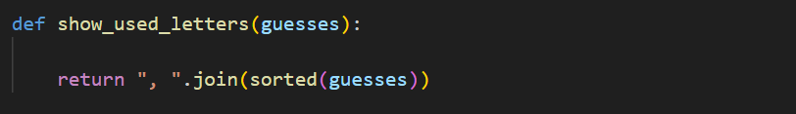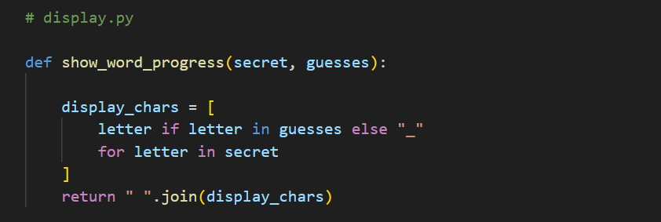

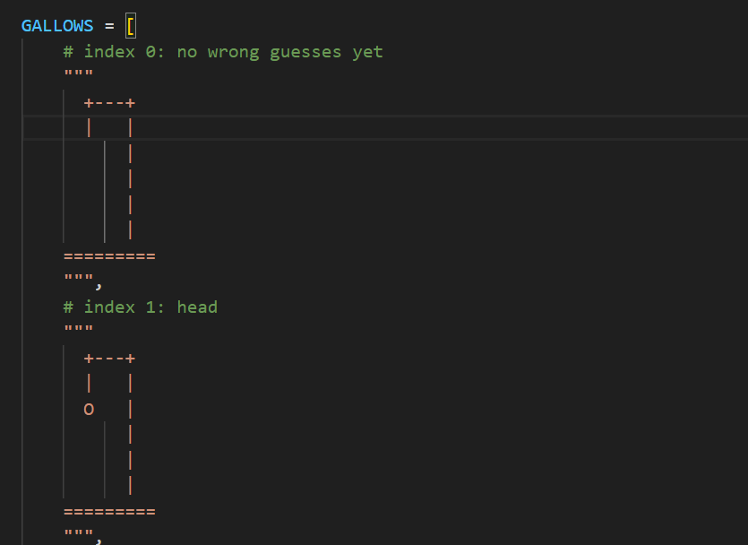

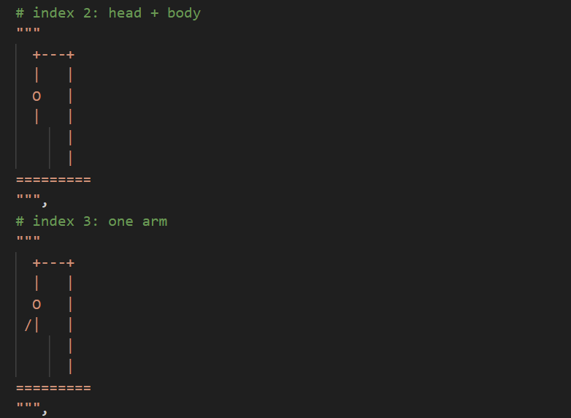

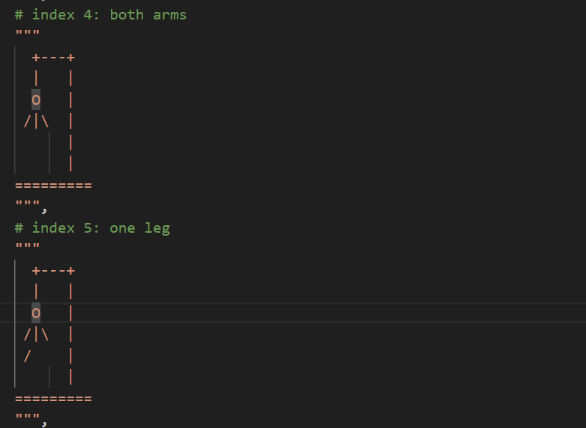

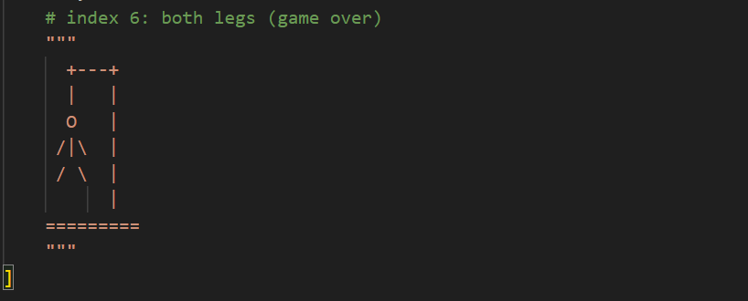

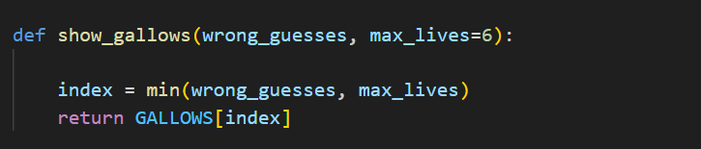

**Deep Dive:**

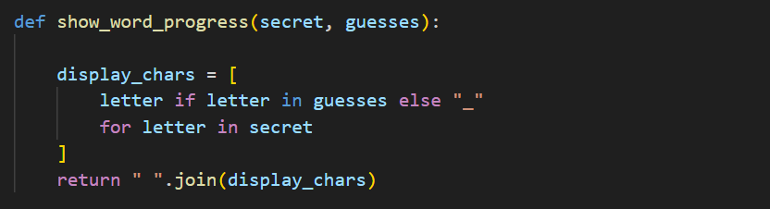

**Masked Word: show_word_progress(secret, guesses)List comprehension**

**1.1 The Goal**

* **Secret word:** "PYTHON"
* **Guessed letters so far:** {"P", "O", "X"}
* **Desired display:**



**1.3 Step-by-Step Logic**

1. **Iterate over each letter** in the secret word:



* First iteration: letter = "P"
* Second: letter = "Y"
* Third: letter = "T"
* …and so on through "H" and "N".

2. **Decide what to show** for each letter:



* If the current letter is in our guesses set, **keep** it.
* Otherwise, **replace** it with an underscore _.

Using our example:

* "P"? Yes, in {"P","O","X"} → "P"
* "Y"? No → "_"
* "T"? No → "_"
* "H"? No → "_"
* "O"? Yes → "O"
* "N"? No → "_"



3. **Join with spaces** to make a readable string:



It mean : **.join(["P","_","_","_","O","_"])**

**Result :**



**Used Letters: show_used_letters(guesses)**

**2.1 The Goal**

* Guessed letters set: {"P", "O", "X"}
* Desired display:



(letters in alphabetical order, separated by commas)

**Step-by-Step Logic**

1. **Sort the guesses** so they appear in order:



* sorted({"P","O","X"}) → ["O", "P", "X"]

**Result:**



**logic.py – Processing Guesses & Game State**

With **display** showing the board and **utils** selecting a word, our next focus is the **heart** of Hangman’s rules: deciding what happens when the player guesses a letter. In **logic.py**, we’ll write functions to:

1. **Update** which letters have been guessed correctly or incorrectly.
2. **Determine** if the player has won (all letters revealed).
3. **Determine** if the player has lost (no lives remaining).

We’ll walk through each function **step by step**, with examples to help you **imagine** the logic in action.

**1. Projected Functions in logic.py**

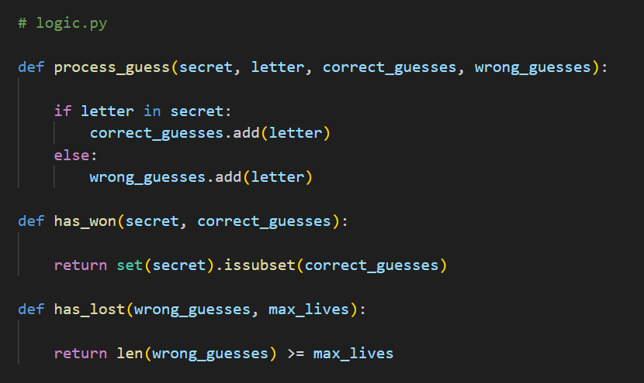

**Deep Dive:**

**2.1 Goal**

* Secret: **"PYTHON"**
* Initial sets:
  + correct_guesses = set()
  + wrong_guesses = set()
* Player guesses: **"P"**, then **"X"**, then **"O"**.

**2.2 Step-by-Step Logic**

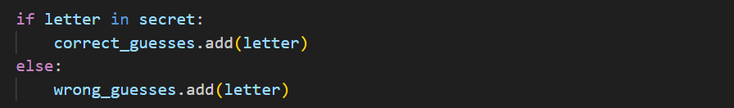

1. **Check membership** in the string secret (e.g., "P" in "PYTHON" is True).
2. **Add** the letter to the appropriate set:
   * Correct guess → correct_guesses.add(letter).
   * Wrong guess → wrong_guesses.add(letter).

**Example Run**

* Guess "P":
  + "P" in "PYTHON" → True
  + correct_guesses = {"P"}
  + wrong_guesses = {}
* Guess "X":
  + "X" in "PYTHON" → False
  + correct_guesses = {"P"}
  + wrong_guesses = {"X"}
* Guess "O":
  + "O" in "PYTHON" → True
  + correct_guesses = {"P","O"}
  + wrong_guesses = {"X"}

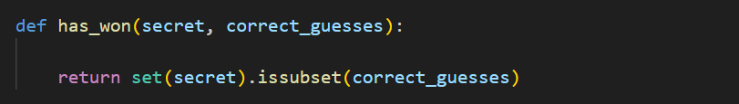

**3.1 Goal**

* **Secret:** "APPLE"
* **Unique letters:** {"A", "P", "L", "E"}
* **Correct guesses so far:** {"A", "P", "L"} → Not yet won.
* **After guessing "E"**, the player should win.

**3.2 Step-by-Step Logic : has_won()**



* **set(secret)** creates the set of unique letters in the word.
* **.issubset(correct_guesses)** checks if **every** letter in the secret has been guessed.
* If {"A","P","L","E"}.issubset({"A","P","L"}) → False.
* After adding "E", → True.

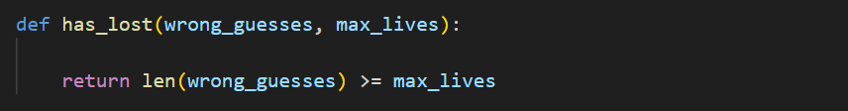

**4.1 Goal**

* **Maximum lives:** 6
* **Wrong guesses set:** size grows each time the player misses.
* **Loss** occurs when wrong_guesses count ≥ max_lives.

**4.2 Step-by-Step Logic**

* **len(wrong_guesses)** returns how many incorrect attempts have been made.
* Once that number reaches or exceeds **max_lives**, the player has no more lives and loses.

**5. Testing the Logic**

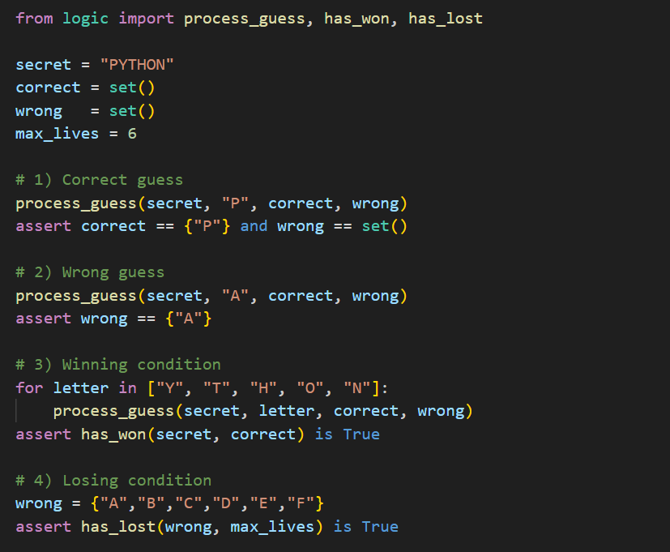

By isolating these core rules in **test_logic.py**, your main game loop simply:

1. Calls **process_guess()** to update the state.
2. Uses **has_won()** / **has_lost()** to decide whether to continue or end the game.

**input_handler.py – Validating a Single Letter Guess**

Before we let the player guess a letter, we need to ensure they:

1. Enter **exactly one character**.
2. That character is an **alphabet letter**.
3. They haven’t **already guessed** it.

By handling all checks in **input_handler.py**, our main loop stays clear of repetitive validation code.

**1. Player’s Perspective**

On each turn, the player sees something like:



* If they type **AB**, we must reject (“Enter only one letter”).
* If they type **!** or **5**, we must reject (“Enter a letter A–Z”).
* If they type a letter they’ve already tried (e.g., **P** again), we must reject (“You already guessed that”).
* Only when they type a **new, single letter** do we accept it.

**2. Writing the Code**

Create **input_handler.py** and add:

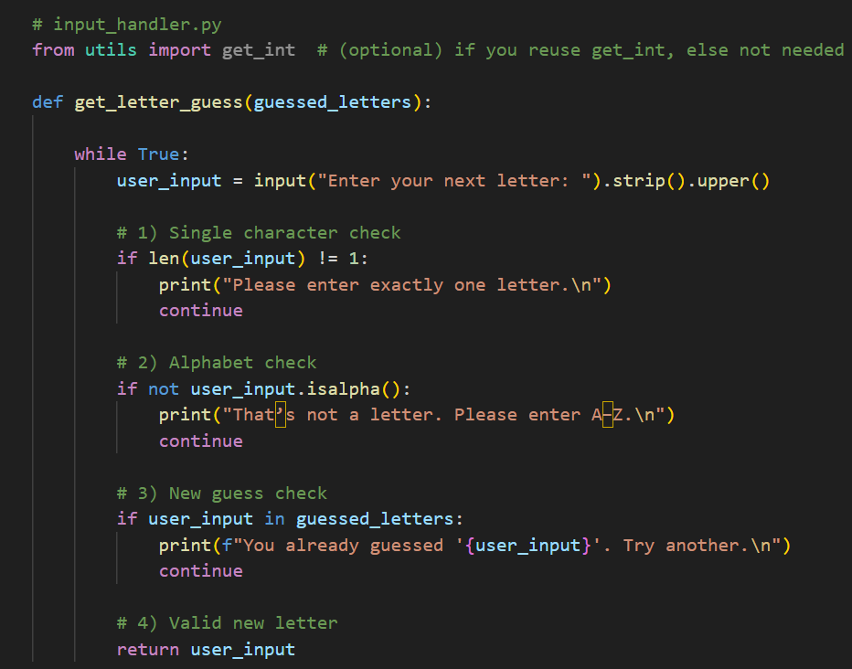

**Deep Dive:**



* **while True:**

 We repeat until a valid letter is returned.

* **Read & Normalize Input**

**.strip()** removes leading/trailing spaces.

**.upper()** converts any lowercase to uppercase, so we treat a and A the same.

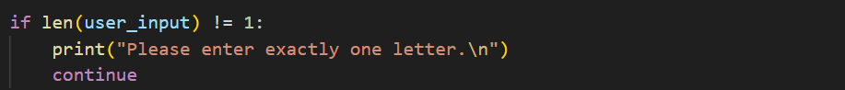

* **Single Character Check**

Rejects empty input **(len=0)** or multi-character **(len>1)**.

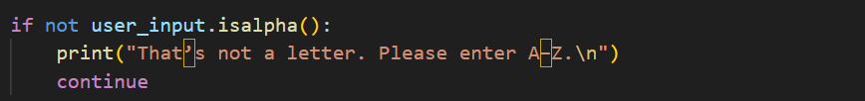

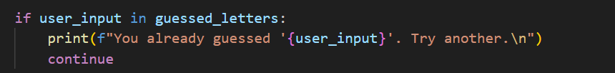 Ensures the character is in A–Z (no digits or punctuation).

Prevents guessing the same letter twice.



Once all checks pass, we hand back the clean, uppercase letter.

**example Interactions**

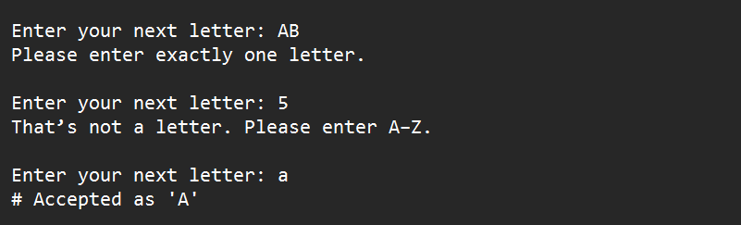

And if guessed_letters = {"A","B"}:



With **get_letter_guess()** securing clean, unique letter input, your **game loop** can simply call:



where all_guesses = correct_guesses ∪ wrong_guesses

**game.py – Orchestrating Hangman**

At last, we bring together every module—**utils**, **display**, **logic**, and **input_handler**—into the full Hangman game loop. Think of **game.py** as the director: it sets the stage, cues each act, and declares the finale.

**1. Overall Flow**

1. **Load** the word list and **select** a secret word.
2. **Initialize** game state:
   * correct_guesses (letters revealed),
   * wrong_guesses (letters missed),
   * max_lives (e.g., 6).
3. **Loop** until the player **wins** or **loses**:
   * Clear the screen and show current gallows.
   * Display masked word and used letters.
   * Prompt for a letter.
   * Process the guess (update correct/wrong sets).
   * Check win/lose conditions.
4. **Announce** the outcome and reveal the word if lost.

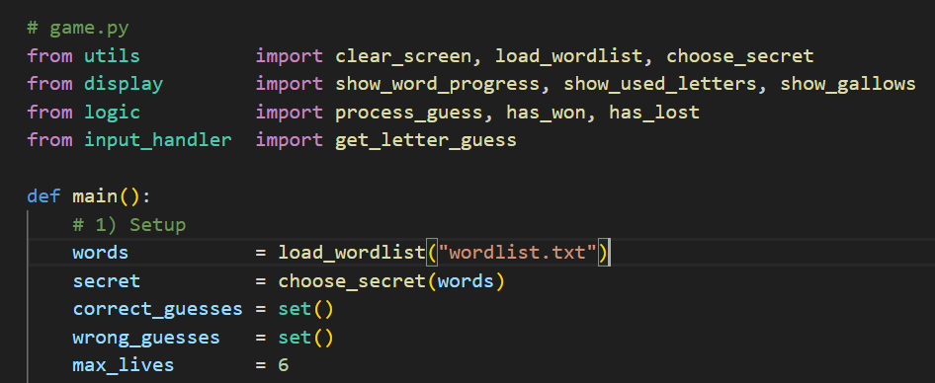

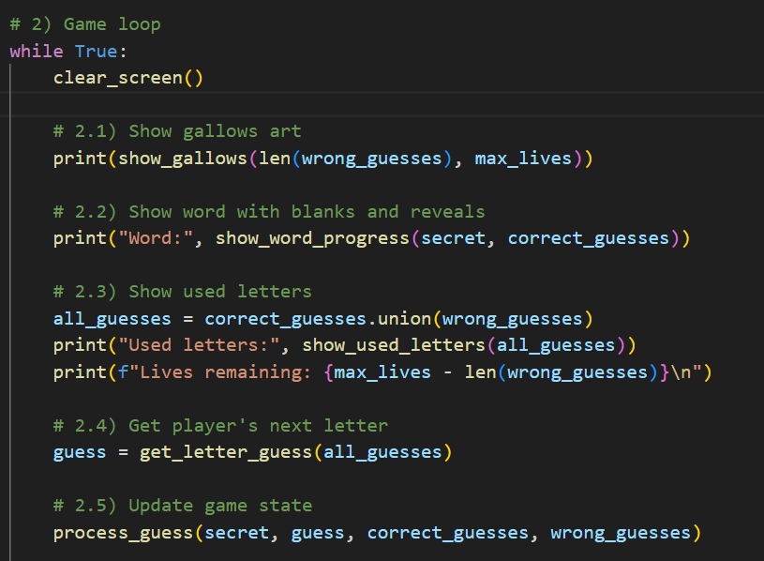

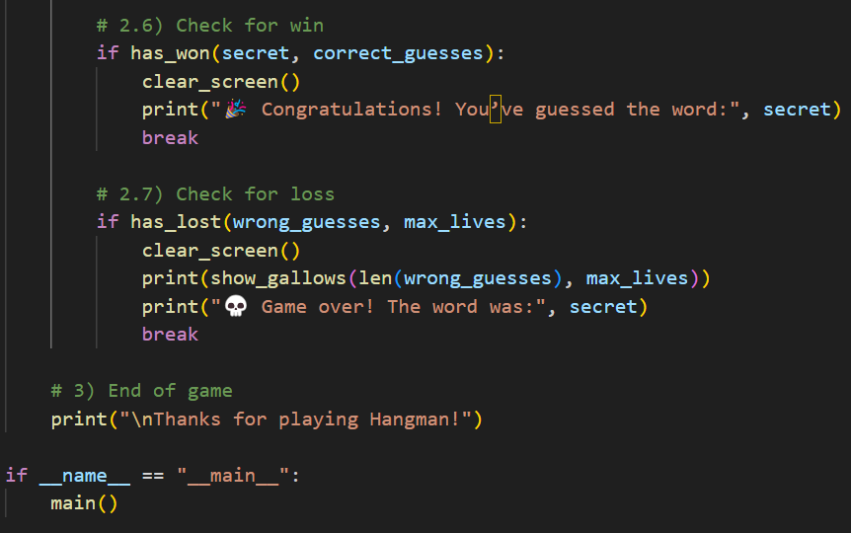

3. Deep Dive: Step-by-Step Logic

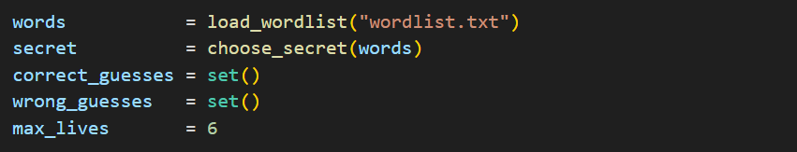

* **load_wordlist()** reads your file into a list of words.
* **choose_secret()** picks one at random.
* Two empty sets track correct vs. wrong letters.
* **max_lives** caps how many wrong attempts before losing.

**Game Loop (while True)**  
Repeats until a **break** on win or loss.

2.1 **Clear & Gallows**

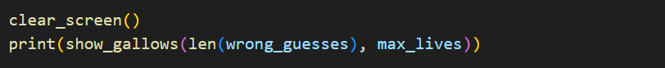

* Clears previous output.
* Shows the ASCII gallows corresponding to how many wrong guesses have occurred.



2.2 **Display Word Progress**

Masks unrevealed letters with _ and reveals correct ones.

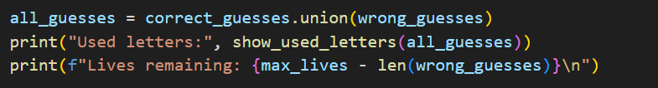

2.3 **Display Used Letters & Lives**

* Combines both sets for display.
* Shows how many lives remain by subtracting wrong guesses.



2.4 **Prompt for Next Letter**

Validates single, new letter input.



2.5 **Process the Guess**

Adds the guess to correct or wrong set based on presence in secret.

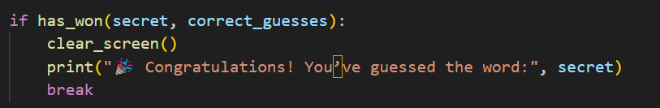

2.6 **Win Check**

If every unique letter has been guessed, the player wins.

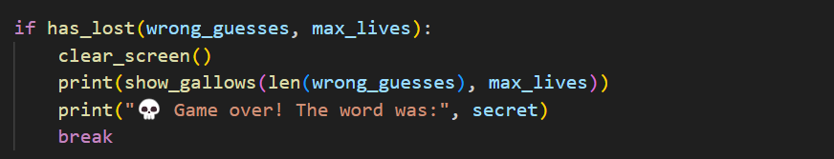

2.7 **Loss Check**

If wrong guesses reach max_lives, the player loses—reshow final gallows and reveal the word.



* End Message

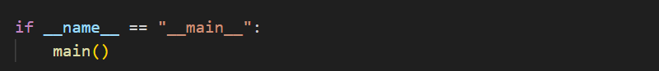

* Ensures main() runs only when the script is executed directly.

**Run & Result :**

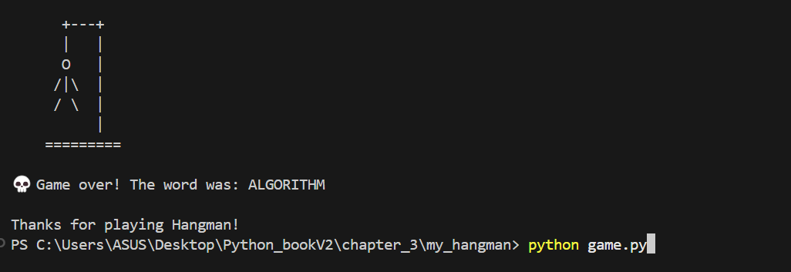

**Closing Thoughts for Chapter 3**

You’ve successfully crafted a full‐featured Hangman game, and in the process you:

1. **Mastered String Handling**
   * Revealed and hid letters using list comprehensions and str.join().
   * Performed case‐insensitive comparisons with .lower() and .upper().
2. **Leveraged File I/O**
   * Safely read a word list via with open(..., "r", encoding="utf-8").
   * Stripped and filtered lines to build a clean list of secret words.
   * Used random.choice() to pick a new secret each play.
3. **Applied Separation of Concerns**
   * **utils.py** for loading words and clearing the screen.
   * **display.py** for drawing the masked word, used letters, and ASCII gallows.
   * **logic.py** for processing guesses and checking win/lose.
   * **input_handler.py** for validating single‐letter input.
   * **game.py** as the conductor, orchestrating eight clear turn steps.
4. **Built Robust Control Flow**
   * A concise loop: clear → render → input → update → check → repeat.
   * Thorough input validation prevents crashes and guides the player smoothly.
5. **Enhanced User Experience**
   * Immediate feedback on each guess.
   * A “fresh” screen each turn for immersion.
   * Simple ASCII art that brings the classic Hangman feel to the console.

**Chapter 4**

**: Quiz App – File I/O and Functions**

**Ready to level up?** In Chapters 2 and 3 you built games that read and wrote files, handled input, and organized code into clear modules. Now we’ll create a **Quiz App**—your turn to master text parsing, CSV handling, dynamic scoring, and robust, reusable functions.

**4.0 Game Mechanics Before the Code**

Imagine sitting down to a quiz in the console:

1. **Loading Questions**
   * From a simple **text file** (questions.txt) of prompt-answer pairs.
   * And/or from a structured **CSV file** (questions.csv) with multiple-choice options.
2. **Shuffling** the questions so each quiz feels fresh.
3. **Asking** each question:
   * For text questions: simply type the answer.
   * For CSV multiple-choice: pick the number corresponding to the correct option.
4. **Validating** the user’s response and giving **instant feedback** (“Correct!” or “Sorry, the answer was ‘Paris.’”).
5. **Tracking** score:
   * Increment on correct answers.
   * Keep a total count of questions asked.
6. **Reporting** at the end:
   * Show “You got 7 out of 10 (70%).”
   * Perhaps award a badge for 90%+.

By the end of this chapter, your console will host a fully interactive quiz—driven entirely by external files and neat, single-purpose functions.

**4.1 Project Structure**

Create a folder called **my_quiz_app/** with:

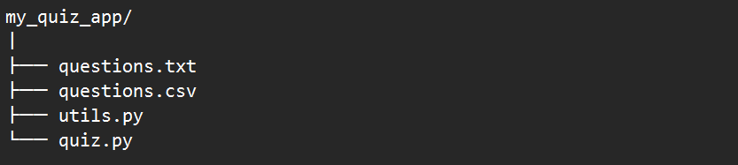

**questions.txt**

* Plain text.
* 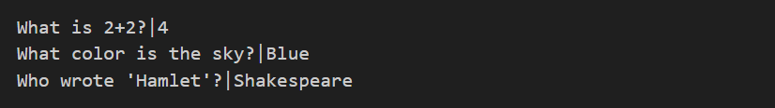Each line:

**questions.csv**

* Comma-separated values.
* 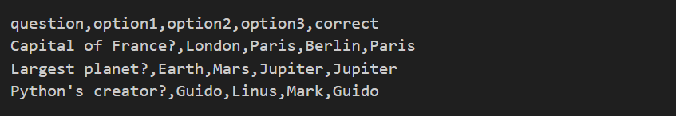Header row, then multiple-choice entries:

**utils.py**

* Functions to read and parse each file type into a **uniform** internal format:

**quiz.py**

* Imports your utils, shuffles questions, asks them, validates answers, updates and displays score at the end.

***Why this layout?*** *By keeping file parsing in utils.py, your quiz.py remains a straightforward sequence: load → shuffle → ask → score → report.*

**4.2 Reading from Text Files**

**4.2.1 Goal**

Turn each line of questions.txt into a dictionary:



**utils.py**

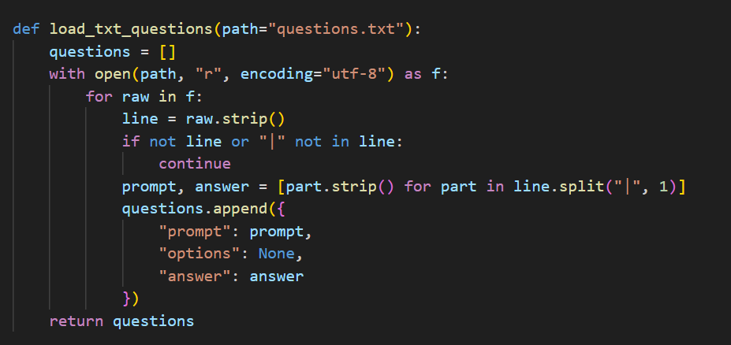

**Deep Dive:**



* **Open** the file with open(path, "r", encoding="utf-8").

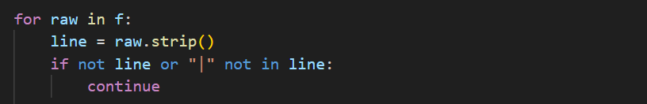

**Loop** over each line:

* **.strip()** to remove \n and whitespace.
* **Skip** blank lines (if not line: continue).



**Split** on the first pipe only:

💡💡💡 **You Should know: split("|", 1)**

**Why split("|", 1)?** It ensures that if the prompt itself contains |, we only split at the first one, preserving the rest as part of the answer.

**💡💡💡------------------------------------------------------------------------------------------💡💡💡**

**4.3 Reading from CSV Files**

To handle multiple-choice questions in **questions.csv**, we’ll use Python’s built-in csv module. Our goal is to parse each row into the **same internal format** as text questions:

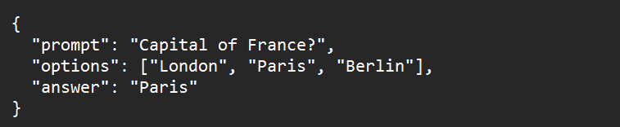

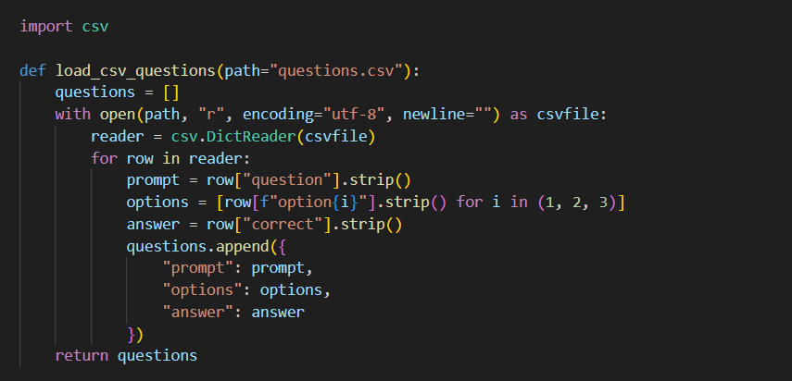

**4.3.3 Deep Dive**



* Python’s built-in csv library knows how to parse comma-separated files, handling any quoting and line breaks correctly.



* **path** defaults to "questions.csv".
* **"r"** opens for reading.
* **encoding="utf-8"** ensures non-English characters are handled properly.
* **newline=""** lets csv manage newlines across platforms.
* The **with** statement ensures the file closes automatically when you’re done.

**💡💡💡 You Should Know: open(..., newline="")**

When you work with CSV or other strict line-based formats in Python, you must prevent Python’s automatic newline conversions from interfering with the csv module’s own logic. Always open such files with newline="" so that the csv library—not Python’s text I/O layer—controls exactly how lines are read and written.

**1. The Problem: Double Translation**

By default, when you open a file in text mode, Python will:

* On read: convert all \r\n (Windows) or \r (old Mac) line endings into \n.
* On write: convert every \n back into your system’s native line ending (\r\n on Windows, \n on Unix).

The csv module expects to see the raw line breaks so it can split rows correctly. Python’s translation can confuse it, leading to:

* Extra blank lines between every record
* Merged or split rows in unexpected places

**2. How newline="" fixes it**

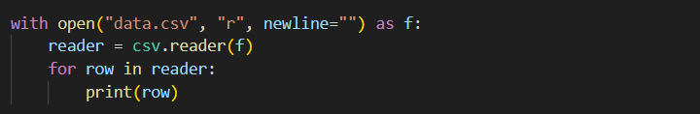

* **newline=""** tells Python **not** to change any \r, \n, or \r\n characters.
* The **csv** module then sees the file’s original line endings and splits each row **exactly once**—no blank lines, no dropped records.

**💡💡💡------------------------------------------------------------------------------------------💡💡💡**



* **csv.DictReader**
  + Reads the first line as headers: ["question","option1","option2","option3","correct"].
    - Each subsequent line becomes a **dictionary** mapping these header names to the cell values.

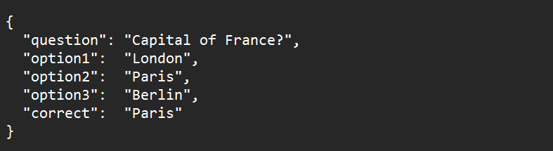 Now **row** is a dict like:



**.strip()** removes leading/trailing spaces or stray \n characters.



* A **list comprehension** loops i over 1, 2, 3.
* For each i, it looks up row["option1"], row["option2"], and row["option3"], strips whitespace, and collects the results into a list:

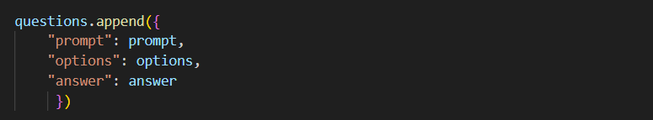

Every question becomes a dictionary with three keys:

* "prompt": the question text
* "options": a list of three possible answers
* "answer": the correct answer string

 After the loop, you have a complete list of question dicts, ready to shuffle and ask.

**Chapter 4, Step 4: Handling Quiz Logic — Asking Questions & Checking Answers**

Now that you’ve **loaded** questions into a uniform format, the next task is to **present** them and **validate** the player’s responses. We’ll write two focused functions in **quiz.py**—one for free-text questions from questions.txt, and one for multiple-choice questions from questions.csv. Each function will:

1. **Show** the prompt (and options, if any).
2. **Accept** and **normalize** user input.
3. **Check** the response against the correct answer.
4. **Return** True if the answer is correct, otherwise False.

**4.4.1 Free-Text Questions: ask_text_question(q)**

When a question’s "options" value is None, we treat it as a free-text prompt:

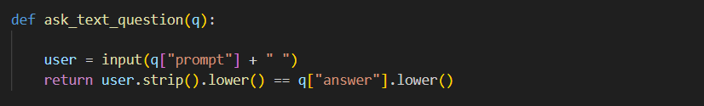

**Deep dive :**



Shows the question and waits for the player to type a response.



* **.strip()** removes leading/trailing whitespace.
* **.lower()** makes the comparison **case-insensitive**, so “paris”, “Paris”, or “ PARIS ” all match.



**Return a Boolean**

* If the normalized response equals the correct answer, return **True** (correct).
* Otherwise, return **False** (incorrect).

**4.4.2 Multiple-Choice Questions: ask_mc_question(q)**

When "options" is a list of strings, we present numbered choices:

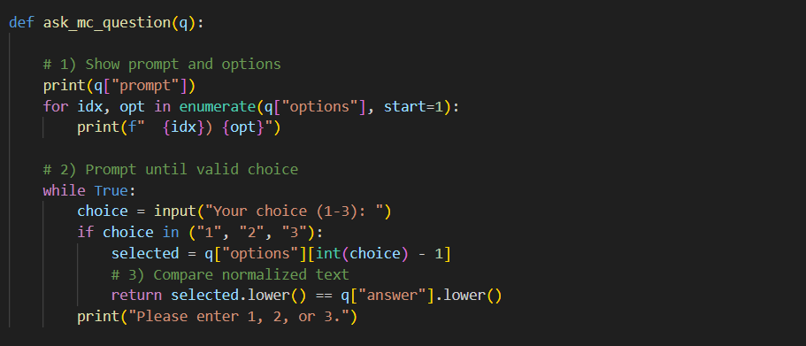

**Deep Dive:**



**Print the prompt**

Shows the question text in the console.



enumerate(..., start=1) pairs each option with a number: (1, first), (2, second), (3, third).

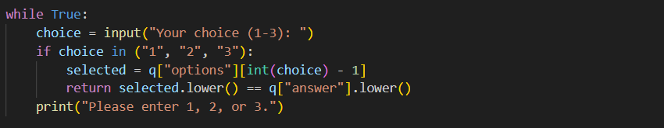

* Rejects any input outside exactly “1”, “2”, or “3”, guiding the player back to a valid choice.
* **selected = q["options"][int(choice) - 1]** : Converts the string index into an integer, subtracts 1 for zero-based list lookup.
* selected.lower() == q["answer"].lower() : Returns **True** if the chosen option matches the correct answer, **False** otherwise.

**The Quiz Loop in run_quiz()**

This single function brings together all your helpers—question loaders, ask-functions, and scoring—into a concise, readable flow. Let’s walk through each line to understand the logic and how it maps to the player’s experience.

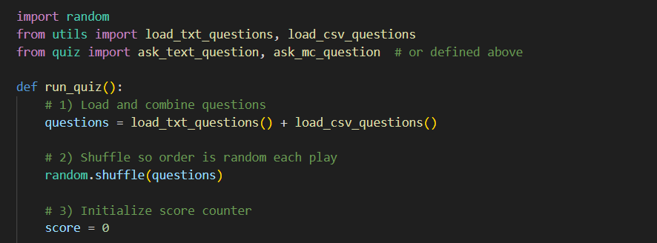

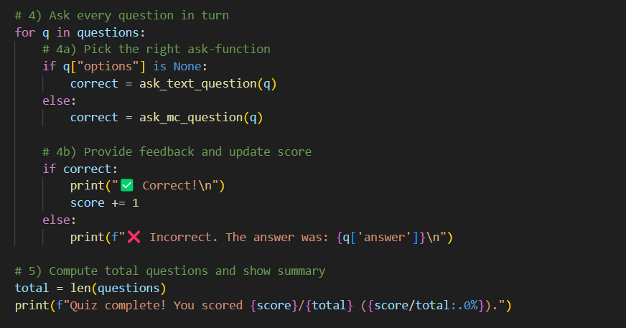 **Deep Dive:**

* **load_txt_questions()** returns a list of free-text question dicts.
* **load_csv_questions()** returns a list of multiple-choice question dicts.
* The **+** operator concatenates the two lists into a single list of all questions.

**Logic:** You now have every question, regardless of format, in one collection.



* **random.shuffle()** reorders the list **in place**, ensuring a fresh quiz each time.
* Without shuffling, questions would always appear in the same sequence, making repeated play predictable.

**Logic:** Shuffling increases replay value by varying question order.



* Starts at zero.
* Each correct answer will increment this counter.
* Loops over each question dict q
* Within each iteration, you present the question, validate the answer, and give feedback.

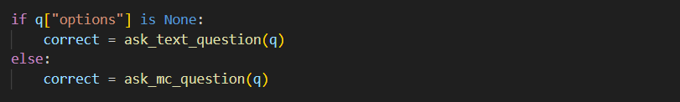

* **Free-text question** (options is None): calls ask_text_question(q).
* **Multiple-choice**: calls ask_mc_question(q).
* Each returns a **Boolean**: True if the player’s answer was correct.

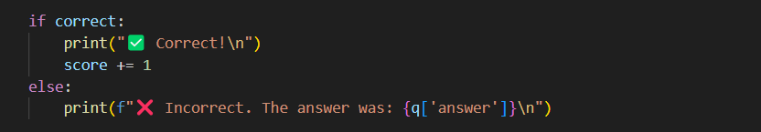

* **If correct**:

Print a green check mark and “Correct!”

**Increment** score by 1.

* **If incorrect**:

Print a red cross and reveal the correct answer using an **f-string**:

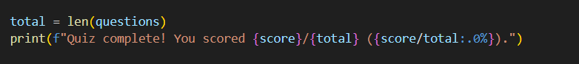

* **total = len(questions)** counts how many questions were asked.
* **Formatted output** with an **f-string**:

{score}/{total} shows raw numbers (e.g., 7/10).

{score/total:.0%} converts the fraction to a **percentage** with zero decimal places

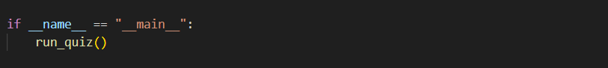 (e.g., 70%).

With run_quiz() defined, your **quiz.py** needs just an entry-point guard:

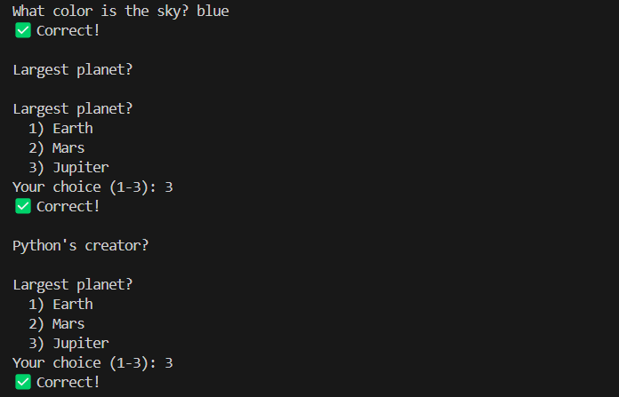Run : quiz.py

**Step 4.5: Scoring & Feedback**

With question loading and answer-checking functions solidly in place, it’s time to **polish** the end-of-quiz experience. In this step, we’ll:

1. **Track** both raw score and total questions.
2. **Calculate** a percentage.
3. **Format** the final message with f-strings.
4. **Customize** feedback based on performance thresholds (badges, praise, encouragement).

**1. Tracking Score & Total**

At your **run_quiz** loop, you initialize:



* **score** counts correct answers.
* **total** is the number of questions you’ll ask.

Each time a question is answered correctly:

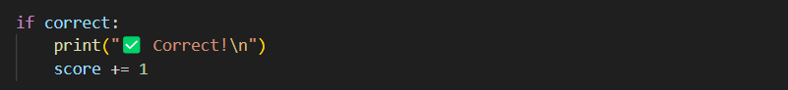

By the end, you have two integers—e.g. score = 7, total = 10.

**2. Calculating the Percentage**

To convert (score, total) into a percentage, use simple arithmetic:



* This yields a **float** between 0.0 and 1.0 (e.g. 0.7).
* When formatted as a percent, 0.7 → "70%".

**3. Formatting the Final Message**

Python **f-strings** make it easy to embed expressions:



* **{score}/{total}** : displays raw numbers (e.g. 7/10)
* **{score/total : .0%}** : formats the fraction as a percent with **zero** decimal places:
* .0% means “percent with 0 digits after the decimal.”
* 0.7 → 70%; 0.95 → 95%.

This single line gives your player both the count and the percent in one concise message.

**Customizing Feedback with Thresholds**

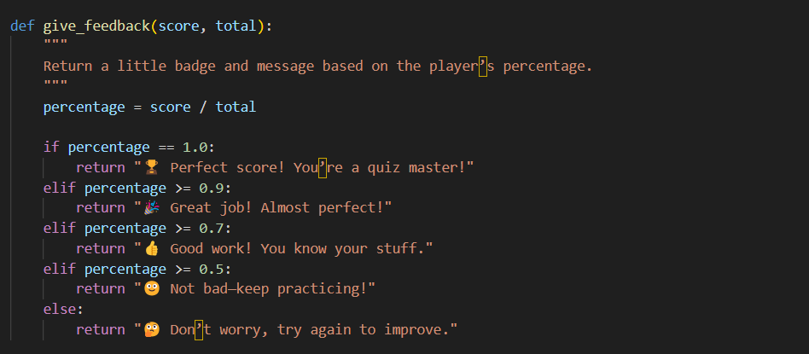For an extra motivational touch, you can add conditional messages—“badges” or praise—based on how well the player did:

**Logic Breakdown**

1. **Compute** the same percentage = score / total.
2. **Check** descending thresholds in order:
   * **1.0** (100%) → perfect
   * **≥ 0.9** (90–99%) → excellent
   * **≥ 0.7** (70–89%) → good
   * **≥ 0.5** (50–69%) → fair
   * **else** → needs improvement
3. **Return** a short, friendly message with an emoji badge for extra flair.

**Putting It All Together**

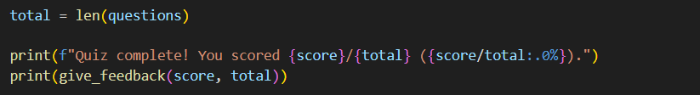At the end of **run_quiz()**, your final block becomes:

This two-step ending reads smoothly:

1. **Summary**: “You scored 7/10 (70%).”
2. **Feedback**: “👍 Good work! You know your stuff.”

**Result :**

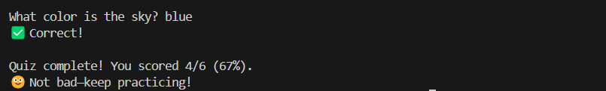

**Closing Thoughts for Chapter 4**

You’ve just crafted a full‐featured Quiz App that showcases how to :

1. **Read & Parse External Files**
   * Loaded free‐text Q&A pairs from questions.txt.
   * Used the csv module to handle structured multiple‐choice data in questions.csv.
2. **Structure Code with Single‐Purpose Functions**
   * File‐I/O helpers (load_txt_questions, load_csv_questions) live in **utils.py**.
   * Question‐asking routines (ask_text_question, ask_mc_question) focus solely on presentation and validation.
   * The orchestration in run_quiz() stays concise, managing only shuffle, loop, score, and summary.
   * Feedback logic (give_feedback) sits neatly alongside, enhancing user experience without cluttering the main loop.
3. **Provide Robust Input Handling**
   * Blank or malformed lines in your files are safely skipped.
   * Free‐text answers are normalized (stripped, lowercased) for tolerant matching.
   * Multiple‐choice input loops until you receive exactly one valid number.
4. **Deliver Polished Scoring & Feedback**
   * Raw score and percentage summary via f-strings.
   * Custom badges and motivational messages based on performance thresholds.
5. **Maintain a Clear, Modular Layout**
   * Each file has a single responsibility, making your codebase easy to navigate, test, and extend.
   * Want to add a timer, categories, or persist high scores? You know exactly which modules to touch.

**Chapter 5**

**: Snake – Embracing Object-Oriented Programming**

With your Quiz App solidly in place, you’re ready to level up into graphical games and **Object-Oriented Programming**. In Chapter 5, we’ll build **Snake**—a timeless arcade classic—using Python classes to model the snake, its food, and the game board. You’ll learn how to:

* **Design classes** for game entities, encapsulating state and behavior.
* **Manage game loops** with methods, attributes, and event handling.
* **Render graphics** in a simple GUI library (we’ll use tkinter for accessibility).
* **Handle collisions**, scoring, and increasing difficulty as the snake grows.

We’ll break Chapter 5 into digestible steps—each with hands-on code and clear logic explanations—so you can follow along even if this is your first GUI or OOP project.

**5.0 Game Mechanics Before the Code**

Before writing any Python, let’s **visualize** how Snake works:

1. **The Playing Field**
   * A grid of cells (e.g. 20×20).
   * The **snake** occupies a sequence of adjacent cells.
   * A single **food** item sits in one free cell.
2. **Movement & Growth**
   * The snake moves one cell at a time in its current direction (up/down/left/right).
   * When it eats food (head enters the food cell), the snake **grows** by one segment, and new food appears randomly.
3. **Win & Lose Conditions**
   * **Lose:** Snake’s head collides with its own body or the wall.
   * (No formal win; the goal is to achieve the highest score possible.)
4. **Score Tracking**
   * Each food eaten increments the player’s **score** by a fixed amount (e.g. 10 points).
5. **Increasing Difficulty**
   * As the snake grows longer, movement speed gradually increases, challenging the player.
6. **Translating to Code**  
   Your program will need to:
   * **Represent** the snake as a list of coordinate tuples.
   * **Render** each segment and the food on a canvas.
   * **Listen** for arrow‐key events to change direction.
   * **Advance** the snake on a timed loop, handling growth and collisions.
   * **Display** the current score and end the game gracefully on loss.

**5.1 Project Structure**

Create a folder named **my_snake_game/** with these files:

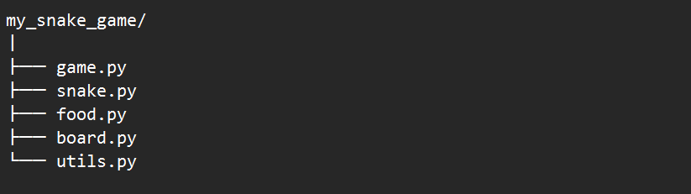

**game.py :** Entry point: sets up the window and starts the Game class

* **class Game:**
  + Sets up the window, binds keys, starts the main loop with after().
  + Orchestrates snake.move(), collision checks, food eating, score updates.

**snake.py :** Defines the Snake class: position list, movement, growth

* class Snake:
  + Attributes: segments (list of (x, y)), direction.
  + Methods: move(), grow(), change_direction(), collides_with_self().

**food.py :** Defines the Food class: random placement, rendering

* class Food:
  + Attribute: position (x, y).
  + Method: place(snake_segments) to choose a new free cell.

**board.py :** Defines Board/Canvas: drawing grid, snake, and food

* class Board: Defines Board/Canvas: drawing grid, snake, and food
  + Holds the tkinter.Canvas.
  + Methods: draw_snake(), draw_food(), update_score().

**utils.py :** Common helpers: coordinate conversion, random position

* Helper functions for random position generation and boundary checks.

**Designing the Snake Class**

Before we dive into GUI or event loops, our first task is to model the snake itself in **snake.py**. The **Snake** class encapsulates everything about the snake’s body, movement, growth, and self-collision logic. Once it works correctly in isolation, you’ll plug it into the graphical game loop.

**1. Imagining the Snake Data Structure**

* **Grid coordinates:** We’ll represent positions as (x, y) tuples, where 0 ≤ x < WIDTH, 0 ≤ y < HEIGHT.
* **Ordered segments:** The snake is a list of these tuples, with the **head** at the **front** (segments[0]) and the **tail** at the **end**.
* **Direction:** One of four vectors: (1,0) for right, (-1,0) for left, (0,1) for down, (0,-1) for up.

**1.1 Movement**

* **Step 1:** Compute a new head position:



* **Step 2:** Insert new_head at the front of segments.
* **Step 3:** Remove the last element of segments (the old tail), unless we’re **growing**.

**1.2 Growth**

* When the snake eats food, we still **insert** the new head but **skip** removing the tail, effectively lengthening the list by one.

**1.3 Self-Collision**

* After moving, if the new head **equals** any other tuple in segments[1:], that indicates the snake has run into itself.

💡💡💡 **You Should Know: Python Classes**

Before we dive into the **Snake** class in our game, let’s cover the absolute fundamentals of **classes** in Python—what they are, how they work, and why we use them.

**1. The Big Idea: Blueprint vs. House**

* Class = the architect’s plan (“How do I build a Dog?”)
* Instance = one actual house built from that plan (fido = Dog("Fido"))
* Every instance has its own rooms (attributes) and can perform actions (methods).

**2. Anatomy of a Class**

**example_5.1.py**

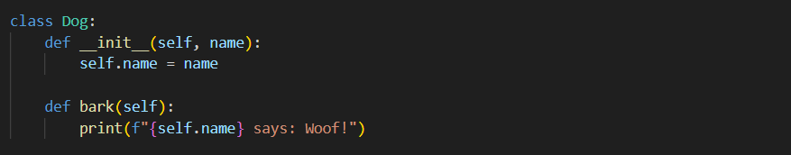

* **class Dog:**Declares a new blueprint named Dog.
* **__init__(…)  
  The constructor—runs automatically when you make Dog("Spot").**
  + - self refers to the new instance itself.
    - You assign attributes on self to store per-object data.
* **Methods (bark)**Functions defined inside the class that use self to read or modify that object’s state.

**3. Using a Class**

**Example_5.1.py**

* **spot** is an **object** in memory and also an **instance** of Dog.
* You can create many dogs (fido, rex, etc.), each with its own name.

**Why Classes Matter**

* **Encapsulation**: Keep related data (attributes) and logic (methods) together.
* **Reusability**: Build once, instantiate many times with different settings.
* **Clarity**: High-level code calls snake.move() or player.jump() without worrying about how those work internally.

**5. Logic Behind Classes**

1. **State** = what the object “knows”
   * Stored in attributes like self.direction or self.segments.
2. **Behavior** = what the object “does”
   * Defined by methods like move() or grow().
3. **Self-management**
   * Each instance manages its own state: two snakes never share the same segments list!
4. **Initialization**
   * __init__ ensures every new object starts in a valid, predictable state.

**💡💡💡------------------------------------------------------------------------------------------💡💡💡**

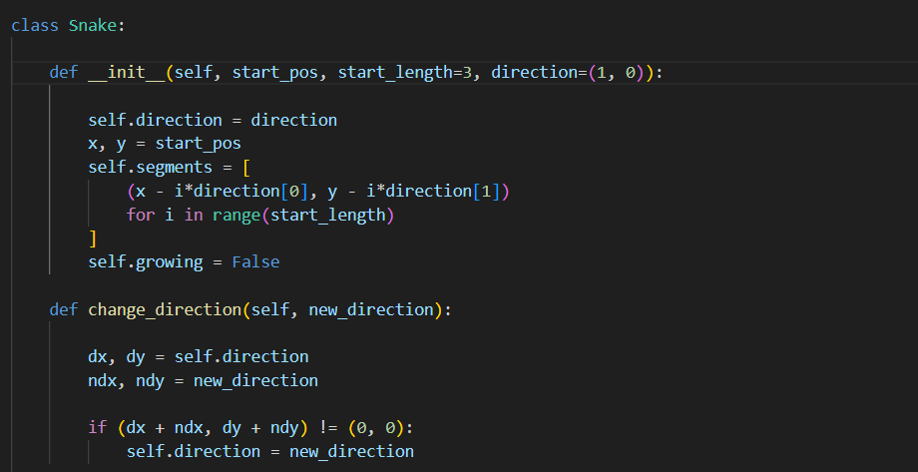**2. Writing the Snake Class in snake.py**

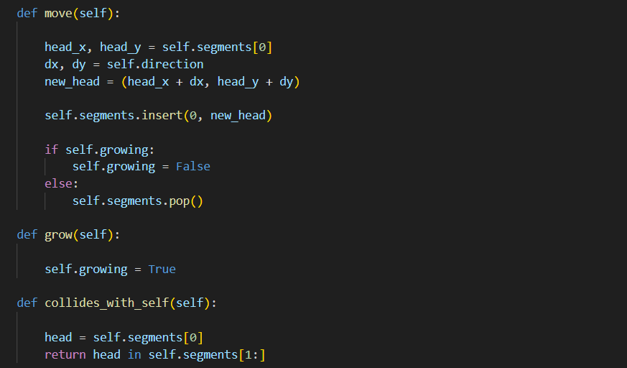

**Deep Dive:**

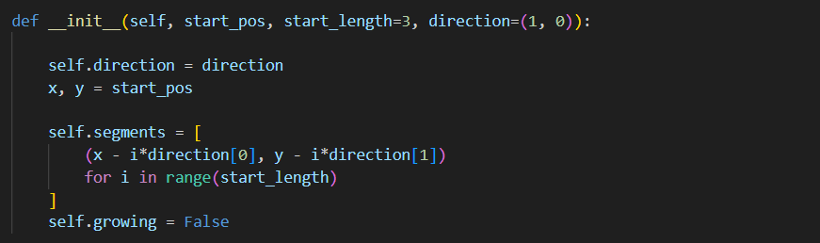**3.1 __init__: Building the Initial Snake**

**1.Coordinates:**

* We treat each segment as a tuple (x, y) on an invisible grid.
* start_pos = (x, y) is where the **head** begins.

**2. Direction Vector:**

* direction = (dx, dy) is the snake’s initial facing: e.g. (1, 0) means “to the right,” (0, -1) means “up.”

**3. List Comprehension Loop:**

* We loop i from 0 up to start_length - 1.
* **When i = 0:**
  + Compute (x - 0*dx, y - 0*dy) = (x, y) → the head.
* **When i = 1:**
  + Compute (x - 1*dx, y - 1*dy) → one cell **behind** the head.
* **When i = 2:**
  + Compute (x - 2*dx, y - 2*dy) → two cells behind, and so on.

1. **Result:**
   * You get a straight line of segments trailing back from the head, exactly start_length long, all facing the chosen direction.

**Why this matters**

* You’ll always start with a correctly sized snake, oriented in the direction you want it to move.
* Because the tail is behind the head, a single move() call will naturally “crawl” forward.

💡💡💡 **You Should Know : How We’re Interpreting (dx, dy) in GUI**

* **Tuple meaning**
* The first number, dx, is how much we change the **x-coordinate** (left/right).
* The second number, dy, is how much we change the **y-coordinate** (up/down).
* **Coordinate origin**
* In most GUI frameworks (including tkinter) and in our grid, the top‐left corner is **(0, 0)**.
* 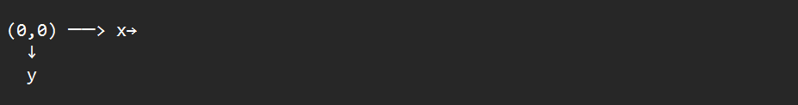**x increases to the right**, and **y increases downward**.
* **Putting it together**
  + **(1, 0)** → dx=+1, dy=0 → move one cell **right**.
  + **(-1, 0)** → dx=–1, dy=0 → move one cell **left**.
  + **(0, 1)** → dx=0, dy=+1 → move one cell **down** (because y grows downward).
  + **(0, -1)** → dx=0, dy=–1 → move one cell **up** (because subtracting from y moves you back toward the top)
* **Quick Visual**
* Imagine a 5×5 grid of (x,y) coordinates:

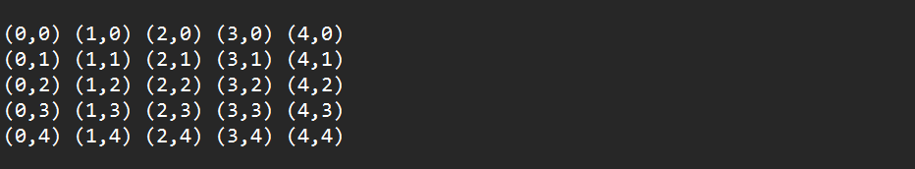

* If your head is at **(2, 2)** and you add **(0, -1)**, new head = **(2, 1)**—one row **up**.
* If you add **(0, +1)**, new head = **(2, 3)**—one row **down**.

**💡💡💡------------------------------------------------------------------------------------------💡💡💡**

**3.2 change_direction: Safely Turning the Snake**

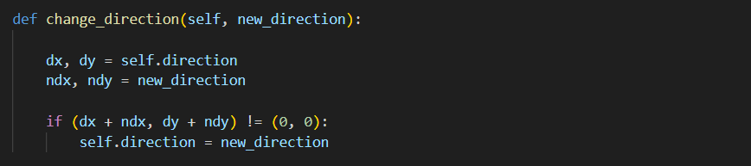

* **Current Direction (dx, dy):**
* E.g., (1,0) means right.
* **Requested Direction (ndx, ndy):**
* Perhaps the player pressed “Left,” giving (-1,0).
* **Opposite-Check:**
* Adding the two vectors: (1,0) + (-1,0) = (0,0).
* If the sum is (0,0), the new direction is exactly opposite—i.e. a 180° turn.
* **Guarding Against Reversal:**
* A sudden U-turn in a single step would place the head back onto the neck segment and cause an instant self-collision.
* This check ensures we **ignore** any direct reverse, but still allow left-to-up or right-to-down, etc.

**Why this matters**

* It preserves the classic Snake rule: you can’t flip back on yourself in one move.
* It keeps movement logical and prevents the snake from “biting” its own neck by accident.

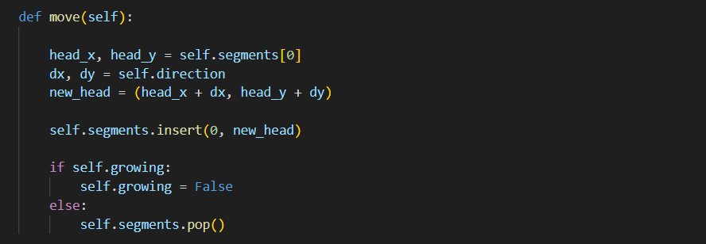

**3.3 move(): Crawling Forward (and Growing)**

1. **Calculate the Next Head Position:**
   * Look at the **current head** coordinates (head_x, head_y).
   * Add your direction vector (dx, dy) → new_head.
2. **Insert the New Head:**
   * self.segments.insert(0, new_head) makes the new head the first element in the list.
3. **Tail Management:**
   * **Normal move:** remove the last segment (pop()), so the snake “slides” forward without changing length.
   * **If Growing:** skip the pop() once—so after inserting the new head you **keep** the old tail, making the snake one segment longer.
4. **Reset Growth Flag:**
   * If you were growing, you reset self.growing = False so only a single extra segment is added.

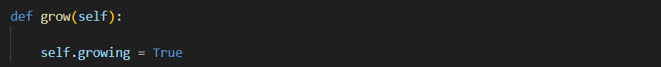**3.4 grow(): Scheduling Growth**

* You simply set a boolean flag.
* On the **very next** move() call, the snake will insert its new head but **not** remove its tail, growing by one segment.

**Why this matters**

* Calling grow() right when the snake eats food cleanly defers the length change to the next movement step, keeping movement and growth logic distinct.
* You avoid complex index juggling—just a simple flag check.

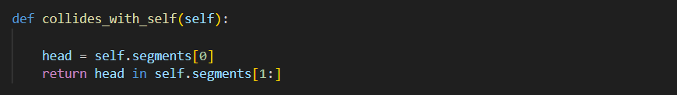

* **Grab the Head:**

head = self.segments[0].

* **Check the Body:**

Look through self.segments[1:] (all the other segments).

If any equals the head coordinate, you’ve collided.

* It’s a concise way to determine if the snake has run into itself.
* Returning a simple True/False lets your main loop handle game-over logic cleanly.

**4. Testing the Snake Class in Isolation**

By writing small **assert**‐based tests, you confirm each piece works **before** wiring up graphics:

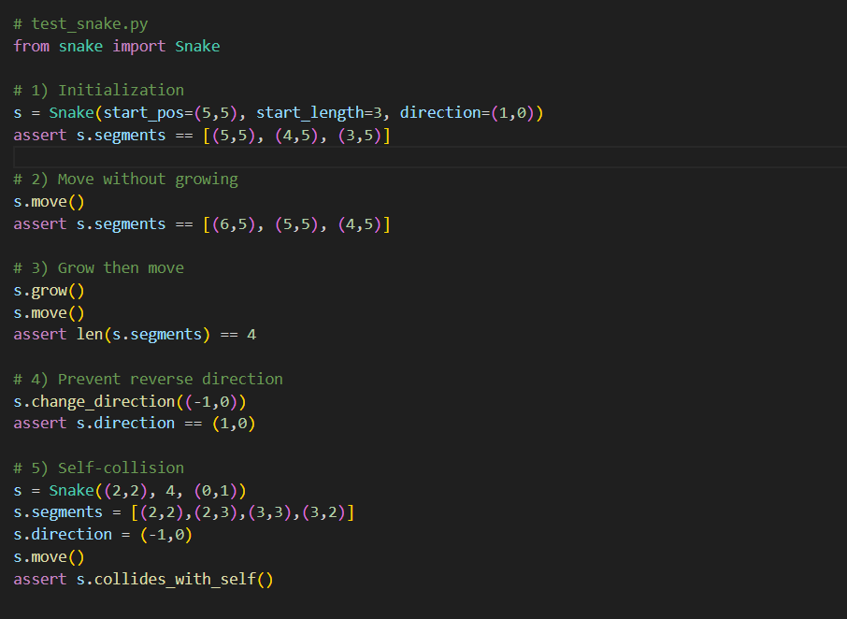

**Deep dive :**

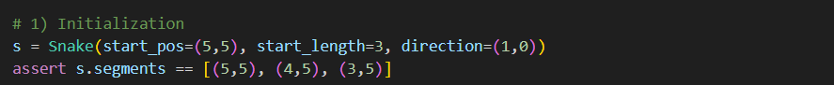

**1) Initialization**

* **Constructor call**
* start_pos = (5,5) → the head’s starting coordinates.
* start_length = 3 → we want three segments.
* direction = (1,0) → facing **right**.
* **List comprehension** in **snake.py __init__ builds**:

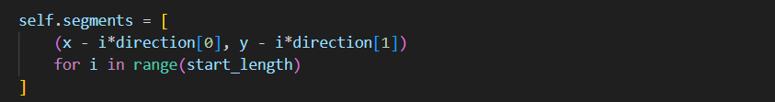

* **i = 0** → (5 - 0*1, 5 - 0*0) = (5,5) (head)
* **i = 1** → (5 - 1*1, 5 - 1*0) = (4,5) (segment)
* **i = 2** → (5 - 2*1, 5 - 2*0) = (3,5) (tail)
* **Segments list** is therefore [(5,5),(4,5),(3,5)]. The assert confirms our initialization logic is correct.

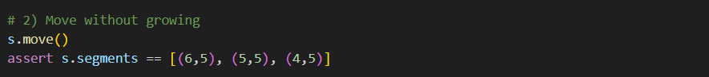

**2) Move without Growing**

* **Before move:** segments = [(5,5),(4,5),(3,5)], direction = (1,0).
* **Compute new head:**
* Current head = (5,5).
* Add direction (1,0) → new head = (6,5).
* **Insert new head** at front → [(6,5),(5,5),(4,5),(3,5)].
* **Remove tail** (because growing is False) → pop last → [(6,5),(5,5),(4,5)].
* The assert confirms the snake “slid” forward one cell to the right.

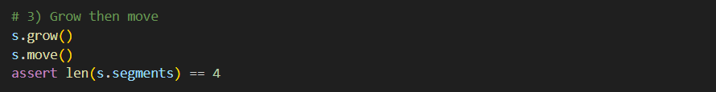

**3) Grow then Move**

* **Call s.grow()**
* Sets s.growing = True. This flags that the next move should **not** remove the tail.
* **Before move:** segments = [(6,5),(5,5),(4,5)].
* **s.move()**
* Compute new head: (6,5) + (1,0) = (7,5).
* Insert at front → [(7,5),(6,5),(5,5),(4,5)].
* Because growing was True, skip pop(), and then reset growing = False.
* **Resulting length** = 4. The assert len(...) == 4 verifies that growth logic correctly adds one segment.

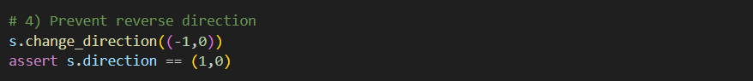

**4) Prevent Reverse Direction**

* **Current direction** = (1,0) (right).
* **Attempt to reverse**: new_direction = (-1,0) (left).
* **In change_direction:**
* Compute (dx+ndx, dy+ndy) = (1 + -1, 0 + 0) = (0,0).
* Since it equals (0,0), we **do not** update self.direction.
* **assert** confirms direction remains (1,0), preventing an illegal 180° turn.

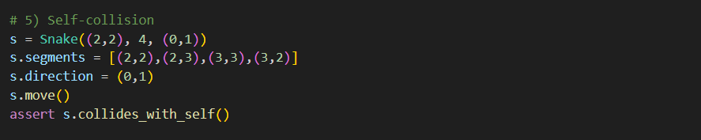

**5) Self-Collision**

**Re‐create the snake** with dummy parameters:

* start_pos and direction don’t matter because we immediately override segments and direction.

**Manually set segments** to a “U” shape:

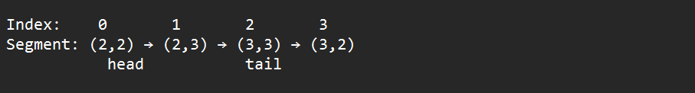

**Set direction** to (0,1) (move **down**).

**Call s.move()**:

* **Compute new head:**  
  (2,2) + (0,1) = (2,3)
* **Insert** at front → [(2,3),(2,2),(2,3),(3,3),(3,2)]
* **Pop** tail (last element) → [**(2,3)**,(2,2),**(2,3)**,(3,3)]

Notice **(2,3)** appears twice: at index 0 and index 2.



**collides_with_self()** checks: which returns **True**.



Because the head has moved into its own body, **the assertion passes**, confirming the collision logic works as intended.

Now that your **Snake** class is rock‐solid, the next piece is the **Food**—a simple object whose only job is to appear in an empty cell and be eaten by the snake. In **Section 5.3**, we’ll:

1. **Model** the food’s position as a coordinate tuple.
2. **Randomly place** it into a cell that the snake does *not* occupy.
3. **Re‐place** it after each time the snake eats.

We’ll write a Food class in **food.py** and then step through its logic in detail.

**5.3 Designing the Food Class**

**1. Food Responsibilities**

* **Holds** a single attribute: position (an (x, y) tuple).
* **Places** itself in a free spot on the board.

No drawing code here—that lives in board.py. Food only cares about picking valid coordinates.

**2. Writing food.py**

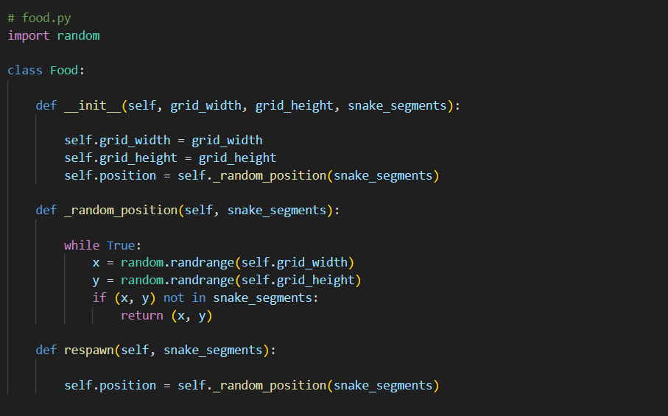

**Deep Dive:**

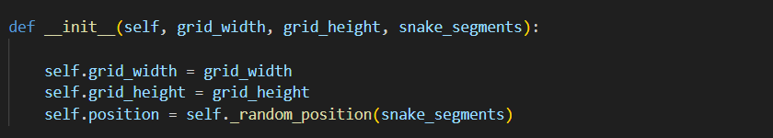

* **Inputs:**
* grid_width, grid_height: board dimensions.
* snake_segments: the list of (x,y) tuples the snake currently occupies.
* 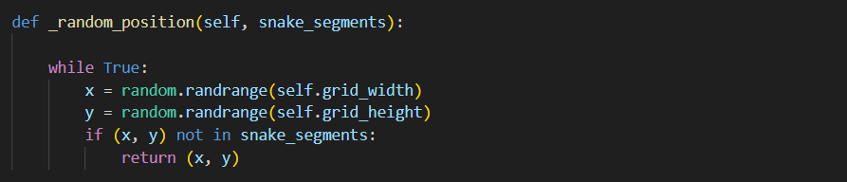**Action:** Immediately calls _random_position() to pick a valid spot.

**3.2 _random_position()**

1. **Infinite loop** until we find a free cell.
2. **random.randrange(n)** returns an integer in [0, n) uniformly at random.
3. **Check** (x,y) is not in snake_segments.
4. **Return** the first free coordinate.

**Why a loop?** On a full board, this could in theory loop forever—but in practice, the board is never completely occupied until game over. For small boards, performance is fine; for very dense boards you might switch to a pre‐computed list of free cells, but that’s an optimization for later.

💡💡💡 **You Should Know: The Leading Underscore in Python Names**

In Python, a single underscore prefix (e.g. _random_position) is a **convention** signaling that this function or attribute is **internal** to its module or class—**not** part of the public API you expect users to call directly.

**1. The Convention, Not Magic**

* **def _random_position(...):**  
  By naming it with a leading underscore, you’re telling other developers:

“This is for internal use only—please don’t import or call me from outside.”

* Python **won’t** enforce this (you can still call it!), but most tools and linters honor it and won’t expose it in from module import *.

**2. Why It Matters**

1. **Encapsulation**
   * Keeps your public interface clean.
   * Hides helpers or implementation details you might change later.
2. **Maintenance**
   * Users know they shouldn’t rely on underscored parts—so you’re free to refactor them without breaking downstream code.
3. **Readability**
   * When someone reads your code and sees _random_position, they immediately recognize it’s an internal helper, not a main feature.

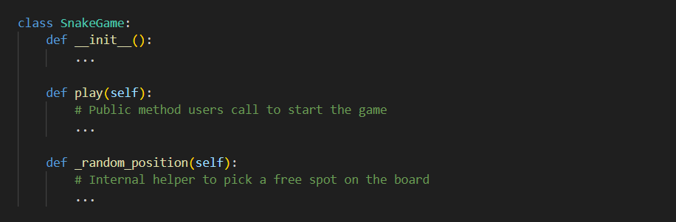

* **Public**: play() is the game’s main entry point.
* **Internal**: _random_position() is only for play() or other methods inside SnakeGame.

**4. Quick Tips**

* Use **one leading underscore** (_name) for **module- or class-internal** names.
* Use **two leading underscores** (__name) to trigger Python’s name-mangling (harder to access from subclasses).
* Avoid trailing underscores unless needed to avoid keyword conflicts (e.g., class_).

**💡💡💡------------------------------------------------------------------------------------------💡💡💡**

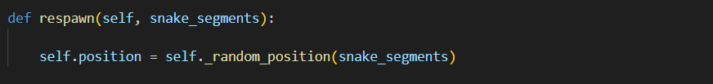

**3.3 respawn()**

Exactly the same mechanism, called when the snake eats the existing food.

**4. Testing Food in Isolation**

Create **test_food.py**:

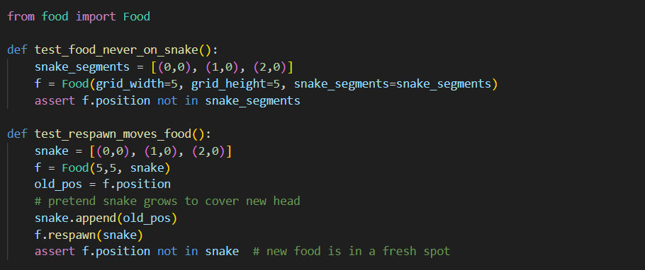

**Deep Dive:**

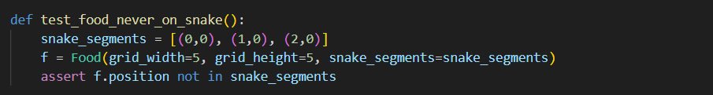

**1. Define the occupied cells**

We simulate a snake occupying three cells along the top row:



**2. Create a Food instance**



* **grid_width=5**, **grid_height=5**: our board has coordinates from 0 to 4 in both x and y.
* **snake_segments**: tells Food which cells are off–limits.

Inside __init__, the constructor calls _random_position(snake_segments), which:

1. Picks x = randrange(5) → some integer in [0,4].
2. Picks y = randrange(5).
3. Checks if (x,y) is **not** in [(0,0),(1,0),(2,0)].
4. If occupied, repeats until it finds a free spot.



**3. Assert food is not on the snake**

* If f.position somehow equals one of (0,0),(1,0),(2,0), the test fails.
* Passing this assertion guarantees our initializer never places food on top of the snake.

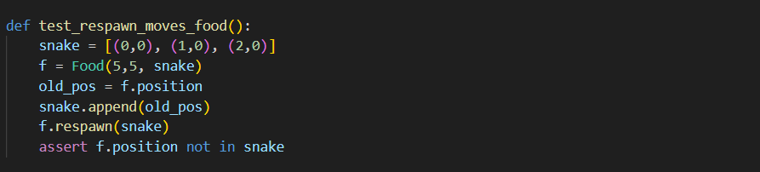

**Test 2: test_respawn_moves_food**

**1. Initial setup**

* We start with the same snake occupying [(0,0),(1,0),(2,0)].
* We create f = Food(5,5, snake).
* old_pos = f.position remembers where the food first appeared (guaranteed by Test 1 to be off–snake).



**2. Simulate “eating” the food**

* We pretend the snake has moved onto old_pos and eaten the food.
* Now the snake’s segments include the previous food cell.



**3. Call f.respawn(snake)**

This method internally calls _random_position(snake_segments) again, avoiding **all** current snake segments—including the newly added old_pos.



Confirms that **after** respawning, f.position is in a **fresh** cell not part of the updated snake body.

Now that **Snake** and **Food** are solid and tested, our next module is the **Board**—the visual canvas where everything comes to life. We’ll build **board.py** using **tkinter.Canvas**, and step through each method so your reader sees **exactly** how the snake and food get drawn.

**5.4 Designing the Board Class**

**Responsibilities**

* **Create** a window and a drawing surface (tkinter.Canvas).
* **Draw** the snake segments and the food pellet, turning their (x,y) grid coordinates into screen pixels.
* **Display** the current score.
* **Clear** and **refresh** the canvas each frame.

**File: board.py**

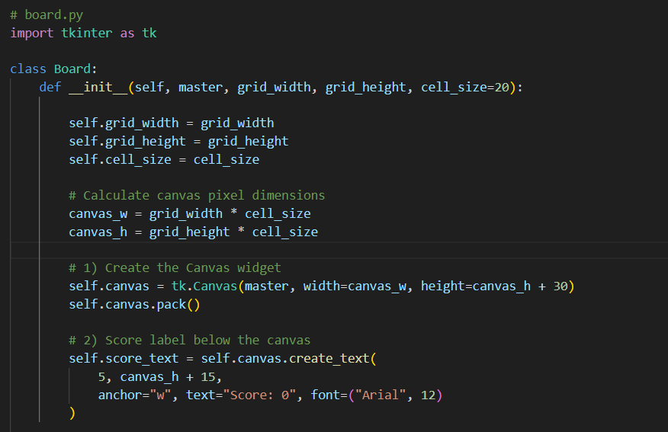

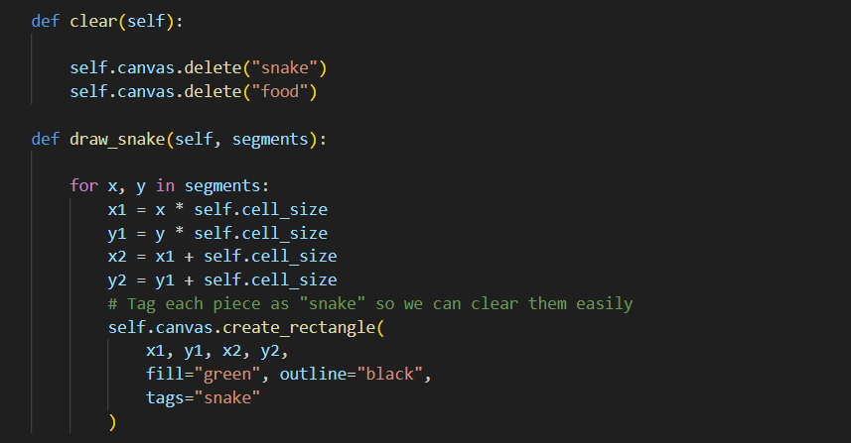

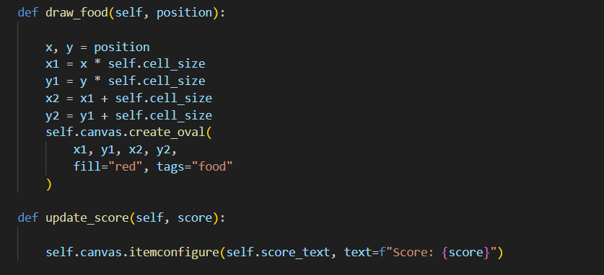

**Deep dive:**

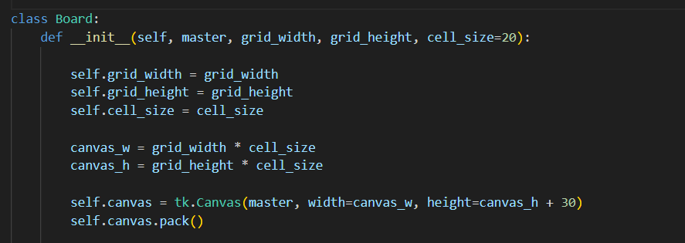

**1) Initialization (__init__)**

* **Translate grid to pixels:**
* If each cell is 20×20 px and grid is 20×20 cells, the canvas is 400×400 px.
* We add **30 px** height for the score display area.
* **Create and pack the Canvas:**
* master is the main window (tk.Tk()).
* pack() places the canvas in the window.

💡💡💡 **You Should Know: tk.Tk() & .pack() in Tkinter**

When building a GUI with Python’s **Tkinter** library, two foundational pieces are **creating the main window** and **laying out widgets**. Here’s what every new Pythonista needs to grasp before drawing the game board.

**1. tk.Tk(): Your Application’s Root Window**

* **What it is**:



* Calling tk.Tk() **instantiates** (creates) the main application window—think of it as opening the game’s empty frame.
* **Mechanism & Logic**:
  1. **Initializes** the Tcl/Tk interpreter behind the scenes.
  2. **Allocates** a top-level window with title bar, close/minimize buttons, and an empty client area.
  3. **Becomes the “master”** for all your widgets (buttons, canvases, labels), passing it as the master or parent argument so they know where to live.
* **Why it matters**:  
  Without tk.Tk(), there is nowhere to place your Canvas or other UI elements. It’s the **root of the widget tree**.

**2. tk.Canvas(...): A Drawing Surface**

* **Creating a Canvas:**
* **master**: the tk.Tk() window that will contain the canvas.
* **width/height**: pixel dimensions—here, grid cells × cell size, plus extra for the score.

**Purpose**:

* Provides methods like .create_rectangle(), .create_oval(), and .create_text() so you can draw shapes, images, and text.
* Manages items on named **tags** (e.g., "snake", "food") for easy updating and clearing.

**3. .pack(): Placing Widgets in the Window**

* **What it is**:



* .pack() is a **geometry manager** method that tells Tkinter **where and how** to display the widget inside its parent.
* **Mechanism & Logic**:
  1. **Calculates** the widget’s requested size (from width/height).
  2. **Allocates** screen space in the parent window.
  3. **Arranges** the widget according to packing rules (default: top-to-bottom, center-aligned).
* **Why it matters**:  
  Without calling a geometry manager (.pack(), .grid(), or .place()), your widget exists in memory but is **never displayed** on screen.

**💡💡💡------------------------------------------------------------------------------------------💡💡💡**

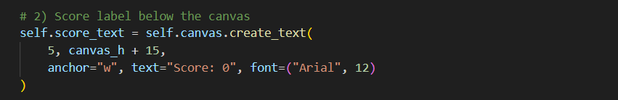

**Score label:**

* We draw text at **x=5 px** (left margin) and **y=canvas_h + 15 px** (just below the grid).
* The **anchor="w"** makes the text left‐aligned.

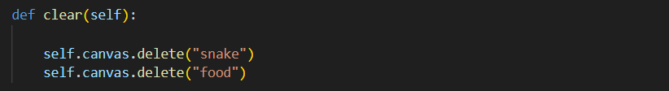

* We use **tags** ("snake", "food") when drawing each item.
* Deleting by tag removes all previous parts, so each frame starts fresh.

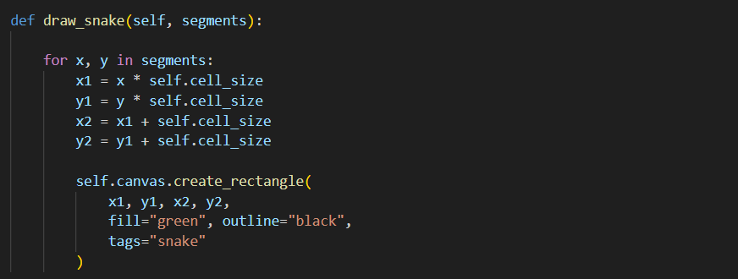

* **Grid→Pixel conversion:**
* (x,y) cell becomes pixel box from (x1, y1) to (x2, y2).
* **Rectangle:**
* Green fill with black border.
* Tagged "snake" for easy deletion next frame.

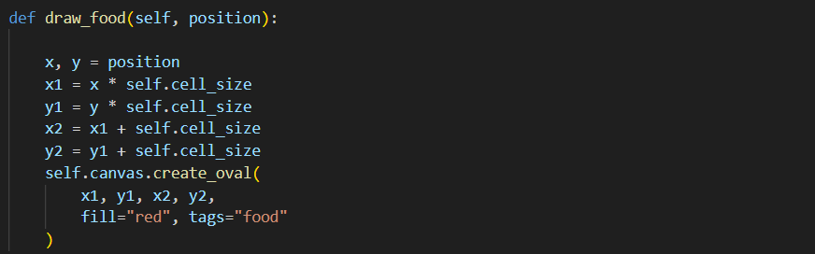

* We draw an **oval** to distinguish food from snake.
* Tagged "food" so it can be cleared and redrawn.

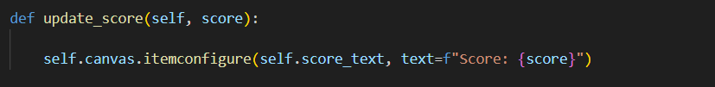

* Changes the existing text item without recreating it.
* Keeps the score display dynamic and efficient.

**5.5 Orchestrating Everything in the Game Class**

Now that you have **Snake**, **Food**, and **Board**, it’s time to tie them together in **game.py**. The **Game** class will:

1. **Set up** the window, board, snake, and food.
2. **Bind** keyboard events to change the snake’s direction.
3. **Schedule** a recurring “tick” (movement and redraw) via tkinter’s after().
4. **Check** collisions with walls or self, and food‐eating.
5. **End** the game on a collision, or grow the snake and respawn food on eating.

**File: game.py**

**Introduction**

The **Game** class is the “conductor” of our Snake application. It:

1. **Builds** the window and all game objects.
2. **Listens** for arrow-key presses to steer the snake.
3. **Runs** a recurring loop (“ticks”) where the snake moves, collisions are checked, and the screen is redrawn.
4. **Handles** game-over and scoring.

**game.py**

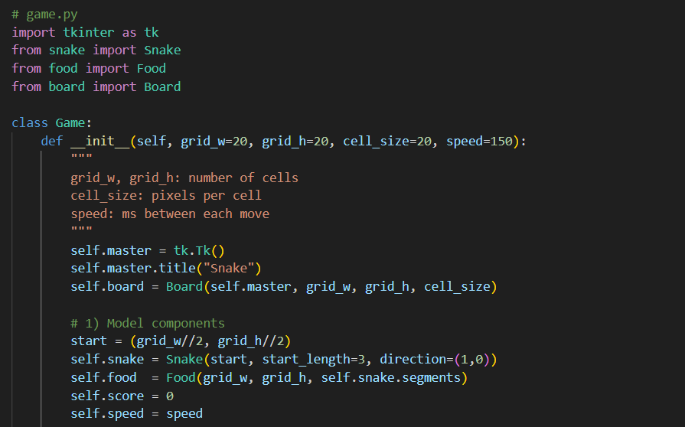

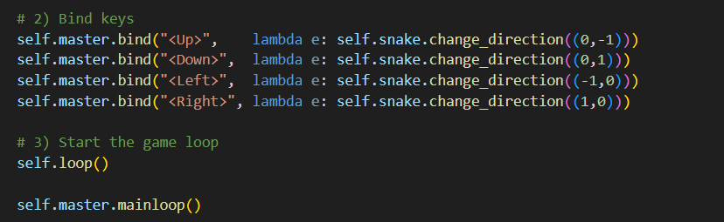

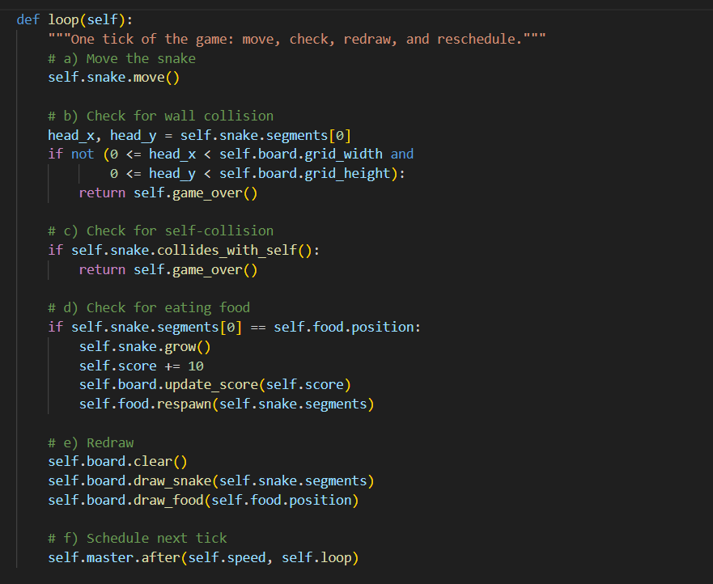

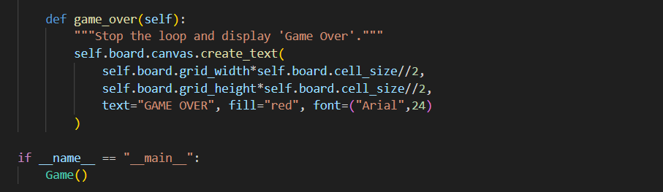

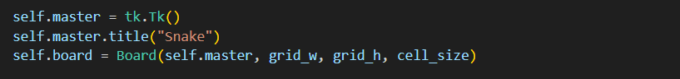Let’s unpack each part.

**1. Setting Up the Window and Board**

* **tk.Tk()**
* Creates the main application window.
* Think of it as the empty frame for everything to live in.
* **title("Snake")**
* Sets the window’s title bar text.
* **Board(...)**
* Instantiates our **Board** class (from **board.py**) with the window (master), grid dimensions, and pixel size per cell.
* The Board creates a Canvas where snake segments and food will be drawn.

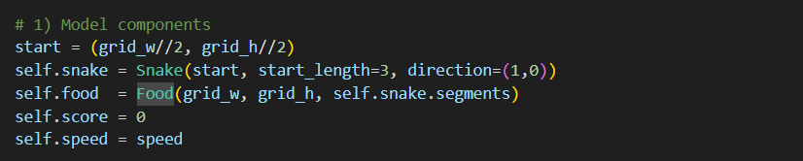

1. **start coordinate**
   * Centers the snake in the grid: (grid_w//2, grid_h//2).
2. **Snake**
   * Creates our Snake object with:
     + **start position**
     + **length** of 3 segments
     + **initial direction** (1,0) → moving right
3. **Food**
   * Places a food pellet randomly in any cell *not* occupied by the snake’s segments.
4. **score**
   * Initialized to zero; tracks how many pellets have been eaten (10 points each).
5. **speed**
   * Milliseconds between each move tick (e.g. 150 ms) — controls the game’s tempo.

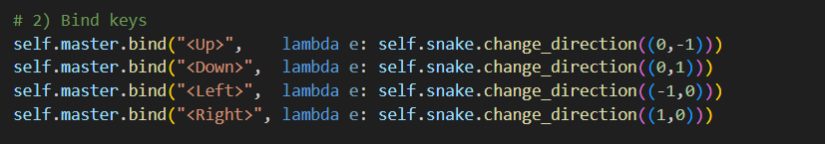

**3. Binding Arrow Keys to Direction Changes**

* **.bind(event, callback)** ties keyboard events (<Up>, <Down>, etc.) to a function.
* When the user presses an arrow key, we call snake.change_direction(...) with the corresponding vector:
  + (0,-1) → up
  + (0,1) → down
  + (-1,0) → left
  + (1,0) → right
* The change_direction method ensures no 180° turns are allowed.

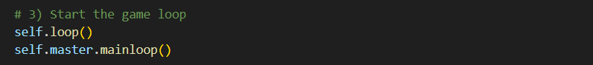

1. **self.loop()**
   * Immediately calls our custom loop() method—this is the very first “tick.”
2. **mainloop()**
   * Enters tkinter’s event loop, which processes keypresses, timers, and redraws.
   * From here on out, our loop() method is re-scheduled repeatedly via after().

**The Core Game Tick: loop()**

Every **150 ms** (or whatever self.speed is), loop() executes once. Here’s its recipe:

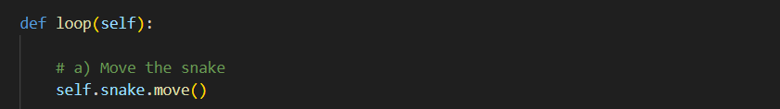

* Advances the snake’s head by one cell in its current direction.
* Inserts a new head segment, and pops the tail (unless we just ate food).

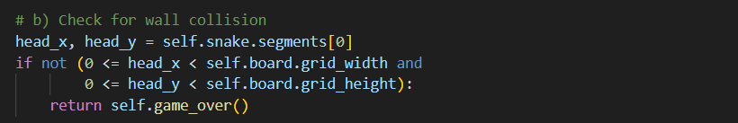

**b) Wall Collision Check**

* **Extract head coordinates** from the first segment.
* **Bounds test:**
* Must satisfy 0 ≤ head_x < grid_w AND 0 ≤ head_y < grid_h.
* **If out of bounds**, we immediately call game_over() and return—ending the loop.

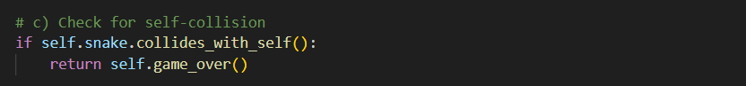

**c) Self-Collision Check**

* If the head’s position matches any other segment, collides_with_self() returns True.
* We again call game_over() and return to stop further ticks.

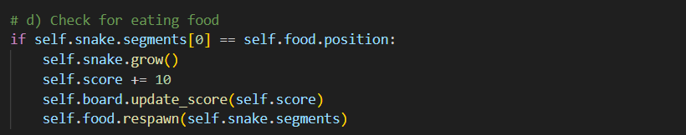

**d) Food-Eating Check**

* **Head equals food position?**
* **Grow** the snake on the next move.
* **Increment** score by 10 points.
* **Update** the on-screen score display.
* **Respawn** the food in a fresh, unoccupied cell.

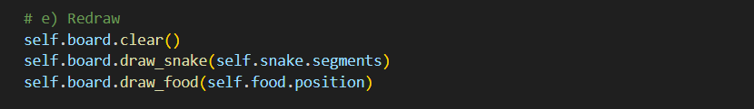

**e) Redraw Everything**

1. **Clear** old snake and food by deleting tagged canvas items.
2. **Draw** the snake’s current segments as rectangles.
3. **Draw** the food pellet as a red circle.



**f) Schedule the Next Tick**

* Instructs tkinter to **call self.loop() again after** self.speed milliseconds.
* This creates the steady heartbeat of the game.

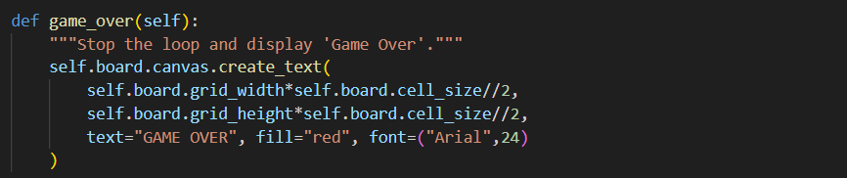

* **Stops** scheduling new loops (because we returned earlier).
* **Draws** a large “GAME OVER” message at the canvas center.
* Leaves the window open so the player sees the result.

**1. Bind the “Restart” Key in __init__**

Right after you bind the arrow keys, add:



Now when the player presses “r” (upper or lower case), it will call a new self.restart() method.

**2. Implement restart()**

Add this method to your Game class, **below** game_over():

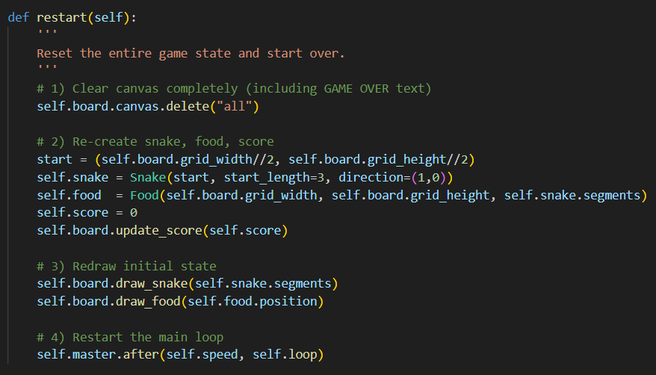

**Breakdown:**

1. **Wipe everything** off the canvas, including the “GAME OVER” text.
2. **Re‐initialize** your game objects (snake, food, score).
3. **Draw** the fresh starting position.
4. **Kick off** the loop again so the snake starts moving.

**3. Update Your Instructions**

You may want to show a prompt on screen so players know they can press R. For example, in game_over() after drawing “GAME OVER,” add:



**Closing Thoughts for Chapter 5 – Snake: Bringing It All Together**

Congratulations—you’ve just built a fully functional, GUI-driven Snake game in Python! Let’s recap the key takeaways from this chapter and see how they prepare you for even bigger projects.

1. **Modular Design**
   * **Snake** handles movement, growth, and self-collision in an isolated class.
   * **Food** encapsulates pellet placement, ensuring it never spawns on the snake.
   * **Board** manages all drawing on a tkinter.Canvas, converting grid coordinates into pixels.
   * **Game** orchestrates input, game logic, and rendering in a clean, easy-to-follow loop.
2. **Step-by-Step Logic**
   * We broke down every method—constructor, move, grow, collision checks—so you could **visualize** exactly what happens, one coordinate and one list operation at a time.
   * Our tick loop (move → collision checks → eating → redraw → schedule next tick) reads like a recipe, making it simple to extend or modify.
3. **Event-Driven Programming**
   * Binding arrow keys to direction changes showed you how to connect user input directly to your game model.
   * Using tkinter’s after() taught you how to schedule recurring tasks—essential for any real-time application.
4. **Testing in Isolation**
   * By writing focused tests for Snake and Food, you gained confidence in your core mechanics before adding the complexity of a GUI.
   * This approach—test logic first, then wire up the interface—keeps your code robust and maintainable.
5. **Smooth User Experience**
   * Clearing and redrawing only what’s necessary each frame keeps the animation flicker-free.
   * A “GAME OVER” message and optional restart key binding (R) ensure players can keep trying without restarting your program.

**Chapter 6**

**: Breakout – Bouncing Balls, Bricks & Power-Ups**

Welcome to the ultimate arcade challenge! In this chapter you’ll build a fully-featured Arkanoid-style Breakout clone. You’ll learn how to:

1. Model game objects—Paddle, Ball, and Brick—using classes.
2. Animate smooth motion with a timed loop, handling callbacks for each frame.
3. Detect collisions between ball and walls, paddle, and bricks using bounding-box logic.
4. Implement scoring, multiple levels of bricks, and power-ups (like wider paddles and multi-ball).
5. Add sound effects and music using pygame.mixer for that authentic arcade feel.

We’ll break the work into focused modules:

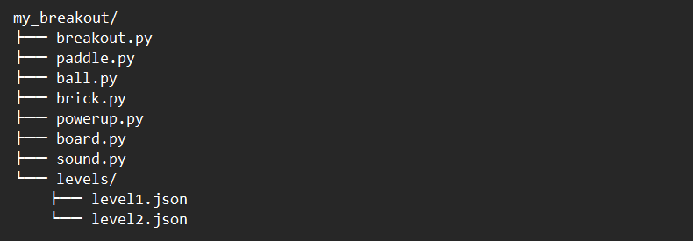

* 6.2 – Paddle class: movement, boundary checks, and drawing.
* 6.3 – Ball class: handling velocity vectors, bounce logic, and collision detection.
* 6.4 – Brick class: initialization from level data, rendering, and hit management.
* 6.5 – Sound module: loading .wav files and playing bounce/brick-break effects.
* 6.6 – breakout.py: orchestrating the game loop—moving objects, checking collisions, updating score, and transitioning levels.

**6.0 Game Mechanics Before the Code**

Before writing any lines of Python, let’s imagine Breakout’s core rules and flow:

1. **The Playing Field**
   * A rectangular board divided into pixels.
   * At the top: a wall of colored bricks in rows.
   * At the bottom: a movable paddle you control left/right.
2. **The Ball**
   * Moves at a fixed speed, bouncing off walls, paddle, and bricks.
   * If it touches the bottom edge (misses the paddle), you lose a life.
3. **Paddle Control**
   * Player moves the paddle horizontally via arrow keys or mouse.
   * Paddle reflects the ball at an angle determined by the contact point.
4. **Bricks & Levels**
   * Each brick has a “hit count” (some break in one hit, others require two).
   * Once all bricks in the current layout are destroyed, advance to the next level with a fresh brick pattern.
5. **Score & Lives**
   * Destroying a brick grants points (more for tougher bricks).
   * Missing the ball costs one life; game over when lives reach zero.
6. **Power-Ups (optional extensions)**
   * Widen Paddle: temporarily makes the paddle longer.
   * Multi-Ball: splits the ball into two or more simultaneous balls.
   * Slow Ball: reduces ball speed for a short time.

**6.1 Project Structure & Level Definitions**

We’ll start by creating a **levels/level1.json** file:

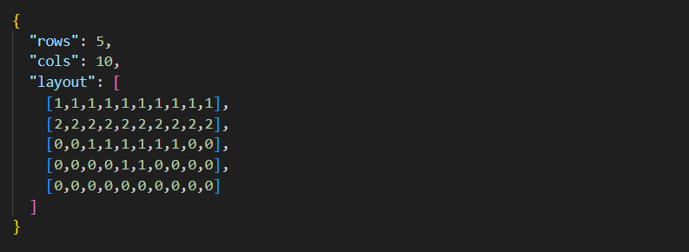

* rows/cols define the grid of bricks.
* layout uses integers to indicate brick type or empty space (0 = no brick).

With this in place, our brick.py can read the JSON and instantiate a 2D array of Brick objects, each knowing its position, color, and hit‐points.

**6.2 Building the Paddle Class – Smooth, Bounded Movement**

Before we code, let’s visualize what the paddle needs to do:

1. Appear as a horizontal bar at the bottom of the screen.
2. Move left and right in response to player input (arrow keys or mouse).
3. Stay fully inside the game area—never disappear off the edges.

We’ll encapsulate this in **paddle.py.**

**6.2.1 File: paddle.py**

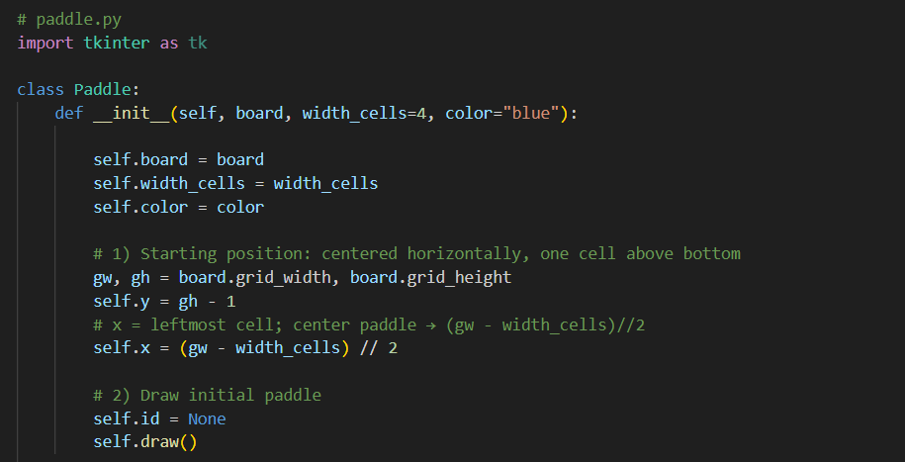

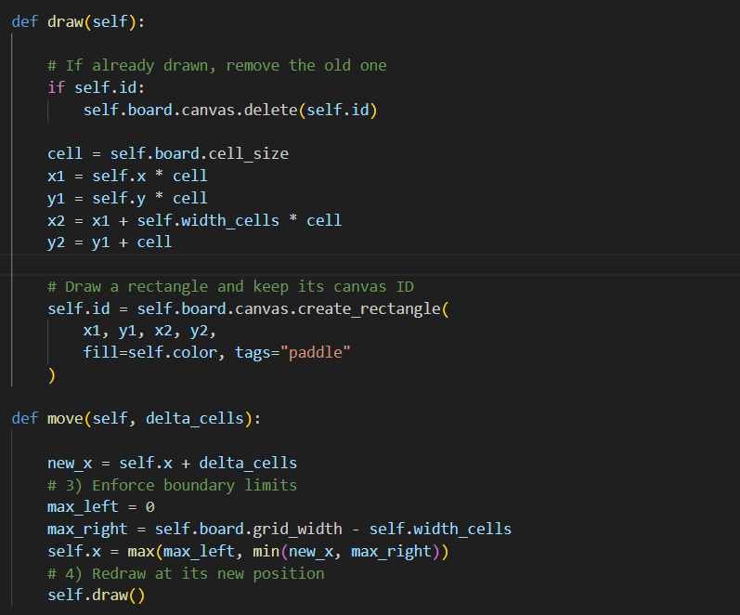

**Deep dive :**

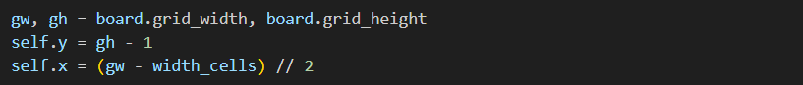

**1) Initialization (__init__)**

* gw, gh are the grid’s width and height in cells.
* self.y = gh - 1 places the paddle on the bottom row (row index starts at 0).
* self.x = (gw - width_cells)//2 centers the paddle horizontally:
* Total free horizontal cells = gw - width_cells.
* Dividing by 2 gives the leftmost x‐coordinate so the paddle sits centered.

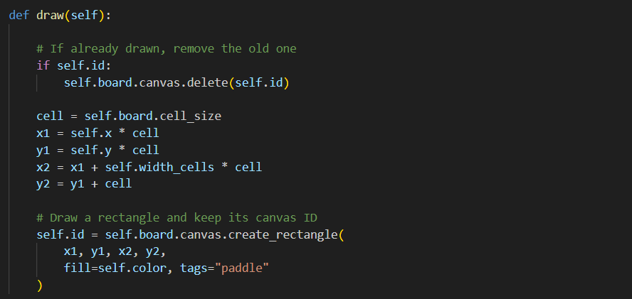

**2) Drawing (draw)**

* Erase the old paddle if it exists (using its canvas ID).
* Compute pixel corners:
* x1 = self.x * cell_size, y1 = self.y * cell_size.
* x2 = x1 + width_cells * cell_size, y2 = y1 + cell_size.
* Draw a colored rectangle and store its ID for future deletion.

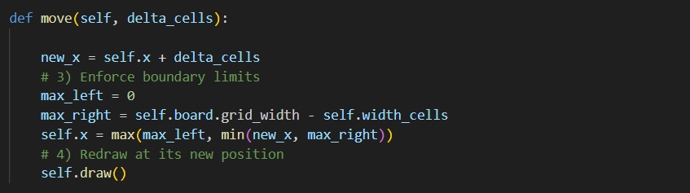

**3) Moving (move)**

* delta_cells is typically +1 (right) or −1 (left).
* Calculate new_x, then clamp it:
* Lower bound 0 → paddle’s leftmost cell can never be negative.
* Upper bound gw − width_cells → ensures the right end never goes off the board.
* Redraw the paddle in its updated position.

**Building the Ball Class – Velocity, Bouncing & Collision**

Now that our Paddle smoothly moves along the bottom, it’s time to bring the Ball to life. The ball must:

1. Travel in a straight line at a fixed speed (grid cells per tick).
2. Bounce off the left, right, and top walls.
3. Bounce off the paddle, reversing its vertical direction and possibly changing its horizontal component.
4. Hit bricks—destroying or weakening them—and bounce off.
5. Detect missing the paddle (touching the bottom)—losing a life.

We’ll encapsulate this in ball.py with a Ball class. Let’s walk through every piece.

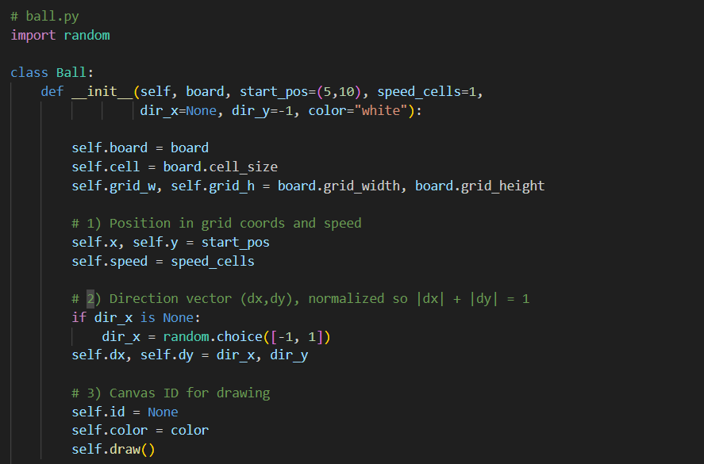

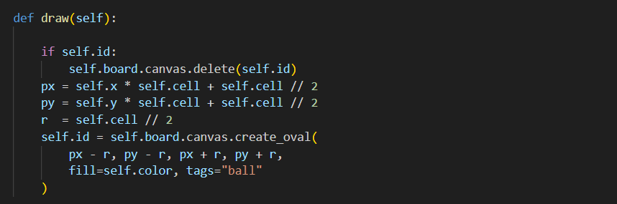

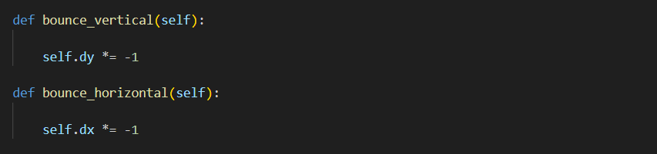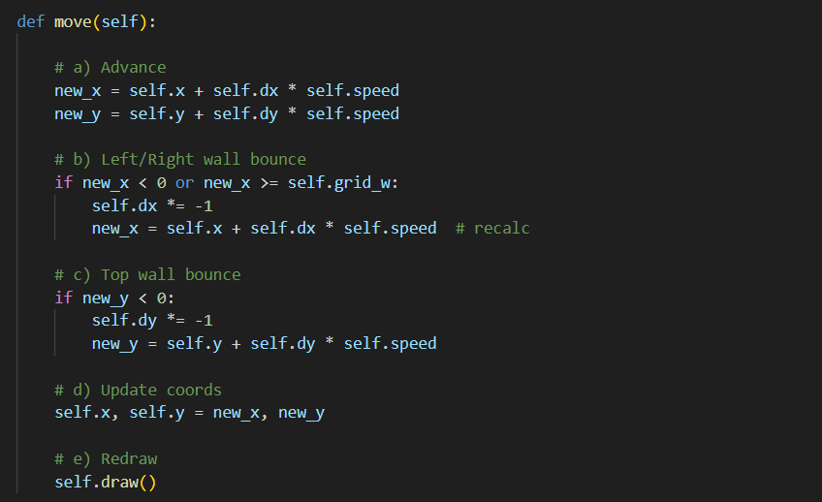

**Deev dive :**

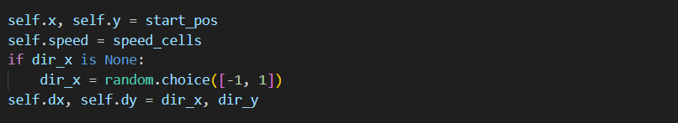

**1) Initialization (__init__)**

**Set the ball’s starting cell**

* start_pos is a tuple like (5, 10).
* By doing self.x, self.y = start_pos, we store those grid coordinates directly.
* Now the ball “lives” in cell column 5, row 10.

**2.Decide how fast it moves**

* speed_cells tells us “how many grid cells per tick.”
* In most Breakout clones, the ball moves exactly one cell each frame, so we set self.speed = 1.

**3. Pick an initial horizontal direction**

* dx controls left/right movement. dy controls up/down.
* If the caller passed dir_x=None, we randomly choose left (-1) or right (+1) so each new ball starts at a slightly different angle.
* We always start moving upward, so dir_y is typically -1.

**4. Store the direction vector**

* self.dx, self.dy = dir_x, dir_y bundles those two numbers into a coherent “direction” the ball will follow every tick.

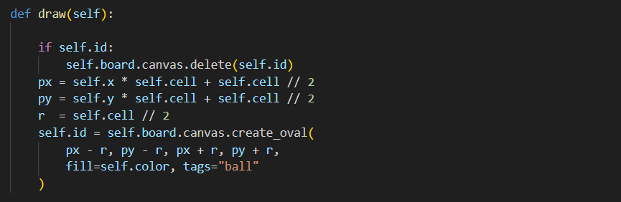

**2) Drawing (draw)**

**Erase previous frame’s circle**

* If self.id holds an old shape’s ID, delete(self.id) removes it so the canvas stays clean.

**Translate grid→pixels**

* Each cell is, say, 20 pixels wide (cell_size = 20).
* The ball’s center in pixels is (self.x * 20 + 10, self.y * 20 + 10)—that’s why we add cell//2.

**Choose a radius**

* r = cell // 2 makes the ball exactly as tall as one cell, so it “fits” perfectly.

**Draw new circle**

* create_oval(px-r, py-r, px+r, py+r) paints the ball.
* Storing its returned ID in self.id lets us erase it next frame**.**

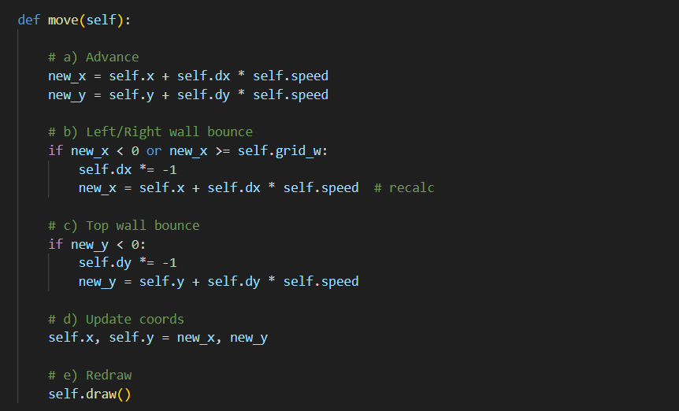

**3) Moving Each Tick (move)**



**Advance by one step**

* dx = +1 means one cell to the right; dx = -1 means left.
* dy = -1 means one cell up; dy = +1 means down (after a bounce or serve).

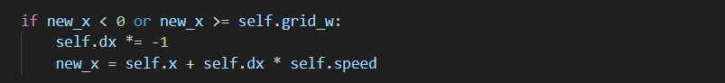

* Left edge? new_x < 0
* Right edge? new_x >= grid_w
* Flip dx so the ball “bounces” off the side wall.
* Recalculate new_x to ensure the ball stays inside.

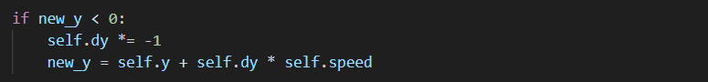

**3b) Top Wall Bounce**

* If the ball tries to go above row 0, invert dy so it bounces down one cell.

**3c) Bottom Edge (Missed Paddle)**

* There’s no code here for new_y >= grid_h.
* Handling a missed paddle (ball falling off bottom) happens in your main loop as a life lost, not a bounce.



**4) Commit & Redraw**

* Store the confirmed new coordinates.
* Erase & paint the ball at its new cell.

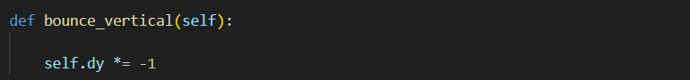

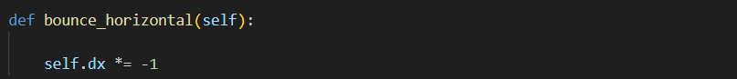

**5) Bouncing on Paddle & Bricks**

* bounce_vertical() → self.dy *= -1  
  Call this when the ball hits a flat surface (top of paddle or brick bottom) to send it back the opposite vertical way.
* bounce_horizontal() → self.dx *= -1  
  Use this for side‐hits on tall bricks to reverse horizontal travel.

**Building the Brick Class – Initialization, Rendering & Hit Management**

With our Paddle and Ball in place, it’s time to give the ball something to break: Bricks. Each brick must:

1. Know its position in the grid.
2. Know how many hits it takes before disappearing (1 for a simple brick, 2 or 3 for stronger ones).
3. Draw itself in a distinct color or style based on its remaining hits.
4. Detect when the ball strikes it, reduce its hit count, and signal its removal when hits reach zero.

We’ll encapsulate all this in brick.py. Below is the complete Brick class followed by a step-by-step “deep dive” of every method and line of logic.

**6.4.1 File: brick.py**

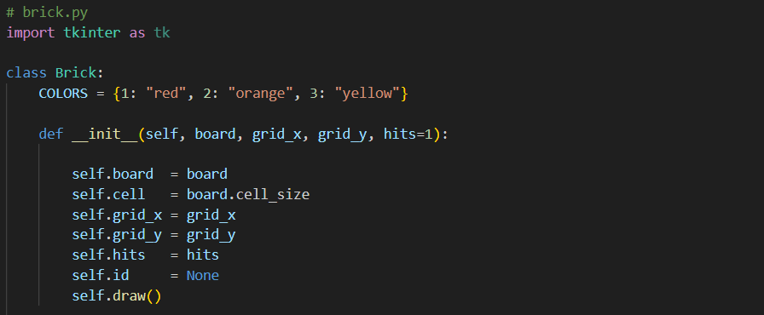

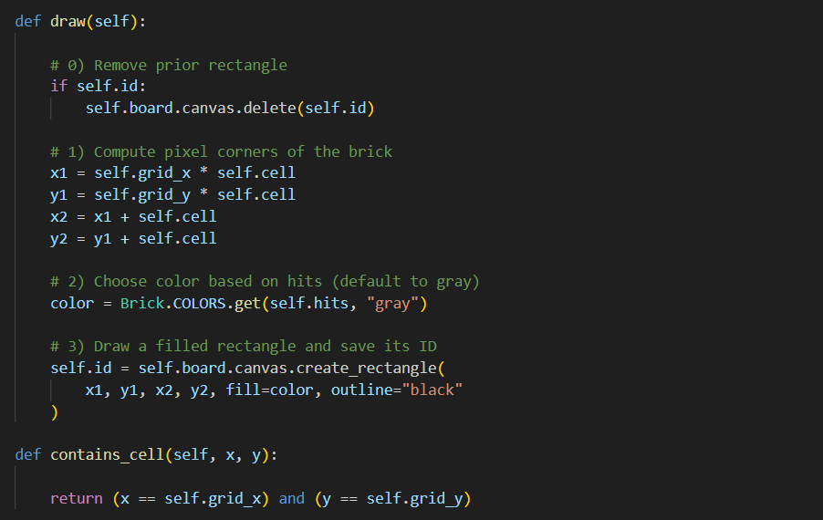

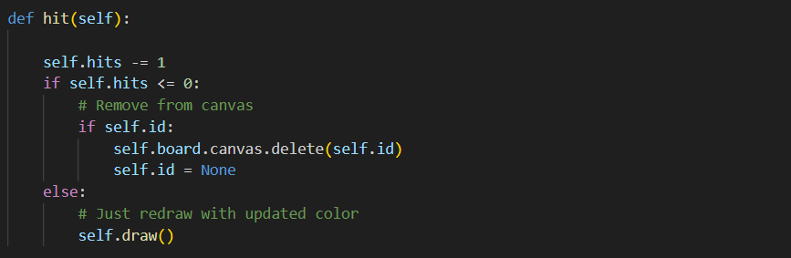

**6.4.2 Deep Dive:**

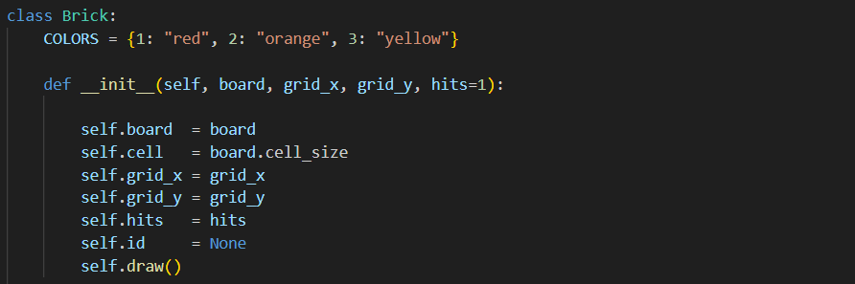

**1. Store the Board Reference**You hand the brick a board object. That object holds:

* A canvas where shapes are drawn
* A cell_size, the number of pixels in each grid square  
  By tucking board away, our brick knows where to draw and how big each cell is.

**2. Remember cell_size**  
We copy board.cell_size into self.cell. Now self.cell is our “magic multiplier” to convert grid units into pixels.

**3. Record Grid Coordinates**You pass in grid_x and grid_y—the brick’s column and row on the game grid. These tiny integers (like 3,2) tell the brick its precise “address.”

**4. Set Hit Count**self.hits starts at the number of strikes this brick can take. A 1-hit brick is easy; a 3-hit brick is tougher.

**5. Initialize Canvas ID**self.id = None means “I haven’t drawn anything yet.” Later, when we paint the rectangle, we’ll store its ID so we can erase it cleanly.

**6. Draw Immediately**Finally, calling self.draw() makes the brick appear on-screen right away—no delays, no extra steps.

💡💡💡 **You Should know:** **Pixel conversion using cell_size**

**Grid vs. Pixel**Your game world runs on a grid—cells labeled (0,0), (1,0), (2,0)….  
Your screen uses pixels—tiny dots in X/Y coordinates.  
cell_size (from board.cell_size) tells us how many pixels make one grid cell.

**Drawing a Brick at (3,2)**

Grid coordinates (self.x, self.y)

* Think of your game world as a checkerboard: columns 0,1,2… and rows 0,1,2…
* A brick at (3,2) lives in the 4th column, 3rd row of that invisible grid.
* The computer screen draws in pixels, not grid cells.
* If each cell is cell_size = 20 pixels wide/tall, then:
  + Left edge of the brick = grid_x * cell_size = 3 × 20 = 60 px
  + Right edge = left + cell_size = 60 + 20 = 80 px
  + Top edge = grid_y * cell_size = 2 × 20 = 40 px
  + Bottom edge = top + cell_size = 40 + 20 = 60 px

So the brick’s rectangle is (60, 40) to (80, 60) in pixel coordinates—exactly filling the 4th column and 3rd row on screen.

**💡💡💡------------------------------------------------------------------------------------------💡💡💡**

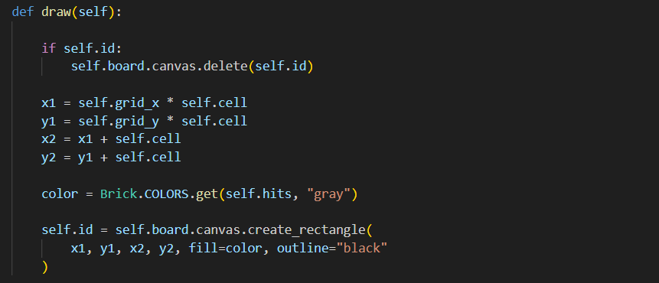

**2. Drawing (draw())**

Each time the brick appears or updates its look, it runs through these substeps:

1. **Erase Old Shape (if any)**  
   If self.id isn’t None, we previously drew a rectangle. We call canvas.delete(self.id) to remove it—like wiping a whiteboard clean—preventing leftover outlines or ghost bricks.
2. **Compute Pixel Corners**
   * Left edge = grid_x × cell_size
   * Top edge = grid_y × cell_size
   * Right edge = left edge + cell_size
   * Bottom edge = top edge + cell_size  
     Picture a grid cell as a 20×20 pixel square: if grid_x=3 and cell_size=20, the left edge is at pixel 60; the right at 80.
3. **Pick the Color**  
   We look up self.hits in our COLORS map: 1→red, 2→orange, 3→yellow. If somehow we get more hits than keys, we default to gray.
4. **Draw Rectangle & Save Its ID**  
   We call create_rectangle(x1, y1, x2, y2, fill=color, outline="black").  
   That returns a unique integer ID—think of it like a name tag for that specific rectangle. Storing it in self.id lets us delete or redraw in the future.

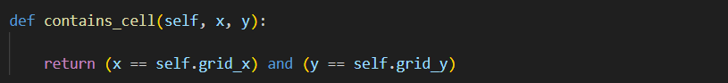

**3. Checking for Collision (contains_cell(x, y))**

Imagine the ball moving cell by cell. To see if it smashed a brick:

1. **Compare Grid Positions**Because each brick occupies exactly one grid cell, we simply check:

**return (x == self.grid_x) and (y == self.grid_y)**

**2. True Means Hit** The moment the ball’s grid coordinates match the brick’s, you know the ball has

entered that cell and therefore collided with the brick.

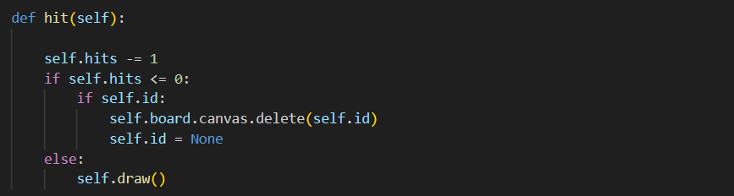

**4. Responding to a Hit (hit())**

When a collision occurs, you call brick.hit(), which does:

1. **Decrease Durability**self.hits -= 1 subtracts one strike from the brick.
2. **Check if Gone**
   * If self.hits <= 0:
     + The brick is destroyed.
     + If self.id exists, we call canvas.delete(self.id), wiping it off the screen.
     + We set self.id = None to mark it as gone forever.
   * Else (still has hits remaining):
     + We call self.draw() again—this time the color lookup sees a lower hit count, so the rectangle repaints in a “weaker” color.

**Putting It All Together**

1. Create Brick → Immediately paints itself at (grid_x, grid_y).
2. Ball Moves → your loop checks if brick.contains_cell(ball_x, ball_y).
3. Call brick.hit() → durability drops, and the brick either changes color or vanishes.
4. Ball Bounces → your ball code reverses its vertical direction.

**6.5 Adding Sound Effects – The sound.py Module**

Up until now, your Breakout clone looks and plays like the arcade—but it’s still eerily silent! In this section, we’ll introduce sound effects for paddle bounces, brick hits, and level-complete jingles, giving your game that authentic “*ka-ching*” and “*boing*” feel.

**6.5.1 File: sound.py**

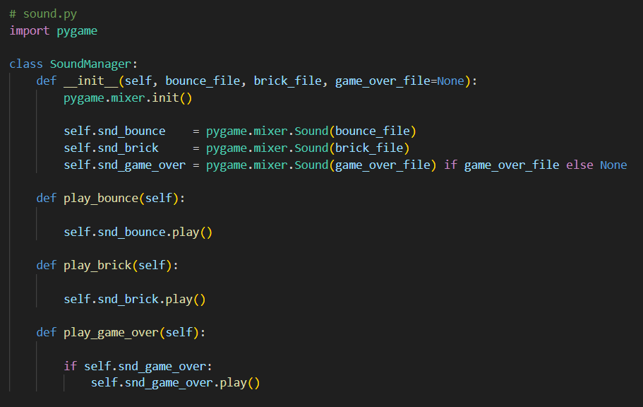

**Deep Dive:**



**Initializing the Mixer**

Think of the mixer as your game’s audio engine.

* Calling init() configures your sound card and prepares everything for playback.
* You do this once at startup; subsequent sounds will share this mixer.

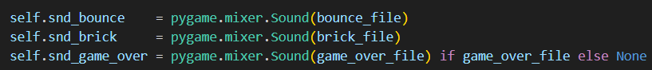

**Loading Sound Files**

* pygame.mixer.Sound(path) loads the WAV into memory.
* Holding each Sound object in memory means instant playback when you call .play().
* Optionally load a game-over tune if you pass its filename.

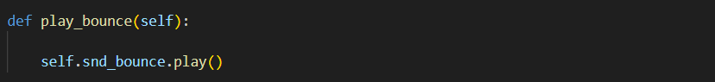

**Playing Sounds**

* .play() immediately starts the clip, mixing it over any currently playing audio.
* No blocking or delays—your game loop continues seamlessly.

**Introducing board.py – Your Game’s Canvas and Score Display**

Before any bricks, balls, or paddles appear on screen, we need a **Board** module that:

1. **Creates the drawing surface** in the window, sized exactly to our grid of cells.
2. **Converts grid coordinates into pixel positions**, so every game object can place itself neatly in the right cell.
3. **Manages the score & lives display**, updating it efficiently each frame without redrawing from scratch.
4. **Clears and refreshes** the play area each tick, so only the current game state is visible—no “ghost” trails.

In short, **Board** is the bridge between your game logic (cells, rows, columns) and what the player actually sees (pixels, canvas items, text).

**board.py**

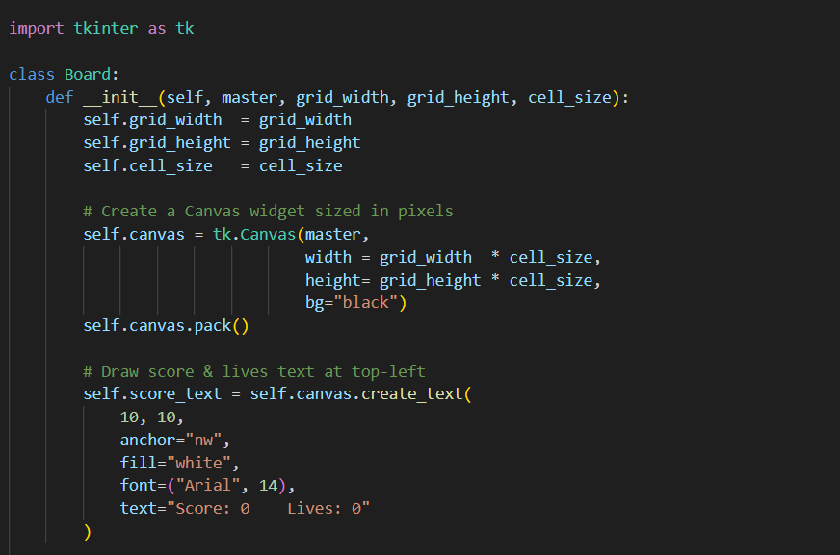

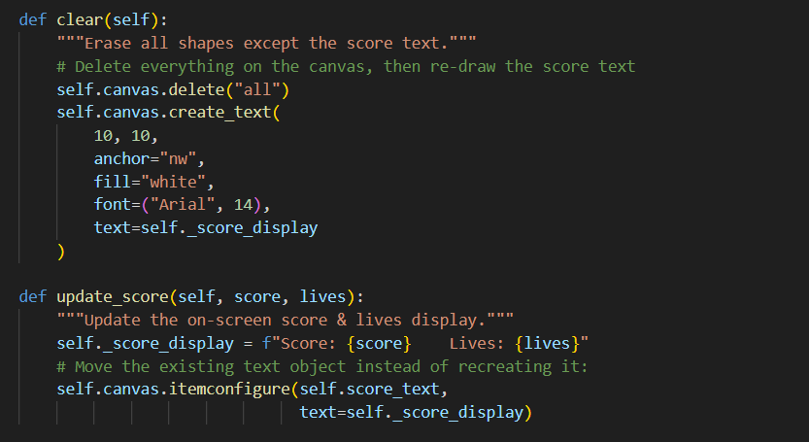

**Deep dive:**

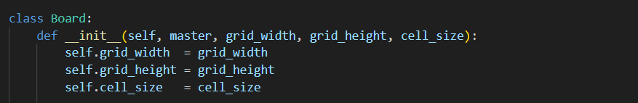

**Storing the Grid Dimensions**  
We begin by remembering three key numbers:

* **grid_width** (how many cells across),
* **grid_height** (how many cells down), and
* **cell_size** (how many pixels each cell measures).  
  These three together let us convert any grid coordinate (like cell (3,5)) into exact pixel positions later on.

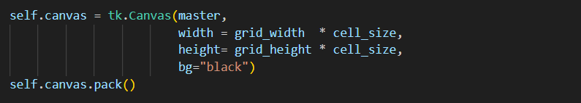

**Building the Drawing Surface**

* We ask Tkinter for a **Canvas** whose pixel width is grid_width × cell_size and whose pixel height is grid_height × cell_size.
* For example, a 20×30 grid of 20-pixel cells becomes a 400×600-pixel black window.
* Packing it onto master makes it visible.

Now any shape we draw on self.canvas will align one-to-one with our invisible grid.

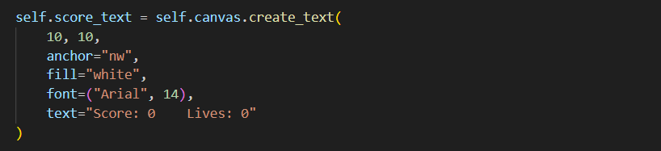

**Placing the Score Display**

* At pixel (10,10)—a little margin down and right from the top-left corner—we place a white text item.
* anchor="nw" means that the text’s **n**orth-**w**est corner sits exactly at (10,10).
* We store the returned ID in self.score_text so we can change its content later without deleting and recreating it.

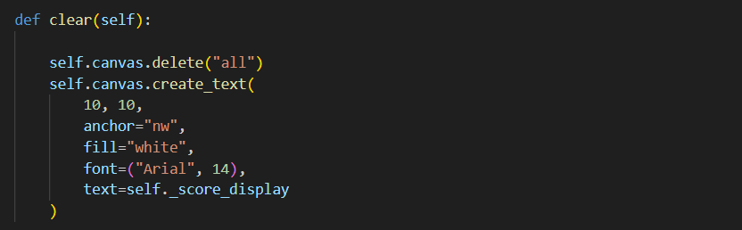

**Wiping the Playfield**

* Each game frame, before drawing bricks, ball, and paddle, we call clear().
* self.canvas.delete("all") removes every shape and text on the canvas.
* We then recreate the score text in the exact same spot, using self._score_display (which was set by update_score).
* This gives us a clean slate for all moving objects, while preserving the latest “Score / Lives” display.

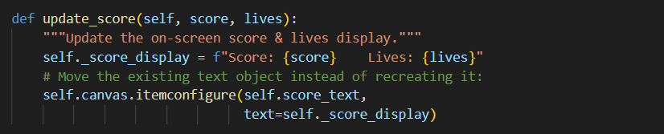

1. **Keeping Score & Lives Up to Date**
   * Whenever the player breaks a brick or loses a life, breakout.py calls board.update_score(...).
   * We build a string like "Score: 42 Lives: 3" and stash it in self._score_display.
   * Then we call itemconfigure on the original self.score_text object—changing its displayed text in place, without flicker or repositioning.

**6.6 breakout.py – The Orchestrator: Putting It All Together**

Now that you’ve built Board, Paddle, Ball, Brick (and even SoundManager), it’s time to write the “director” of the show: the Breakout class in breakout.py. This module ties everything together into a running game: it creates the window, loads levels, instantiates each object, and then runs a repeating “tick” loop that moves elements, checks collisions, redraws, and schedules the next frame.

**1) The Audio Helper: SoundManager**

Before the game starts, we want sound effects for bounces, brick breaks, and game-over. Rather than sprinkling raw pygame.mixer.Sound calls everywhere, we wrap them:

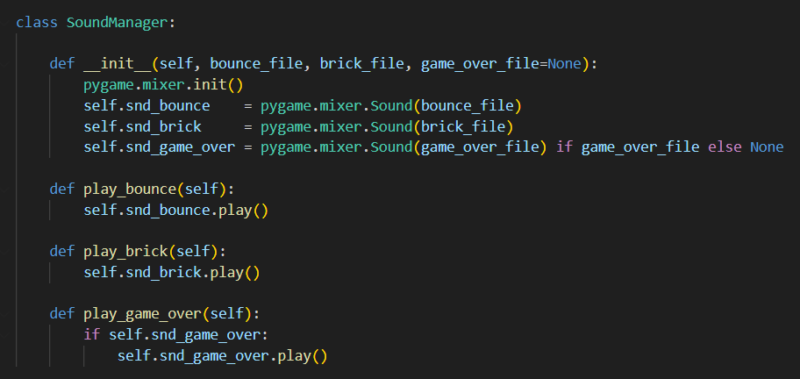

**1) Waking Up the Audio Engine and Loading Files**

1. pygame.mixer.init()
   * Like flipping the “on” switch in a radio booth, this wakes up the mixer subsystem: it allocates channels, sets up audio buffers, and primes the decoder so everything’s ready to go.
2. self.snd_bounce = pygame.mixer.Sound(bounce_file)
   * Imagine dropping a tiny cartridge of that “bounce” WAV file straight into memory. Now you’ve got a preloaded object—no file reads or decoding later, just instant playback.
3. self.snd_brick = pygame.mixer.Sound(brick_file)
   * The brick‐break clip joins the in‐memory library, ready to trigger at the exact millisecond the ball shatters a block.
4. Optional game‐over
   * If you supplied a game_over_file, it too is preloaded. Otherwise, self.snd_game_over stays None and the class simply skips any final jingle—no checks sprinkled through your game code.

By the end of __init__, every effect you need lives in RAM, and the mixer stands by to play them with zero latency.

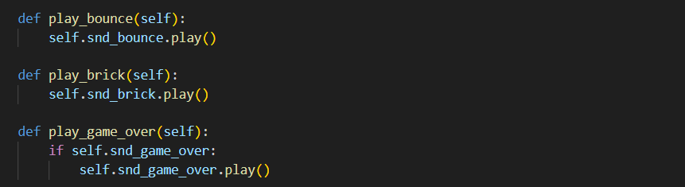

**2) Speaking Sound with Simple Commands**

Imagine your game loop as a conductor’s score. Instead of fumbling with low‐level mixer calls, you now have three crystal‐clear cues:

* play_bounce()  
  You call this the moment the ball smacks the paddle or wall. Behind the scenes, pygame grabs an open channel, streams the bounce sample, and mixes it with whatever else is playing.
* play_brick()  
  Trigger it the instant a brick gives way. No delays—because the sound sits in memory, it erupts the instant you hit .play().
* play_game_over()  
  When lives hit zero, you issue this cue. If you didn’t load a game‐over clip, the if check quietly skips it—no errors, no fuss.

Each method is a single line, yet together they form your game’s entire audio vocabulary. When your loop reads sound_mgr.play_brick(), it’s as intuitive as reading sheet music: “Here, play the brick‐break sound.”

**2) Setting Up the Window & Game State (__init__)**

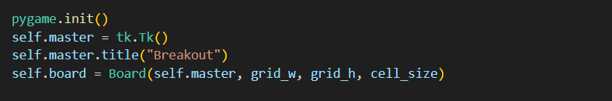

**1) Setting Up the Window and Canvas**

* **What happens:**
* pygame.init() wakes up the entire Pygame system (needed for audio).
* tk.Tk() creates the main window.
* We give that window the title “Breakout.”
* Board(...) builds a drawing surface sized to grid_w × grid_h cells, each cell_size pixels, and packs it into self.master.
* **Imagine:**  
  First, you flip the switches in both the audio booth and the display room. An empty game window pops up, sized exactly to hold your grid of cells—ready for paddle, ball, and bricks.

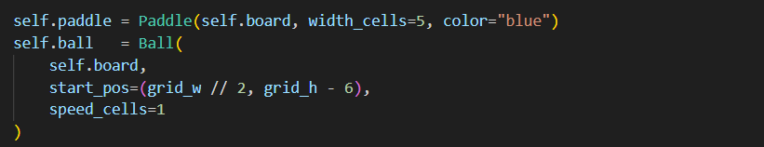

**2) Placing the Paddle and Ball**

* **What happens:**
* The Paddle is created on self.board, 5 cells wide and colored blue; it automatically draws itself at the bottom row.
* The Ball is placed above the paddle (centered horizontally at grid_w//2, 6 cells up from the bottom) moving at one cell per tick.
* **Imagine:**  
  The paddle slides into view like a landing platform at the bottom of your canvas. The ball appears just above it, ready to launch—every object knows its grid address and cell size, so it lands pixel-perfect.

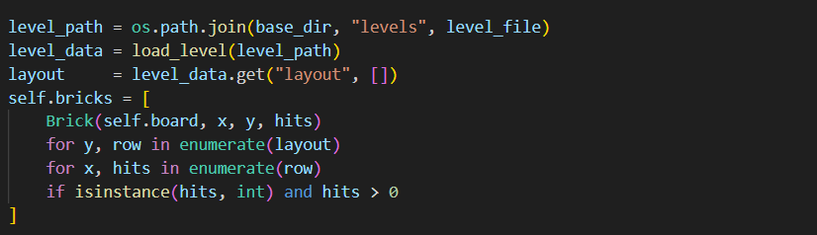

**3) Loading and Laying Out Bricks**

* **What happens:**
* We compute the JSON file’s full path, read it via load_level(), and grab its "layout" array.
* We walk each row (y) and column (x), and whenever a cell contains a positive integer hits, we instantiate a Brick at (x, y) with that durability.
* **Imagine:**Your level designer’s blueprint (a grid of numbers) unfolds into real bricks stacked at the top of the screen. Each brick immediately draws itself in the color matching its hit-count.

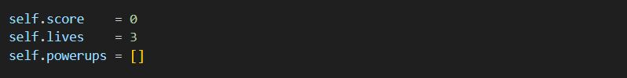

**4) Tracking Game State**

* **What happens:**
  + We start with 0 points, 3 lives, and an empty list of power-ups (to be used later).
* **Imagine:**A digital scoreboard and life counter reset to their starting values, ready to tick upward or downward as the game unfolds—and a slot for bonus tools stands empty, waiting for special brick drops.

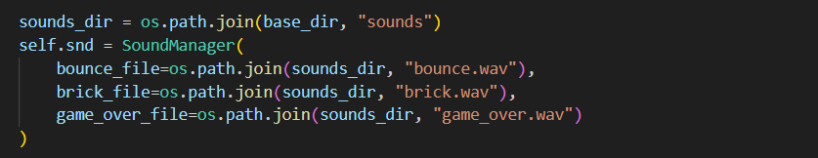

**5) Preparing Sound Effects**

* **What happens:**
* We point SoundManager at the correct folder and files, creating one central object that preloads every effect you’ll need.
* **Imagine:**All the “plink,” “crunch,” and “sad trombone” samples load into memory before the first bounce, ensuring every audio cue sounds crisp and on-time.



**6) Binding Player Controls**

* **What happens:**
* Pressing the left or right arrow keys calls self.paddle.move(-1) or (1), shifting your paddle one cell left or right.
* **Imagine:**As soon as the window appears, your arrow keys become levers you pull to slide the paddle left or right—no extra code needed each frame.

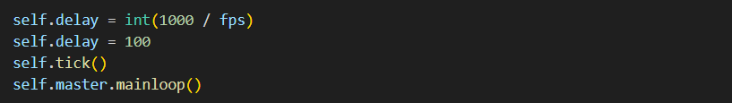

**7) Kicking Off the Main Loop**

* We compute self.delay (milliseconds per frame) based on fps, then hard-set it to 100 ms (~10 FPS) for this demo.
* Calling self.tick() starts the recurring game function that moves everything and checks collisions.
* Finally, mainloop() hands control over to Tkinter’s event system, keeping the window responsive and driving our tick() calls via after().
* **Imagine:**You load a film reel into the projector, hit “Play,” and every 100 ms a new frame springs to life—ball moves, paddle slides, bricks vanish, and sounds ring out—until the game ends.

**The tick() Method – One Frame of Gameplay**

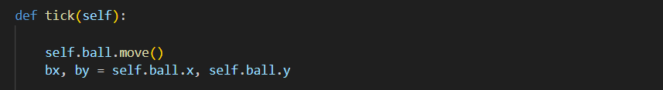Every 100 ms, tick() advances the game by one frame. Let’s step through its seven logical stages so readers can clearly imagine the ball bouncing, collisions firing, and screen refreshing.

* **What happens:**
* The ball updates its (x,y) cell based on its current direction.
* We then grab those new coordinates in bx, by for collision checks.
* **Imagine:**The ball glides silently one cell over or up/down—its new position ready for all the rules that follow.

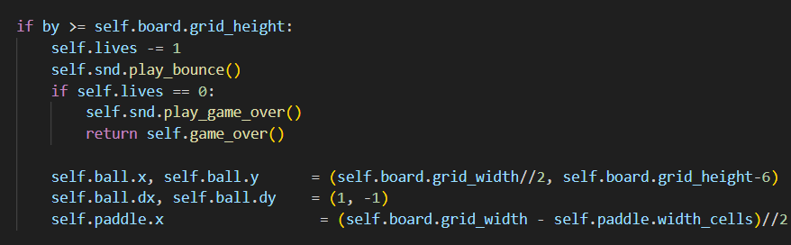

**2) Check Bottom Edge (Life Lost or Game Over)**

* **What happens:**
* If the ball’s row by reaches or exceeds the bottom, the player loses a life.
* Play the bounce sound even on a miss.
* If lives hit zero, trigger game-over logic and exit tick().
* Otherwise, reset the ball to the starting cell above the paddle, point it upward right, and re-center the paddle.
* **Imagine:**The ball falls off-screen, a “plop” sound plays, and either your life count drops or the game ends. If you still have lives, everything snaps back to the starting formation.



**3) Wall Bounces**

* **What happens:**
* If the ball hits the left or right wall (column 0 or last column) or the top row (by == 0), play the bounce sound.
* The ball’s own move() method already inverted its direction when it detected a wall.
* **Imagine:**You hear the “plink” as the ball ricochets off the side or the ceiling, the same sharp noise whether it’s steel or brick.

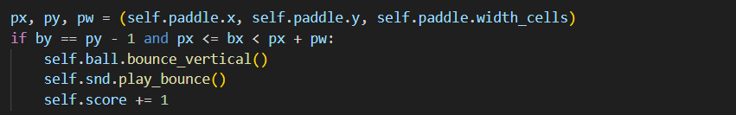

**4) Paddle Bounce**

* **What happens:**
  + We check if the ball’s row by sits just above the paddle’s row py - 1, and if its column bx lies within the paddle’s span (px to px + pw - 1).
  + If so, we flip the ball’s vertical direction, play the bounce, and award one point.
* **Imagine:**You angle the paddle under the ball, see it reverse course instantly, and a tiny “plink” and +1 on your score confirm the perfect deflection.

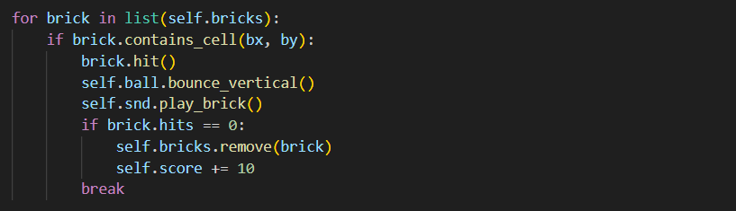

**5) Brick Collisions**

* **What happens:**
* We loop through every brick (using a copy of the list so we can safely remove).
* If the ball’s (bx, by) matches a brick’s cell, we call brick.hit(), flip vertical direction, and play the brick‐break sound.
* If the brick’s hits drop to 0, we remove it from the list and grant 10 points.
* We then break to ensure only one brick is processed per frame.
* **Imagine:**The ball strikes a block—your code immediately weakens or erases that block, the ball bounces off correctly, a satisfying “crunch” plays, and your score jumps.

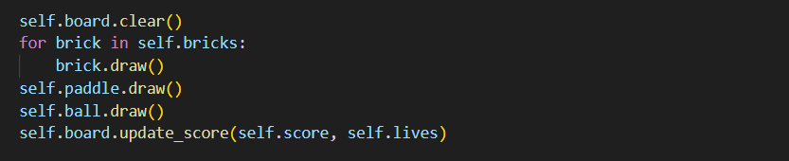

**6) Redraw All Game Elements**

* **What happens:**
* board.clear() erases all dynamic items (paddle, ball, bricks).
* We redraw every remaining brick, then the paddle, then the ball, so the screen matches the current game state.
* Finally, we update the on-screen score and life counter.
* **Imagine:**It’s as if someone lifted an eraser across the glass, then traced each brick, paddle, and ball back into place—plus the scoreboard refreshes instantly.



**7) Schedule the Next Frame**

* **What happens:**

We ask Tkinter to call tick() again after self.delay milliseconds (100 ms).

* **Imagine:**The projector advances to the next film frame, and the cycle repeats—move, collide, redraw, sound—creating smooth, continuous gameplay until the player exits.

**4) Ending the Game: game_over()**

When the player’s lives drop to zero, we want a clear, dramatic finale: the words “GAME OVER” splashed across the center of the screen in big red letters—and then everything stops. Here’s how game_over() does that:

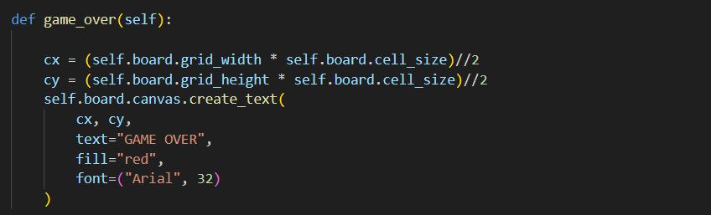

**4) Ending the Game: game_over()**

When the player’s lives drop to zero, we want a clear, dramatic finale: the words “GAME OVER” splashed across the center of the screen in big red letters—and then everything stops. Here’s how game_over() does that:

* **Finding the Center**
* We multiply the number of columns by cell_size to get the total pixel width, then divide by 2 for the horizontal center (cx).
* Likewise, we multiply the number of rows by cell_size for the total height, then halve it for the vertical center (cy).
* Imagine: Calculating the exact midpoint so the “GAME OVER” text isn’t off to one side.
* **Painting the Finale**
* We ask the board’s Canvas to place the text "GAME OVER" at (cx, cy).
* The text is filled in bright red and sized at 32-point Arial—large enough to grab the player’s attention.
* Imagine: A flashing “GAME OVER” sign under a spotlight at center stage.
* **Halting the Loop**
* Unlike tick(), game_over() does not queue another after() callback.
* Result: The game loop ends here—no more ball moves, no more redraws, no more sounds.

**Final Thoughts on Chapter 6**

**Congratulations—you’ve just built a fully featured, Arkanoid-style Breakout clone from the ground up! Along the way you:**

* Modeled every on-screen object as a self-contained class (Paddle, Ball, Brick, even SoundManager), mastering the art of clear responsibilities and easy testing.
* Bridged the gap between your game’s logical grid and the pixel world of Tkinter via the Board class, ensuring that every x,y cell maps cleanly to the correct screen coordinates.
* Implemented smooth, frame-based animation with a concise “tick → move → collide → draw → reschedule” loop, the backbone of nearly every real-time game.
* Handled collision detection with simple bounding-box and cell-matching logic for walls, paddle, and bricks—showing that even classic arcade physics can be coded in a few lines.
* Enhanced the experience with sound effects (pygame.mixer), giving each bounce and brick-break an audible “pop,” and a satisfying game-over jingle when the last life runs out.

**What’s next?**

* New Levels: tweak your levels/level2.json to create harder brick layouts—or write a level-editor.
* Power-Ups: add more drops (multi-ball, slow-ball, sticky paddle) by extending the PowerUp class and integrating them into your loop.
* Visual Polish: swap out your simple rectangles and ovals for images or sprites, and add background music.
* Performance: port the loop to Pygame proper for hardware-accelerated rendering and richer input methods.

By breaking the problem into focused modules and chaining them together with a clean main loop, you’ve laid a rock-solid foundation—one you can now expand, refactor, or redesign into any brick-busting masterpiece you can imagine. Onward to Chapter 7!

**Chapter 7**

**: Space Invaders – Swarms, Shooting & Game State**

In this chapter, you’ll recreate the timeless arcade classic Space Invaders. You’ll learn how to:

1. Model moving swarms of enemies and the player ship as classes.
2. Animate multiple object types (invaders, bullets, barriers) in lock-step with a game loop.
3. Handle collisions between bullets and enemies/barriers, and between enemy bombs and the player.
4. Manage game state: lives, score, levels, and end-game victory or defeat.
5. Add polish: explosions, simple sound effects, and a clean “start → play → game over” flow.

**We’ll split our work into focused modules:**

* 7.2 – Player class: ship movement, firing bullets, boundary checks.
* 7.3 – Invader & InvaderSwarm classes: grid of enemies, edge-bounce & descent logic.
* 7.4 – Bullet & Bomb classes: projectiles for player and invaders, movement & lifespan.
* 7.5 – Barrier class: destructible cover that absorbs shots.
* 7.6 – effects.py: explosion animation and simple sound wrappers.
* 7.7 – space_invaders.py: main orchestrator—spawning, input, collision checks, score/lives, and level progression.

**7.0 Game Mechanics Before the Code**

Let’s shoot down the rules in plain English before typing a single line:

1. **Player Ship**
   * At the bottom of the screen, the player controls a ship that moves left/right and fires bullets upward.
   * The ship has a limited number of lives (usually 3).
2. **Invader Swarm**
   * Enemies are arranged in a grid (“swarm”) at the top.
   * They march horizontally; upon hitting a screen edge, they descend one row and reverse direction.
   * At random intervals, invaders drop bombs downward.
3. **Barriers**
   * Between ship and invaders are destructible “barriers” (chunks of cover) that absorb up to a few hits before disappearing.
4. **Projectiles**
   * Player bullets travel up; if they collide with an invader or barrier, they destroy/remove it.
   * Invader bombs travel down; if they hit the ship or a barrier, they cause damage.
5. **Scoring & Levels**
   * Each invader is worth points (e.g. 10, 20, 30).
   * Clearing all invaders advances to the next, faster wave.
   * Losing all lives ends the game (“Game Over”).
   * Victory (bonus) if you reach a certain score or survive a fixed number of waves.
6. **Flow Recap**
   * Initialize player, swarm, barriers, score/lives.
   * Enter game loop:
     + Read player input (move, fire).
     + Move bullets and bombs.
     + Advance swarm as a group.
     + Check collisions (bullet-invader, bullet-barrier, bomb-ship, bomb-barrier).
     + Update score/lives, remove destroyed objects.
     + Redraw everything.
     + Handle level-complete or game-over.

**Here’s a suggested layout for your Chapter 7: Space Invaders project. Keep each file focused on a single responsibility so that your code stays clean and testable.**

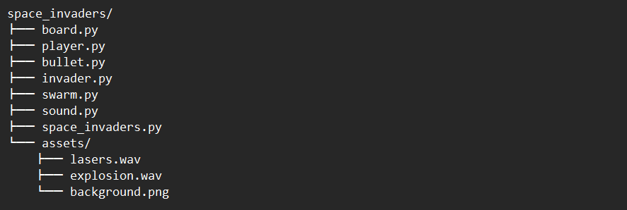

* **board.py**  
  Sets up the Tkinter Canvas, handles clearing/redrawing each frame, and displays score & lives.
* **player.py**  
  Defines Player (we just dove into this): ship movement, firing bullets, and drawing the triangular ship.
* **bullet.py**  
  A simple Bullet class that advances each tick, erases itself off-screen or on collision, and draws as a small circle or line.
* **invader.py**  
  Models a single alien: knows its grid coordinates, how to draw itself, and what happens when it’s shot.
* **swarm.py**  
  Keeps a list of all Invader objects in formation, moves them left/right/down as a group, and checks when they reach the player.
* **sound.py**  
  Wraps pygame.mixer.Sound for laser shots, explosions, and game-over jingles—just like your Breakout SoundManager.
* **space_invaders.py**  
  Orchestrates everything: initializes Board, Player, Swarm, binds keys (←/→/space), and schedules a tick() that

1. moves bullets & invaders
2. checks collisions (bullets vs. aliens, aliens vs. bottom)
3. redraws all objects
4. updates score & lives
5. reschedules itself via after().

* **assets/**  
  A place to stash any external files: sound clips, JSON layouts, or sprite images.

**7.2 Building the Player Ship – Movement, Firing & Boundaries**

Our Player class owns the ship at the bottom of the screen. It must:

1. Move left and right in response to key presses, but never leave the play area.
2. Fire bullets upward, handing them off to a shared list that the main loop will update.
3. Draw itself as a simple triangular “ship” in the correct grid cell.

Below is a complete player.py module, followed by a deep‐dive into each method and the logic that powers it.

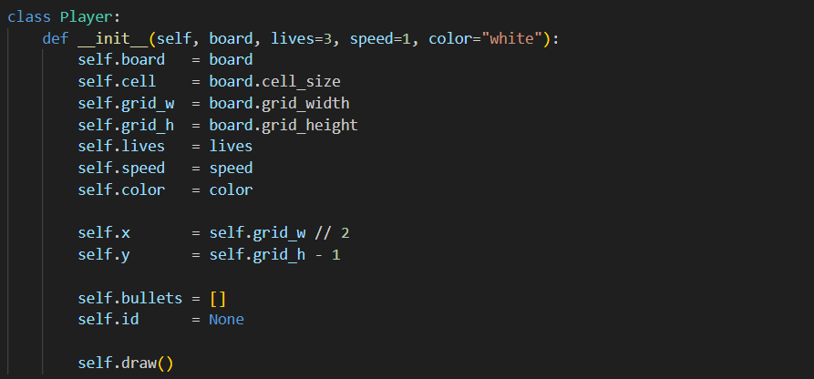

**1) Initialization: Building the Ship**

* Grabs references to the Board (for canvas and sizes), stores grid dimensions, initial lives, move speed, and ship color.
* Positions the ship in the middle of the bottom row by dividing the grid width by two, and subtracting one from the grid height.
* Initializes an empty list for bullets and sets id to None.
* Calls self.draw() so the ship appears immediately.

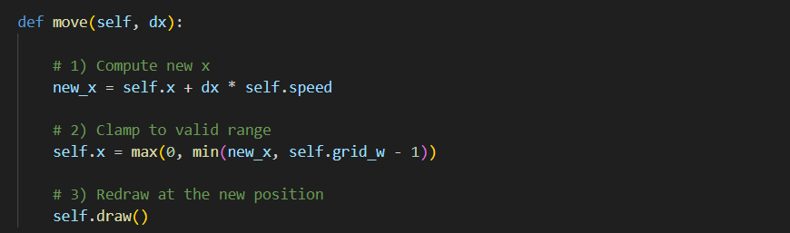

**2) Movement: Clamping & Redrawing**

* **Calculates a tentative new column by adding dx * speed (where dx is –1 or +1).**
* **Ensures the ship never leaves the play area by clamping self.x between 0 (far left) and grid_w - 1 (far right).**
* **Calls self.draw() to erase the old triangle and paint it in its new cell.**

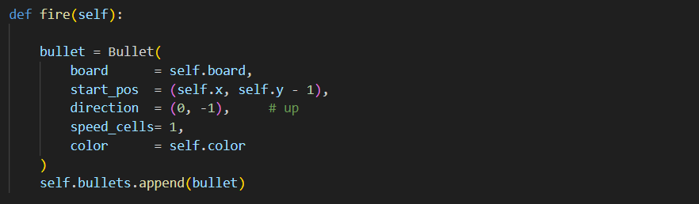

* Creates a new **Bullet** object positioned **one cell above** the ship’s nose (self.y - 1), traveling upwards (dy = -1) at one cell per tick, sharing the ship’s color.
* Adds it to self.bullets, so the main game loop can move and draw it each frame.

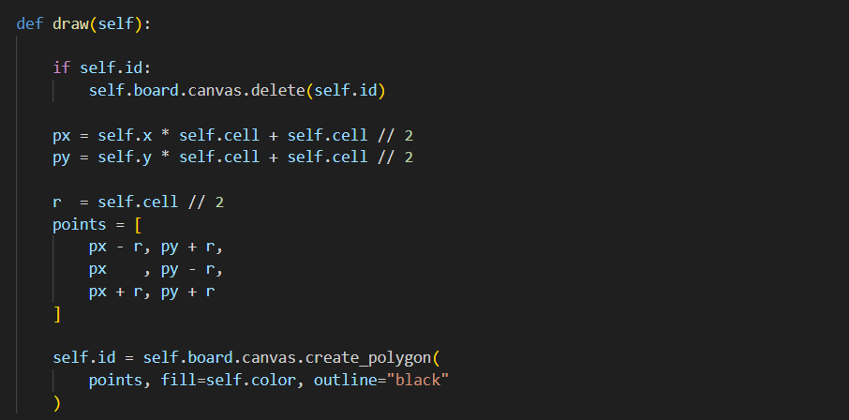

**4) Drawing: A Triangular Ship**

**Step 0: Erase the Old Ship**

* **What’s happening?** If self.id holds a number, it refers to the last triangle we drew. Calling delete(self.id) tells the canvas to remove that shape.
* **Why?** Without this, repeated draws would leave ghost images all over the screen. Erasing first gives you a clean slate.

**Step 1: Find the Pixel Center of the Cell**

* **Grid position**: Suppose the ship is at grid cell (x=5, y=10).
* **Cell size**: Each cell is cell pixels wide (e.g. 20).
* **Left edge of cell**: x * cell = 5 * 20 = 100 px.
* **Right edge**: plus 20 = 120 px.
* **Center X (px)**: halfway between 100 and 120 → 100 + 10 = 110.
* **Similarly for Y**: py = y*cell + cell//2.
* **Result**: (px, py) pinpoints the exact **middle** of the grid cell in pixel coordinates.

**Step 2: Calculate the Triangle’s Points**

* **Radius (r)**: cell // 2 (half the cell size)—here, 10 px—defines how big the triangle is.
* **Bottom-left corner**: (px - r, py + r) → 10 px left and 10 px down from center.
* **Nose tip (top)**: (px, py - r) → straight up 10 px from center.
* **Bottom-right corner**: (px + r, py + r) → 10 px right and 10 px down.
* **Visualize**: These three points form an **isosceles triangle** that sits perfectly inside the cell, pointing upward.

**Step 3: Draw and Remember**

* **Create polygon**: create_polygon(points, fill, outline) tells Tkinter to connect those three points with straight lines, fill the interior with your ship’s color, and draw a black border.
* **Store the ID**: The canvas returns a unique integer ID for this shape. Saving it in self.id means next time draw() runs, we know exactly which shape to erase.

**7.2 File: invader.py**

Each alien in Space Invaders is a little sprite that:

1. Knows its current grid-cell (column, row).
2. Knows how fast it moves (cells per tick).
3. Moves horizontally (and, upon hitting the edge, shifts down and reverses).
4. Draws itself on the canvas at the right pixel position.
5. Disappears when “shot.”

Create **invader.py** beside your other modules:

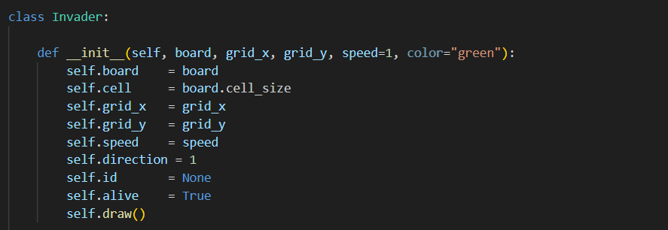

**1) Initialization: Booting Up Each Alien**

* **Board & Cell Size**
* Stores a reference to the board (with its canvas and cell_size).
* self.cell will be used to convert grid to pixel coordinates.
* **Grid Position**
* self.grid_x, self.grid_y set the invader’s location in the invisible grid—like telling it, “You start at column 5, row 2.”
* **Speed & Direction**
* self.speed controls how many cells it moves each frame.
* self.direction = 1 means “begin by moving right.”
* **Lifecycle Flags**
* self.id = None is a placeholder until we actually draw a shape.
* self.alive = True marks it as active—once hit, we’ll flip this to False.
* **Immediate Draw**
* Calling self.draw() at the end means the alien appears on screen the moment it’s created.

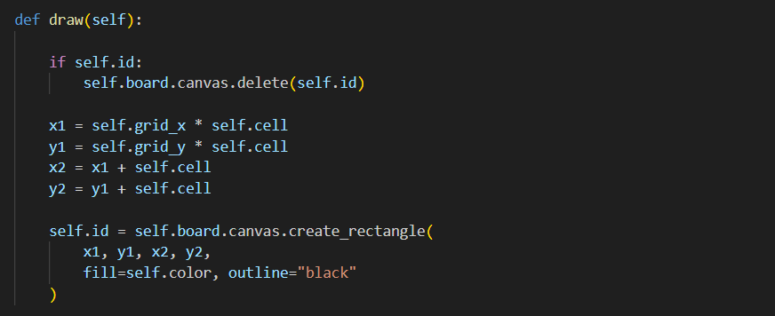

**2) Drawing: From Grid Cell to On-Screen Square**

* **Erase the Old Sprite**
* If self.id holds a previous rectangle’s ID, delete it so there’s never a ghost image.
* **Compute Corners in Pixels**
* **Left** = grid_x * cell, **Top** = grid_y * cell.
* **Right** and **Bottom** are each one cell-size offset away.
* **Draw & Remember**
* Creates a filled rectangle on the canvas, capturing its ID in self.id for future erasure or hit-handling.

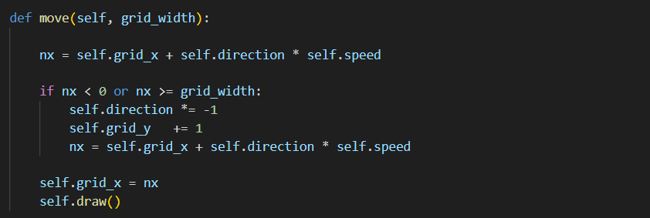

**3) Movement: Marching Across and Dropping Down**

* **Calculate Next Column**
* nx = current_x + (±1 * speed) moves the invader either right or left by speed cells.
* **Edge Detection**
* If nx is outside [0, grid_width-1], we’ve reached the screen edge.
* **Reverse & Descend**
* Flip self.direction so future moves go the opposite way.
* Increment self.grid_y by 1 to drop one row closer to the player.
* Recompute nx so after the turn it immediately advances one cell inward.
* **Commit & Redraw**
* Set self.grid_x = nx and call draw() so the invader visibly shifts and (if needed) moves down.

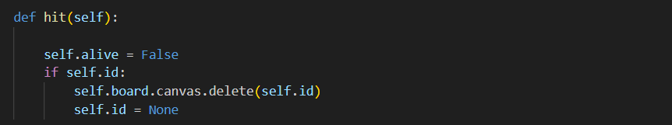

**4) Hit Handling: When a Bullet Strikes**

* **Mark Dead**
* self.alive = False tells the game loop this invader should no longer be updated or collide.
* **Erase from Screen**
* If a rectangle exists (self.id), delete it from the canvas so the alien vanishes.
* **Cleanup**
* Setting self.id = None avoids future attempts to delete a non-existent shape.

**Building the Swarm Class – Coordinated Alien Movement**

The **Swarm** is the “director” of your invader army. It knows:

1. How many rows and columns of aliens you have.
2. How far apart they sit horizontally and vertically.
3. When any alien hits the screen edge, the entire formation shifts down and reverses direction.
4. How to tell if the player has won (all aliens dead) or lost (aliens reached the bottom).

**File: swarm.py**

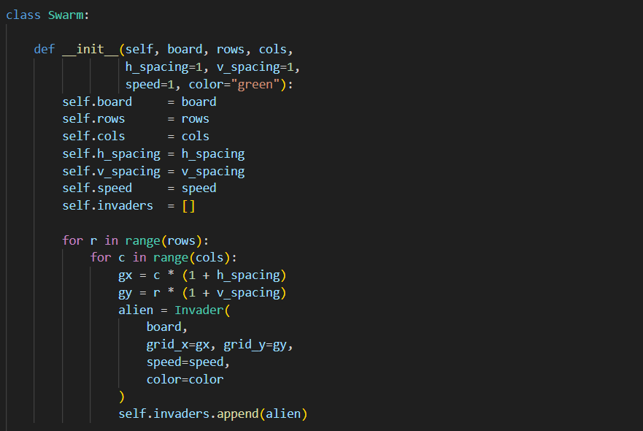**Swarm** class—**Formation Setup**, **Movement Logic**, **Bottom-Reached Check**, and **Victory Check**—each showing the code and then walking through its **step-by-step logic** so readers can **visualize** the entire alien swarm in action.

**1) Formation Setup (__init__)**

1. **Loop over rows and columns**:
   * For each row index r from 0 to rows-1 and column index c from 0 to cols-1, we calculate a grid position.
2. **Compute grid coordinates with spacing**:
   * **gx = c * (1 + h_spacing)** ensures there’s h_spacing empty cells between columns of aliens.
   * **gy = r * (1 + v_spacing)** does the same vertically.
3. **Create each Invader** at (gx, gy) with the shared speed and color.
   * The Invader constructor immediately draws itself on the board.
4. **Collect them** in self.invaders, a flat list of all aliens in the formation.

**Imagine** a perfect grid of aliens, each one spaced out by the horizontal and vertical gaps you chose—ready to march.

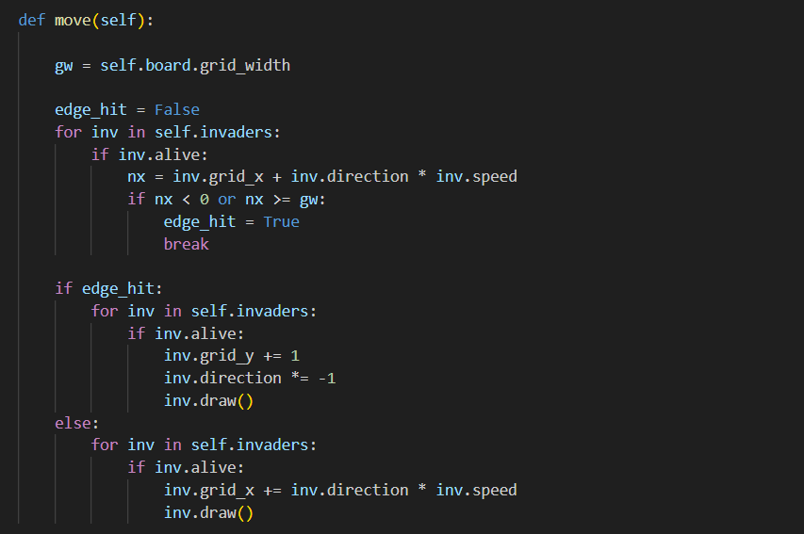

**2) Movement Logic (move)**

1. **Predict next positions**:
   * For each alive invader, compute nx = grid_x + direction * speed.
2. **Detect edge hit**:
   * If any nx would be outside [0, gw-1], set edge_hit = True and stop checking further.
3. **Edge response**:
   * **If** edge_hit is True:
     + **Drop** every alive invader one row (grid_y += 1).
     + **Reverse** its direction (direction *= -1).
     + **Draw** at the new position.
4. **Normal march**:
   * **Else** (no edge ahead):
     + **Advance** each alive invader horizontally by direction * speed.
     + **Draw** it in the new column.

**Imagine** the swarm gliding right until the first alien touches the wall, then the entire army shifts down and reverses to glide left—just like in the classic arcade.

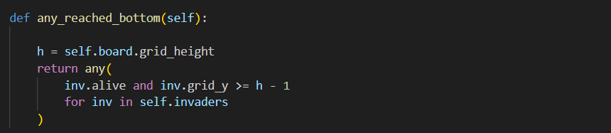

**3) Checking for Player Defeat (any_reached_bottom)**

1. **Compute bottom row index**: h - 1.
2. **Scan each invader**:
   * If an invader is **alive** and its grid_y has reached or passed that bottom row, the generator yields True.
3. **any(...)** returns True if **any** invader meets those conditions.

**Imagine** a single alien slipping through, crossing the player’s defensive line—triggering an immediate game-over condition.

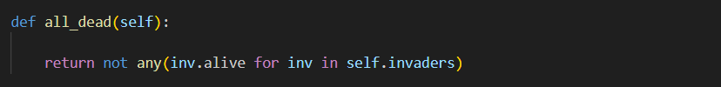

**4) Checking for Player Victory (all_dead)**

1. **Test each invader’s alive flag**.
2. **any(inv.alive for ...)** returns True if at least one alien still stands.
3. **not any(...)** flips it, so all_dead() is True only when **every** invader has alive == False.

**Imagine** the screen clear of moving targets—no aliens left—and the player has

triumphed.

**Building the Bullet Class – Fast, Straight Shots**

To send phalanxes of alien–blasting bullets upward, we’ll encapsulate each shot in its own **Bullet** class. A bullet must:

1. Appear as a thin rectangle (or line) in the grid cell above the paddle.
2. Travel straight up at a fixed speed (cells per tick).
3. Disappear when it leaves the top of the screen or when it hits an invader.
4. Provide its grid position so the main loop can check collisions.

We’ll split this into two parts: the code in bullet.py, then a deep dive explaining every detail.

**7.5.1 File: bullet.py**

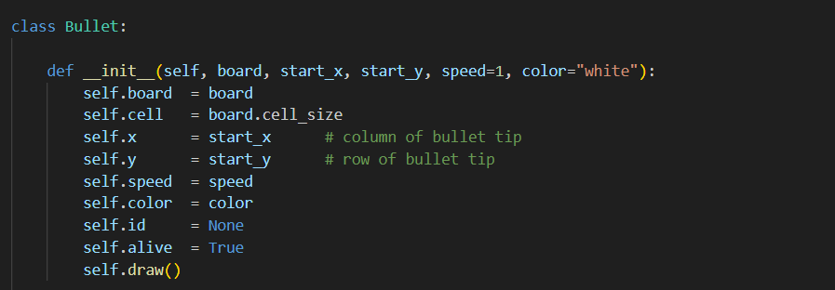

**1) Initialization: Spawning the Bullet**

1. **Store references & parameters**
   * Keeps the board (for canvas and cell size), initial grid coordinates (start_x, start_y), travel speed, and color.
2. **Prepare drawing state**
   * self.id = None means “not on screen yet.”
   * self.alive = True flags the bullet as active.
3. **Immediate rendering**
   * Calls self.draw() so the moment you fire, the bullet appears at the correct cell.

**Imagine** a small spark appearing right above your ship’s nose, ready to streak upward.

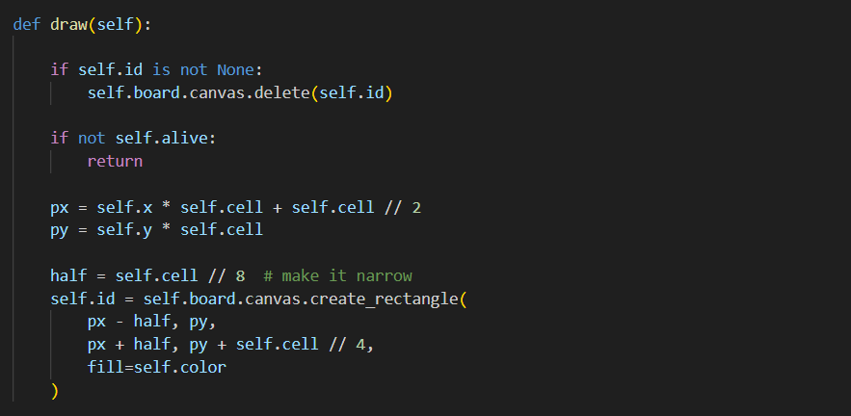

**2) Drawing: A Slim, Tall Sliver**

1. **Erase first**
   * Deletes the old line so only one pixel-tall bullet is visible at a time.
2. **Check alive state**
   * If self.alive is False, we bail out—no drawing of dead bullets.
3. **Grid→Pixel conversion**
   * **Center X (px)**: left edge of the cell plus half the cell width.
   * **Top Y (py)**: exactly the top edge of the cell (bullet’s tip).
4. **Slim rectangle**
   * Width = cell // 4 pixels (half on each side of px), Height = cell // 4 pixels.
   * Paints a tiny vertical bar that visually reads as a bullet.

**Imagine** a vertical flash of light, just a few pixels wide and tall, sharply marking the bullet’s position.

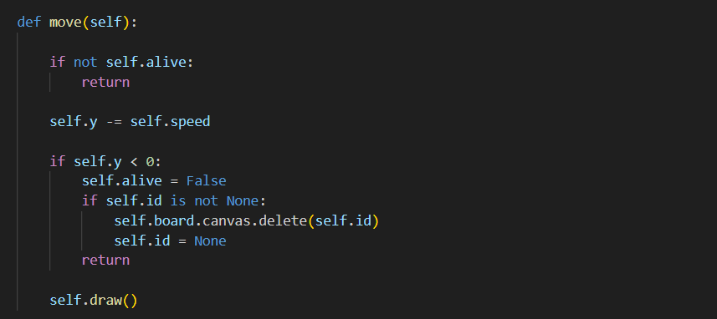

**3) Movement: Zipping Upward**

1. **Skip if dead**
   * Prevents dead bullets from moving or redrawing.
2. **Advance upward**
   * Subtracts speed from self.y, moving the bullet toward row 0.
3. **Top-edge check**
   * If self.y goes negative, the bullet has left the screen:
     + Mark alive = False.
     + Delete any on-screen line.
     + Exit without redrawing.
4. **Redraw**
   * If still on screen, calls self.draw() to show the bullet in its new row.

**Imagine** a spark shooting straight up one cell at a time, vanishing the moment it crosses the top border.

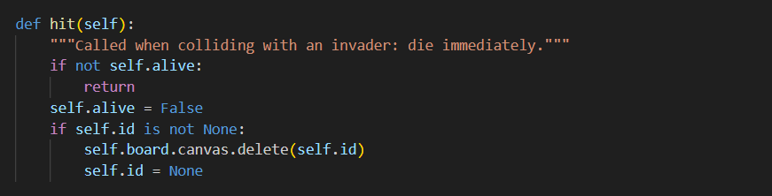

**4) Hit Handling: Vanishing on Contact**

1. **Guard against repeats**
   * If already dead, do nothing.
2. **Mark dead & erase**
   * Sets alive = False so subsequent move() or draw() calls do nothing.
   * Deletes the line from the canvas so the bullet disappears immediately on collision.

**Imagine** the bullet flashing out of existence the instant it strikes an enemy—no lingering lines, only the impact.

Just like the player and the invaders, your battlefield needs a bit of cover — those chunky little bunkers that stand between the ship and the alien swarm. In Space Invaders, barriers serve two purposes:

1. **Tactical Cover**  
   They absorb both the player’s bullets and enemy bombs, giving you a momentary shield as the aliens close in.
2. **Destructible Terrain**  
   Each barrier is made up of many small segments, and every shot gradually wears it down until it crumbles away completely.

In the next section we’ll encapsulate each bunker as a **Barrier** class: a collection of tiny “cells” that know how to draw themselves, detect incoming shots, and vanish when hit. By the end, you’ll have solid, grid‐aligned cover that visually chips away under fire — just like the real arcade!

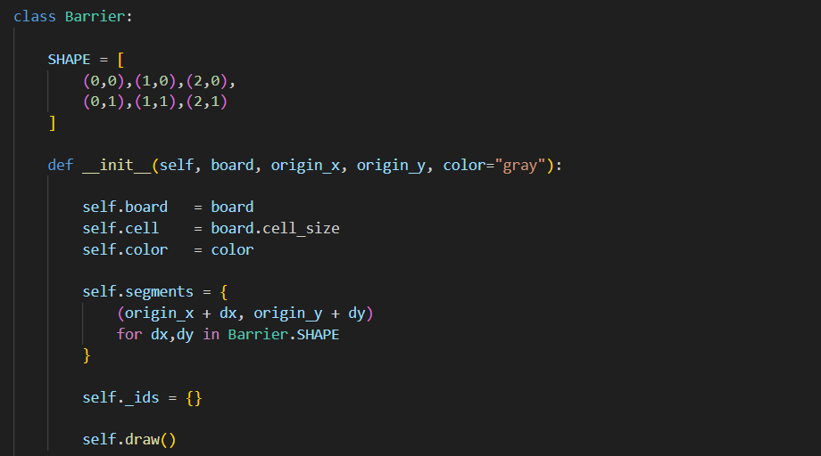

**1) Initialization: Planting the Bunker**

1. **Define the shape**
   * SHAPE lists relative offsets for a 3×2 block: three cells wide, two tall.
2. **Compute absolute positions**
   * For each offset (dx,dy), we add origin_x/origin_y to get actual grid cells.
   * E.g. if origin_x=5, origin_y=10, segments cover (5,10)…(7,11).
3. **Store live segments**
   * self.segments is a set of coordinate tuples still intact.
4. **Prepare ID mapping**
   * self._ids will link each segment’s grid coords to its Canvas rectangle ID.
5. **Draw immediately**
   * Calling self.draw() paints every segment right away.

**Imagine** six gray squares snapping into place to form a little bunker at the given origin.

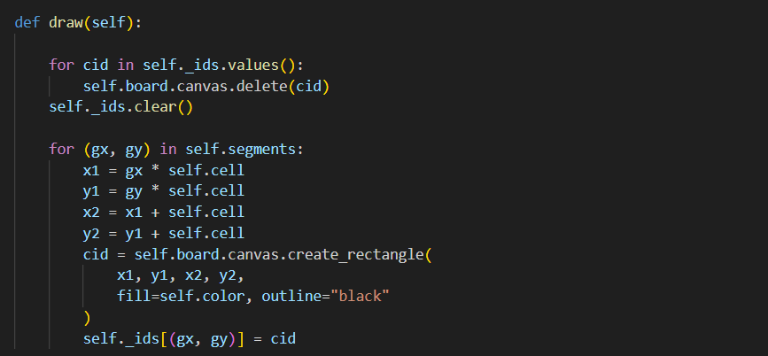

**2) Drawing: Painting Every Live Cell**

1. **Erase old graphics**
   * Deletes every stored Canvas ID so no old cells linger.
   * Clears the _ids map for a fresh redraw.
2. **Grid→Pixel math**
   * Converts each segment’s (gx,gy) into rectangle corners (x1,y1) to (x2,y2).
3. **Draw & record**
   * Paints a filled rectangle for each live segment and remembers its ID keyed by (gx,gy).

**Imagine** someone lifting an eraser over the bunker, then tracing exactly the remaining intact cells back onto the canvas.

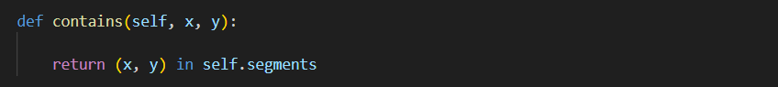

3) Collision Check: “Would a Shot Strike Here?”

* **What it does**
* Returns True if a bullet or bomb at grid (x,y) overlaps an intact bunker cell.
* **Imagine** the game loop asking, “Did my projectile land in this bunker?”—and getting a simple yes/no answer without scanning graphics.

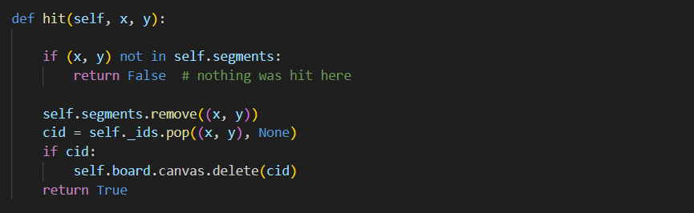

**4) Hit Handling: Removing a Struck Cell**

1. **Check existence**
   * If (x,y) isn’t a live segment, nothing changes—return False.
2. **Logical removal**
   * Deletes (x,y) from self.segments, so future draws won’t include it.
3. **Graphic removal**
   * Pops its Canvas ID from _ids and deletes that rectangle—so the cell vanishes instantly.
4. **Signal success**
   * Returns True so the game loop knows a bunker cell was destroyed.

**Imagine** your bullet striking one of the bunker’s bricks: that square disappears both from memory and the screen with a single call.

**7.6 Adding Explosions & Laser Sounds – effects.py**

Now that we have all of our moving parts—player, bullets, invaders, barriers—it’s time to add the finishing touches: **laser sounds**, **explosion effects**, and **game-over jingles**. We’ll bundle those into an effects.py module.

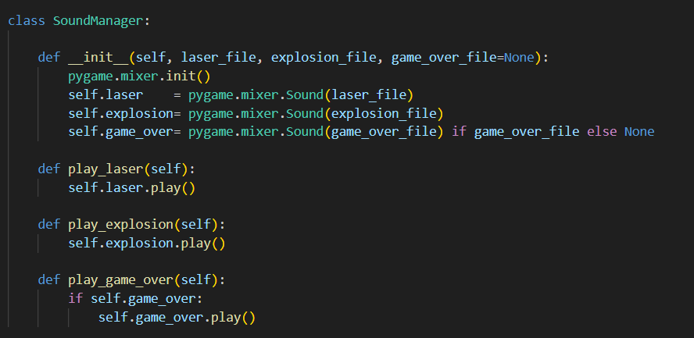

**A) SoundManager: Gathering and Playing Effects**

1. **Mixer Initialization**
   * The constructor calls pygame.mixer.init() once to wake up the audio system.
2. **Preloading Sounds**
   * Each file path is loaded into a Sound object (laser, explosion, optionally game_over) so they play without delay.
3. **Simple Methods**
   * play_laser(), play_explosion(), and play_game_over() each call .play() on the preloaded clip, giving clear, one-line cues in your game loop.

**Imagine** all your audio cues standing at the ready, each wrapped in one tidy method call.

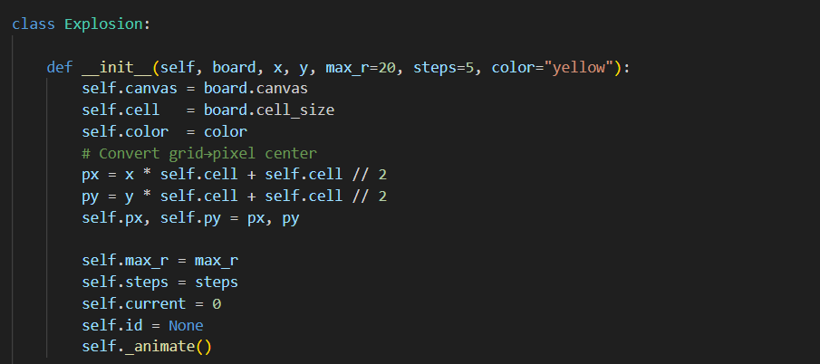

**B) Explosion: A Growing Circle Animation**

**Logic of Initialization**

1. **Store Canvas & Cell Size**
   * So we can draw on the correct canvas and know how big each grid cell is.
2. **Grid→Pixel Center**
   * (x, y) grid cell becomes (px, py) in pixels by multiplying by cell and adding half a cell—placing the circle’s center exactly in the middle of the targeted cell.
3. **Animation Parameters**
   * max_r: how large the circle will grow.
   * steps: how many frames the growth should take.
   * current: starts at 0, will count up to steps.
4. **Start Animating**
   * Calling self._animate() draws the first frame immediately.

**Imagine** the point of impact ready for a little fireworks show, all prepped with size and timing.

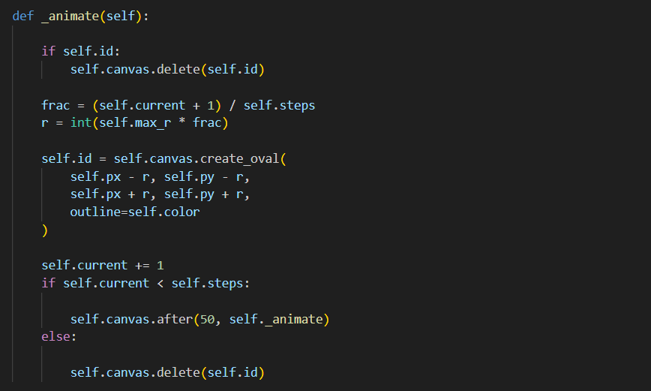

1. **Erase Previous**
   * If a circle from the last frame exists (self.id), delete it—so you see only one circle at a time.
2. **Compute Growth Fraction**
   * frac = (current + 1) / steps gives a number from 1/steps up to 1.
   * Multiply by max_r to get the radius for this frame. Early frames are small, later frames reach full size.
3. **Draw the Circle**
   * create_oval(px - r, py - r, px + r, py + r) draws a ring centered at (px, py) with radius r.
4. **Increment the Counter**
   * current += 1 moves us to the next frame.
5. **Schedule Next Frame or Finish**
   * If current < steps, call self._animate() again after 50 ms for the next growth stage.
   * Once current == steps, delete the final circle and stop—ending the animation.

**Imagine** a glowing ring bursting outward in five smooth steps, then vanishing, like a quick pulsing ripple on the screen.

**7.7 Orchestrating the Game – space_invaders.py**

With all of our pieces in place (Board, Player, Invader/Swarm, Bullet, Barrier, Effects), the last step is to tie them together in **space_invaders.py**, our main game driver. This module will:

1. **Initialize** all subsystems (GUI, audio, data).
2. **Bind** player controls (move & fire).
3. **Maintain** lists of active objects (bullets, bombs, barriers, effects).
4. **Run** the game loop:
   * Move every object (player bullets, invader bombs, swarm).
   * Handle all collisions.
   * Spawn explosion effects and play sounds.
   * Redraw the screen each frame.
   * Check for win/loss conditions and advance levels or end the game.

**7.7.1 File: space_invaders.py**



**1) Booting the Game World (__init__)**

When you instantiate SpaceInvaders(), here’s what unfolds:

1. **Directory & Subsystem Initialization**

The code finds its own folder (so asset paths resolve correctly) and turns on Pygame for audio support.

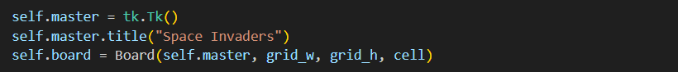

**Window & Canvas Creation**

A Tk window appears, titled “Space Invaders,” and Board lays out a grid of grid_w × grid_h cells, each cell pixels, ready to draw everything.



**Player Ship**

Your blue­green ship lands at the bottom center, with lives and movement logic already wired up.

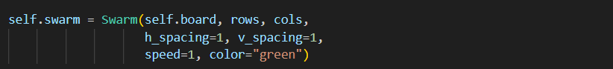

**Alien Swarm**

A formation of rows × cols green invaders springs into view at the top, neatly spaced by one empty cell in both directions.

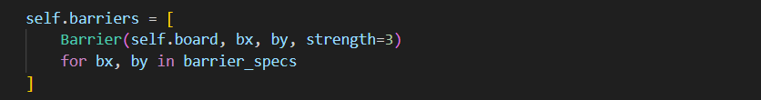

**Barriers**

Three bunkers appear at the specified grid origins, each made of multiple destructible cells.

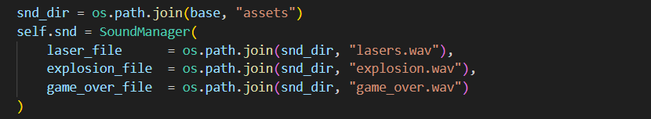

Laser, explosion, and game-over sounds are preloaded so they play instantly when called.

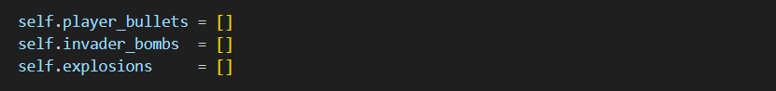

**Game State Lists**

Empty lists stand by to track every bullet, every falling bomb, and every ongoing explosion animation.

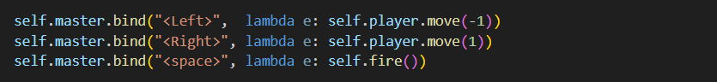

**Input Binding**

Arrow keys slide the ship; hitting space fires a bullet (if none in flight).

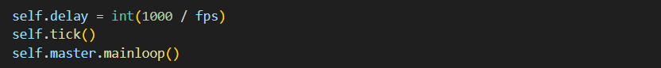

**Start the Loop**

1. Finally, tick() kicks off the recurring loop, and mainloop() hands control to Tk until the window closes.

**Imagine** flipping switches, the window and grid popping up, the ship and swarm materializing, barriers rising, sounds loading, and then the first frame beginning—all before the player even touches a key.

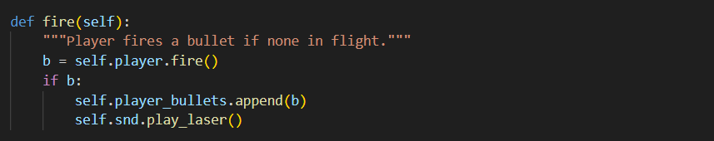

**2) Firing a Shot (fire)**

* **What happens:** The Player attempts to fire. If it returns a new Bullet (i.e. no shot already in flight), we add it to our list and play the laser sound.
* **Imagine:** You hit space, and instantly a small white spark appears above your ship with a sharp “pew!” that echoes across the arcade.

**3) The Heartbeat of the Game (tick)**

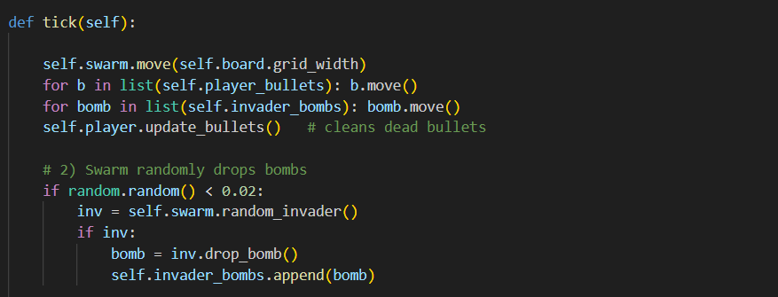Each call to tick()—scheduled every **self.delay** ms—drives one frame:

**3.1 Move All Entities**

* **Aliens** march and drop.
* **Bullets** zip up, vanish off-screen, and get cleaned out.
* **Bombs** plummet downward, disappearing at the top or when flagged dead.

**Imagine** every object sliding into its next cell, ready for collision checks.

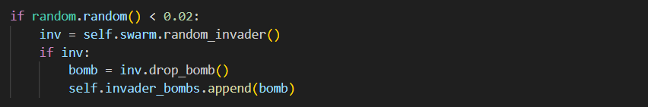

**3.2 Random Bomb Drops**

**2% chance** each frame that a random alive invader drops a bomb, adding suspense—sometimes nothing, sometimes a hail of bombs.



**3.3 Collision Handling**

* **Player bullets** can kill invaders or chip away at barriers, spawning explosion animations and sound.
* **Invader bombs** can destroy barriers or hit the player, costing a life.

**Imagine** sparks flying, bricks vanishing, ships exploding—every collision triggering the right visuals and sounds.

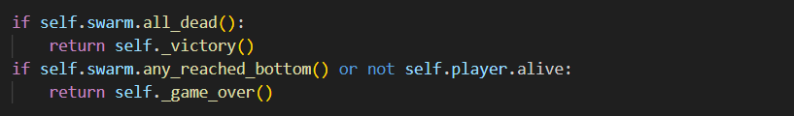

**3.4 Check for End-Game**

* **Victory** if no aliens remain.
* **Defeat** if any invader reaches your row or your ship is gone.

**Imagine** the game instantly recognizing triumph or catastrophe, then locking the final message on screen.

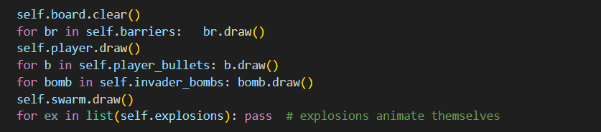

* A fresh canvas is unrolled, then every barrier, the player, shots, bombs, and aliens is repainted in proper order.

**Imagine** someone wiping a slate clean and retracing every living object—like frames in a hand‐drawn animation.



**3.6 Schedule the Next Frame**

* Tkinter queues tick() again after the delay, perpetuating the game’s rhythm until a win, loss, or window close.

Imagine the game’s metronome ticking on until you beat the swarm or they overwhelm you.

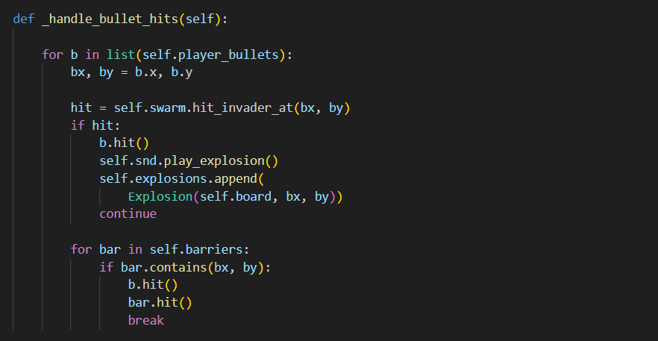

**A) Handling Player Bullets Hitting Invaders and Barriers**

1. **Iterate Over Copies of Bullets**
   * list(self.player_bullets) lets us remove bullets safely inside the loop.
2. **Track the Bullet’s Grid Position**
   * bx, by = b.x, b.y grabs where the bullet currently sits—its tip cell.
3. **Check for Invader Collision**
   * self.swarm.hit_invader_at(bx, by) asks the Swarm: “Is there a live invader here?”
   * If **True**:
     + **b.hit()** marks the bullet as dead and erases it.
     + **self.snd.play_explosion()** plays the explosion sound.
     + **self.explosions.append(...)** spawns a visual explosion animation at (bx,by).
     + **continue** skips the barrier loop—one bullet can’t hit both.
4. **Check for Barrier Collision**
   * Only if no invader was hit: iterate each barrier.
   * bar.contains(bx,by) returns True if that grid cell still has bunker material.
   * On a hit:
     + **b.hit()** removes the bullet.
     + **bar.hit(bx,by)** erases that single bunker cell.
     + **break** stops checking other barriers for this bullet.

**Imagine** each bullet flying upward, first checking “Did I punch an alien?”—if so, ka-boom! Otherwise, “Did I nick a bunker?” and you see a little crater open up.

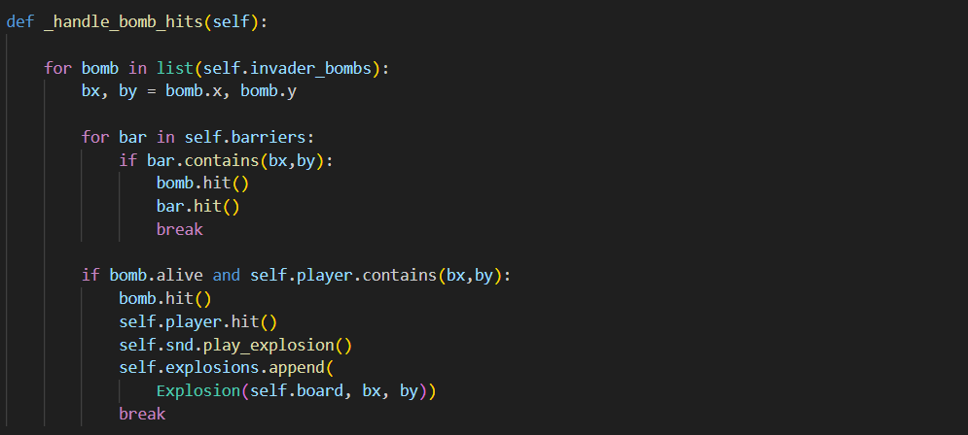

**B) Handling Invader Bombs Hitting Barriers and the Player**

**Logic, Step by Step**

1. **Loop Over a Copy of Bombs**
   * Using list(...) so we can delete bombs mid‐loop without trouble.
2. **Capture Bomb Position**
   * bx, by = bomb.x, bomb.y is where the bomb currently sits—its “nose.”
3. **Barrier Check First**
   * Iterate each bunker: if bar.contains(bx, by), that grid cell is still intact.
   * On hit:
     + **bomb.hit()** kills the bomb and erases it.
     + **bar.hit(bx, by)** removes that bunker cell.
     + **break** stops barrier checks for this bomb (it’s gone).
4. **Then Player Check**
   * Only if the bomb is still alive (didn’t just hit a barrier).
   * self.player.contains(bx, by) tests if the ship occupies that cell.
   * On hit:
     + **bomb.hit()** deletes the bomb.
     + **self.player.hit()** reduces player lives and erases/redraws the ship.
     + **self.snd.play_explosion()** plays the impact sound.
     + **self.explosions.append(...)** shows a blast animation at the ship’s cell.
     + **break** ends processing this bomb.

**Imagine** each bomb plummeting: if it strikes a bunker, you hear a “chunk” and the bunker loses a brick; if it slips through, it slams into your ship with a “boom,” costing you a life and triggering a fiery circle.

**4) End-Game Messages**

**Victory**

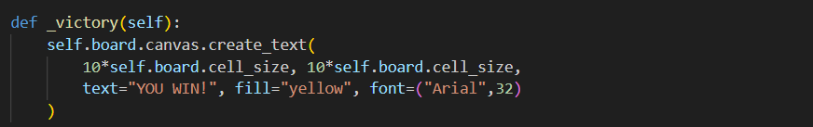

**Centered** near the middle, “YOU WIN!” glows in gold.

**Game Over**

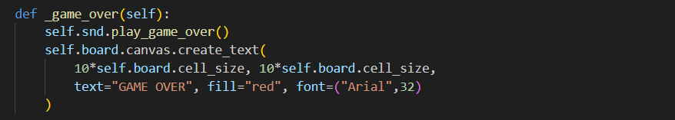

* Plays the final lament, then stamps “GAME OVER” in bold red.

**Imagine** the curtain dropping, the final banner unfurling, and the game pausing on that last, dramatic screen.

**Chapter 8: Platform Jumper – Introducing Physics and Gravity**

In this chapter, you’ll create a side-view Platform Jumper game to explore basic physics: gravity, jumping, and collision with platforms. You’ll work with arrays for level design, sprite animation, and continuous movement using pygame.

**8.0 Project Structure**

Set up your my_platform_jumper/ directory:

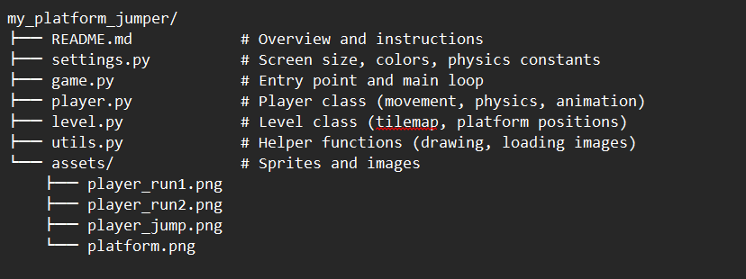

* **player.py**: handles physics, input, and sprite animation.
* **level.py**: defines a grid-based level and draws platforms.
* **settings.py**: contains constants like gravity, jump strength, tile size.
* **8.1 settings.py — Game Constants**

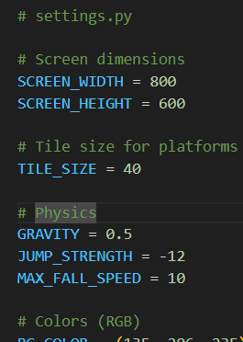

Centralized tuning of physics and display.

**8.2 level.py — Designing the Level**

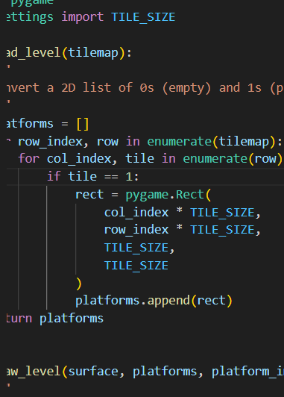

* **tilemap**: list of lists, e.g., [[0,1,0,...], [...]].
* Converts tiles to pygame.Rect objects for collision.
* **8.3 player.py — Player Physics & Animation**

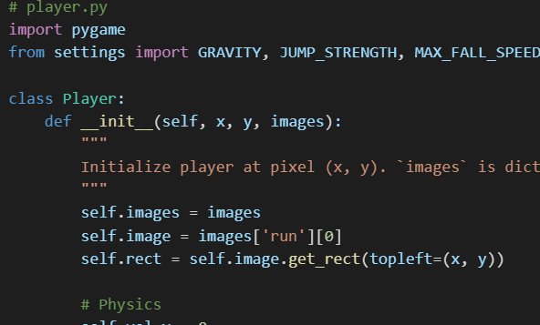

Highlights:

* **Gravity** and **jump strength** control vertical motion.
* **on_ground** prevents double-jump.
* **images** holds run frames and jump frame for smooth animation.

**8.4 game.py — Main Loop and Integration**

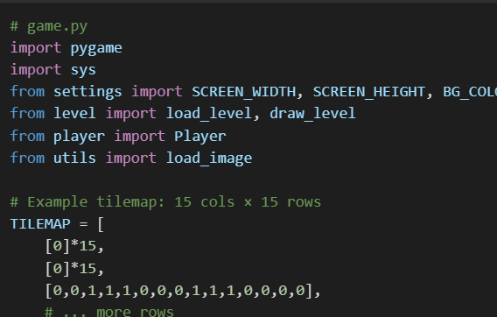

Flow:

1. **Initialization** of pygame, screen, clock.
2. **Load images** for player and platforms.
3. **Build platforms** from TILEMAP.
4. **Game loop**: handle quit, update player physics, draw scene.

**8.5 Exercises and Extensions**

1. **Horizontal Movement**: Add left/right controls and wall collisions.
2. **Scrolling Level**: Make the camera follow the player when reaching screen edges.
3. **Different Tile Types**: Add moving platforms or deadly spikes in tilemap.
4. **Collectibles**: Place coins or stars; track score when collected.
5. **Parallax Background**: Implement layered background images moving at different speeds.

With Platform Jumper complete, you’ve tackled physics, collision detection, sprite animation, and level design. Next, Chapter 9 will focus on polishing your games with menus and high scores!

**Chapter 9: Game Over – Polish and Progress**

Now that your core gameplay is solid, it’s time to polish your game for a professional touch: add menus and UI screens, high-score saving, difficulty scaling, and file organization.

9.0 Project Structure for Polish

Refactor your project into a “polish” module alongside your game logic:

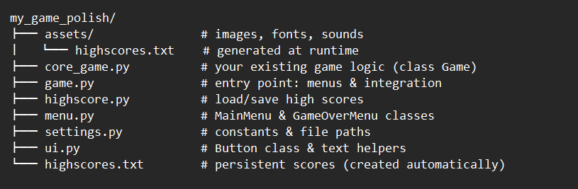

* settings.py: constants for screen width/height, colors, speeds.
* ui.py: basic UI components (text, buttons).
* menu.py: menu screens (main, game-over).
* highscore.py: persists highscores to a file.
* game.py: integrates polish components with your core game.
* assets/: static resources (fonts, icons).

**9.1 settings.py — Shared Constants**

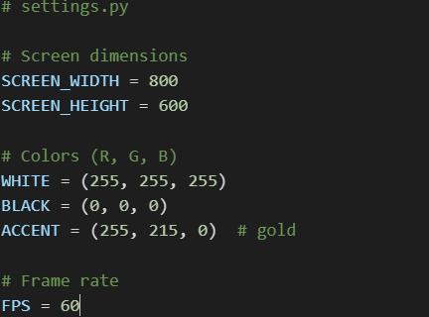

Edit these values to adjust your UI and game timing.

**9.2 ui.py — UI Components**

You can extend this with hover effects or icons later.

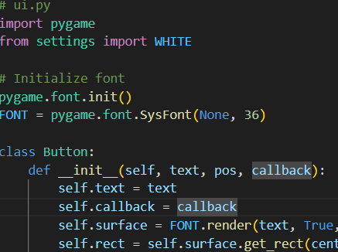

**9.3 menu.py — Main and Game-Over Menus**

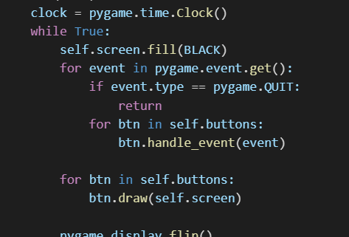

Create a similar GameOverMenu class to show the score and options to retry or quit.

**9.4 highscore.py — Saving and Loading High Scores**

Use load_scores() to fetch leaderboards and save_score() at game end.

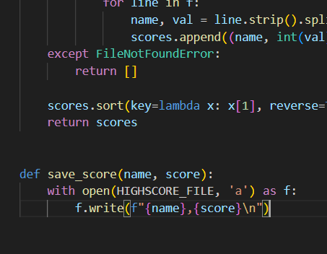

**9.5 Integrating Polish into game.py**

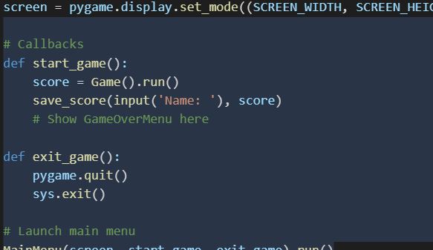

This hooks up your polished UI to the core game loop.

**9.6 Difficulty Scaling**

In your core game loop, ramp up challenge based on score or time:

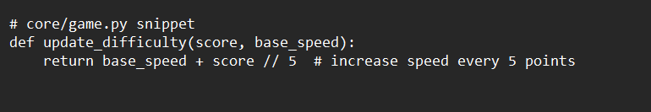

Pass the adjusted speed into your Game constructor.

**9.7 Exercises and Extensions**

1. **Pause and Resume:** Add a pause screen that interrupts gameplay.
2. **Animated Transitions:** Fade between menus using surface alpha.
3. **Configurable Keys:** Let players remap controls via a settings file.
4. **Menu Sounds:** Play sound effects on button clicks.
5. **Online Leaderboard:** Extend highscore.py to sync scores with a server.

With these additions, your game now has a professional polish layer: clear menus, persistent highscores, and scalable challenge. Well done!

**Chapter 10: Final Boss – Build Your Own Game**

You’ve built ten games and mastered Python fundamentals. Now it’s time for your capstone: **designing and implementing your own unique game**. This chapter deep-dives into each phase—planning, structuring, coding, testing, and distributing—so you emerge with a polished, playable title.

**10.0 Phase 1: Concept & Planning**

Before writing code, solidify your vision.

**1. Game Concept**

* **Genre**: Platformer? Puzzle? Shooter? RPG? Decide mechanics first.
* **Theme**: Sci‑fi, fantasy, retro, minimalistic. A cohesive style anchors design choices.
* **Core Loop**: What does the player *do* in a single cycle? (e.g., jump, shoot, match tiles)

**2. Scope Definition**

* **MVP (Minimum Viable Product)**: Identify the smallest set of features that makes the game fun:
  + Player movement
  + One enemy or challenge
  + One level or board
* **Stretch Goals**: Extra levels, power‑ups, multiplayer, level editor.
* **Timeline**: Allocate 1–2 days per feature for a total ~2 weeks project.

**3. Asset Strategy**

* **Placeholders First**: Use colored rectangles or ASCII to represent characters and platforms.
* **Polish Later**: Swap in pixel art or vector graphics once mechanics are solid.
* **Audio**: Download free sound effects/music or generate via tools like BFXR.

Document all of this in docs/game_plan.md, including:

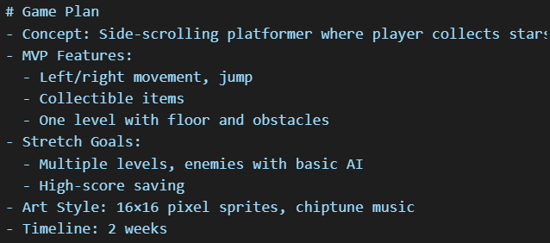

**10.1 Phase 2: Project Structure & Setup**

A clear folder layout prevents chaos as your codebase grows.

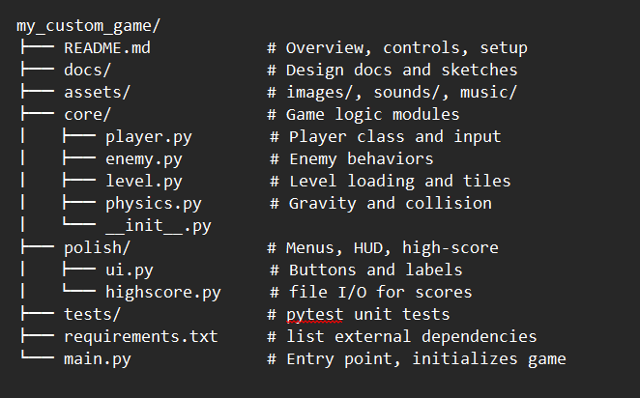

**Quickstart**:

1. Create a virtual environment: python -m venv venv
2. Activate and install requirements: pip install -r requirements.txt
3. Run python main.py to launch your game.

**10.2 Phase 3: Building the Game Loop**

All games share this skeleton in **main.py**:

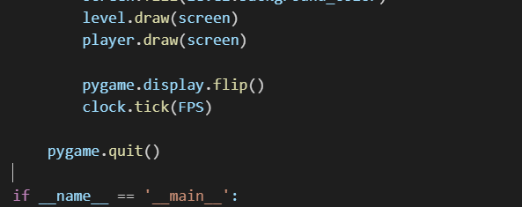

**Notes:**

* **Separate Concerns**: Input, update, logic, and render are distinct steps.
* **Parameters**: Pass FPS from settings.py to ensure consistent timing.
* **Extensibility**: Adding levels or enemy types requires only updating Level and Enemy modules.

**10.3 Phase 4: Core Modules in Depth**

**1. core/player.py**

**2. core/level.py**

**3. core/enemy.py**

**4. core/physics.py**

With player.py, enemy.py, level.py, and physics.py each handling a single concern—input & movement, enemy AI, map loading & rendering, and gravity & collisions—you maintain a clean, testable codebase.

**10.4 Phase 5: Testing & Debugging**

**Unit Tests (in tests/)**

* **Collision logic**: test that player lands on platforms correctly.
* **Level parsing**: test loading platform coordinates from JSON.

Example with pytest:

**Debug UI**

* Display **FPS**: pygame.font.SysFont to blit current FPS in a corner.
* Draw **hitboxes**: outline rectangles for player and enemies.
* Use Python’s logging to record events (e.g., logging.debug(f"Player pos: {player.rect}")).

**10.5 Phase 6: Polishing & Distribution**

1. **Menus & HUD**: Move UI code into polish/ui.py and call from main.py:
   * Start screen, pause menu, game-over screen.
2. **High Scores**: Save final score with polish/highscore.py and display leaderboard.
3. **Packaging**:
   * **PyInstaller**: pyinstaller --onefile main.py --add-data "assets:assets"
   * Create requirements.txt with pip freeze > requirements.txt.
4. **Documentation**: Write a clear README.md with installation steps, controls, and credits.
5. **Sharing**: Publish on itch.io or GitHub Releases with a zipped distribution.

**10.6 Beyond the Capstone**

* **Online Multiplayer**: Use socket or a library like websockets for real-time play.
* **Level Editor**: Build a simple editor (e.g., Tkinter-based) to place platforms and save JSON.
* **AI & Pathfinding**: Implement A* for smarter enemies.
* **Performance**: Profile with cProfile and optimize hot spots.

Congratulations—this roadmap arms you to conceptualize, build, and launch your own unique Python game! Make something you’re proud of.